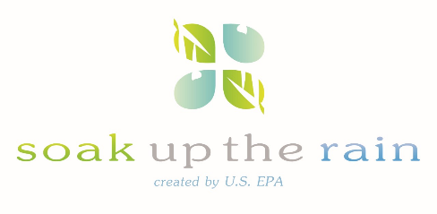

Soak Up the Rain New England Webinar Series

Tuesday, April 11th

3:00-4:30 EST To Register
Who Should Attend:
Teachers, students, anyone from watershed and environmental organizations, practitioners, and interested citizens- anyone who is considering a new project or looking to build on an existing program.
Webinar Series
We will be focusing on a range of innovative approaches to addressing stormwater in New England, presented by leaders from around the region.
- Hear about stormwater public outreach resources and programs
- See who’s soaking up the rain as we showcase green infrastructure projects and programs
- Learn about the latest tools and resources from EPA and others for implementing and promoting green infrastructure and
- Engage with others as we share information about successes, barriers, and lessons learned while implementing green infrastructure in our schools and New England communities.

Earth Day in Schools: Hear about what educators are doing to ‘soak up the rain’ in schools & communities
From rain gardens to green roofs, to tree plantings and more, schools across New England have made real strides in soaking up the rain. Join us for a presentation on student-led green infrastructure projects that have made a difference. Hear about Green Infrastructure practices that don’t cost a fortune and meet the state educational standards.
Presenters include:
Robin Organ, Executive Director/Founder, Project Green Schools. Project Green Schools is a MA-based, leading national non-profit organization, organized for innovative Environmental Education, E-STEM Education, Leadership, and Action. Project Green Schools provides a number of environmental programs and resources to best develop the next generation of GREEN student leaders and schools.
John Kelly, Environmental and Technology Instructor, Upper Cape Cod Regional Technical School. John Kelly has been an instructor for The Upper Cape Cod Regional Technical School for the past five years. John will present student projects utilizing rain runoff from the greenhouse for rain barrel collection and rain gardening in addition to projects involving green roofs and other innovative uses of storm water. He will also highlight how these exciting projects and others have met the state educational standards with ‘buy in’ from school administration.

Ruth Steward, Executive Director, Worcester Tree Initiative. Ruth Steward has been with the Worcester Tree Initiative for over seven years. She has been responsible for coordinating planting programs with more than fifty schools in and around Worcester and starting the ‘Stewards in the Streets’ volunteer tree steward program which assesses the health of city street trees. Ruth will be presenting their school education program which involves teaching children how to plant and care for trees with a focus on the benefits of urban trees and their role in soaking up storm water in cities.
Email registration address-
https://attendee.gotowebinar.com/register/1232502335242151427
*For questions about the webinar series or if you have ideas for additional webinar topics, please send an email to soakuptherain@epa.gov

