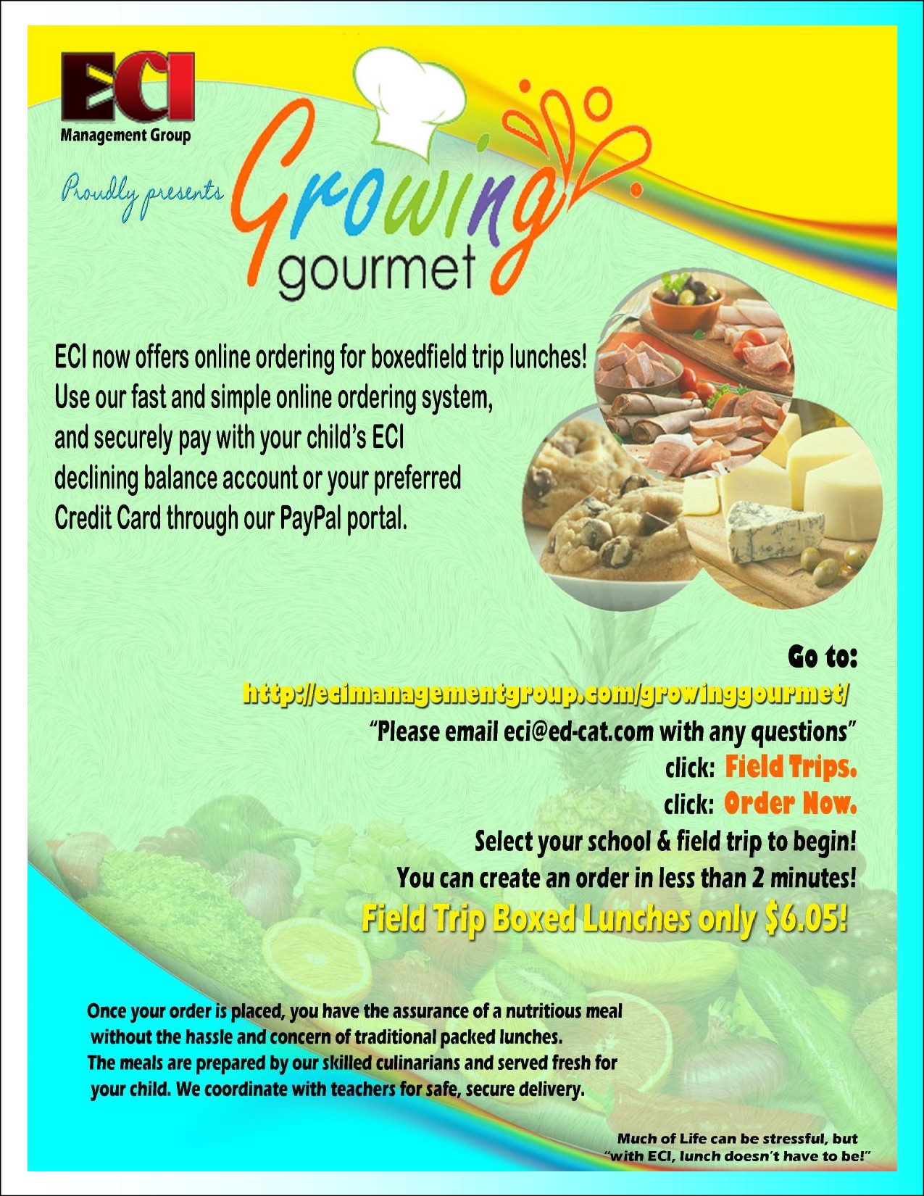

**\*Each Meal comes with a 16 oz. Water Bottle**

**Gluten Free Options**

**Your text here**