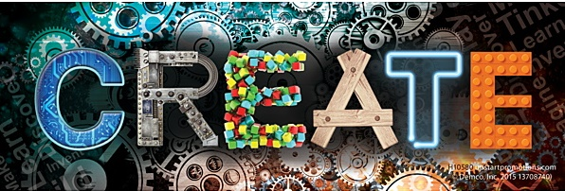

JUNCTION 101
GRAND OPENING MARCH EVENTS
MAKE & DO TUESDAYS @6 PM
March 7 FANCY LETTERING with Kim Gibson
March 14 ELECTRONIC SWITCH CHALLENGE
with Mike Beseres
March 21 CREATE with Sharon Simons
March 28 WEAVING with Amy Sharpe
Events are FREE and open to families and facilitated by community members. Programs are geared for ages 8-12.
Pre-registration is encouraged,
but walk-ins are welcome.
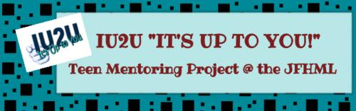
Junction 101 is an IU2U (It’s Up to YOU!) area sponsored by the Hallett Library and JFHML Friends Foundation…

