<INSERT DATE>

RE:
< FIRST NAME LAST NAME, DEGREE>
<INSERT ADDRESS>

Dear <INSERT FIRST NAME LAST NAME, DEGREE>,
<INSERT SPONSOR ORGANIZATION NAME>, as an approved ABMS Multi-Specialty Portfolio Program Sponsor, has attested that you met meaningful participation requirements for the QI Effort entitled “<INSERT QI EFFORT TITLE>”. The ABMS Multi-Specialty Portfolio Approval Program acknowledges receipt and processing of this information, and has notified NCCPA about your participation in this QI Effort.

Within five business days, NCCPA staff members will log this activity in your CME record and will notify you by email when that has been done. At that point, you will be able to sign in to your online record at www.nccpa.net and see the activity reflected there with Category 1 PI-CME credit. Irrespective of the date the activity is logged in your record by NCCPA staff, the dates of the activity will be recorded based on the dates you previously reported as the beginning and ending date of your participation in the QI Effort.

Sincerely yours,
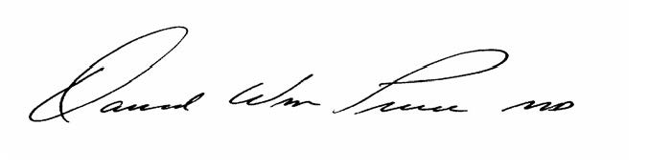
David W. Price MD, FAAFP, FACEHP
Executive Director
ABMS Multi-Specialty Portfolio Approval Program

