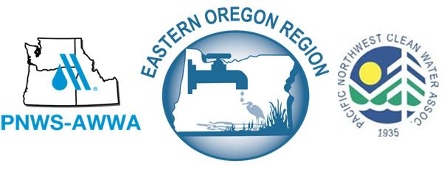

2018 EOR Operators Conference
Scholarship Application
For individuals lacking funding from their employer/system to attend the 2018 EOR Operators Conference, we have two categories of scholarships available. Each scholarship covers registration fees only.

Greenhorn Scholarship—individuals who have been in the field two (2) years or less, and are not certified water and/or wastewater operators.

Arnie Neely Scholarship—for certified water and/or wastewater operators. Recipients of the Arnie Neely Scholarship are eligible to receive this scholarship every other year.

For those interested in a scholarship, fill out the following application completely and email it to easternoregonregion@gmail.com by Wednesday, February 7th. Applicants will be contacted by email after February 9th

Applying For: Greenhorn Scholarship
Arnie Neely

Operator’s Name
Operator cert # (if applying for Arnie Neely)
# Years in the field (if applying for Greenhorn)
Received an Arnie Neely Scholarship previously? Yes No If yes, year rec’d
Employer/system name
Operator’s email address Operator’s daytime phone #
Employer’s email address Employer’s phone #

Briefly describe your system, staffing, and need for financial assistance:

