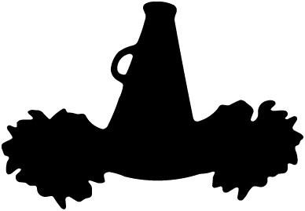
OLP Mini Pantherette Clinic

OLP Cheerleaders are hosting a Mini Pantherette Clinic for girls from the ECC, 3 years old - 2nd grade!
It’s only $30 to participate and includes the following:
NEW, PANTHERS Spirit Shirt
Cheer Bow
Mini Pom Poms
Key Dates:
January 16th – Deadline to register!!
January 29th – Clinic at OLP Gym from 3:30 – 5:00 pm *
Feb. 1st – Clinic review at OLP Gym from 3:30 – 4:15 pm *
Feb. 2nd – Catholic Schools Week Assembly Performance – 10:45am at OLP Gym*
Feb. 3rd – 8th Grade Boys Basketball Game at St. Michael’s High School @ 5:45 pm

* Events on January 29th, February 1st, and 2nd – Cheerleaders will walk Mini Pantherettes from the ECC to OLP and bring them back to the ECC afterwards.

FILL OUT THIS FORM OR REGISTER ONLINE BY JANUARY 16TH!
Forms should be turned into the front office at the ECC.
Online registration can be found on the OLP site under the PTO Online Store tab.

STUDENT’S NAME:_____________________________________ CLASSROOM:_________________________________

PARENT’S NAME(S):____________________________________ EMAIL(S):____________________________________

Mini Pantherette Shirt
TODDLER | 2 | 3 | 4 | 5/6 | 6
YOUTH (unisex sizing) | XS | S | M | L | XL

Please include payment of cash or check (made payable to OLP Cheer) along with this order form.
You can also place your order online through the PTO online store.
REGISTRATION COST IS $30. DEADLINE TO REGISTER IS JANUARY 16!

