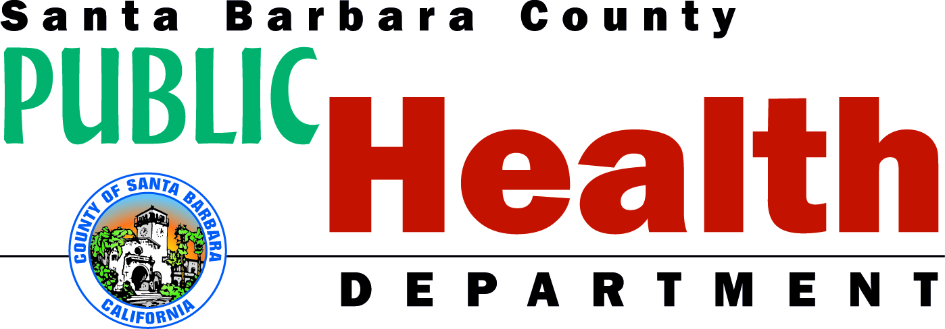
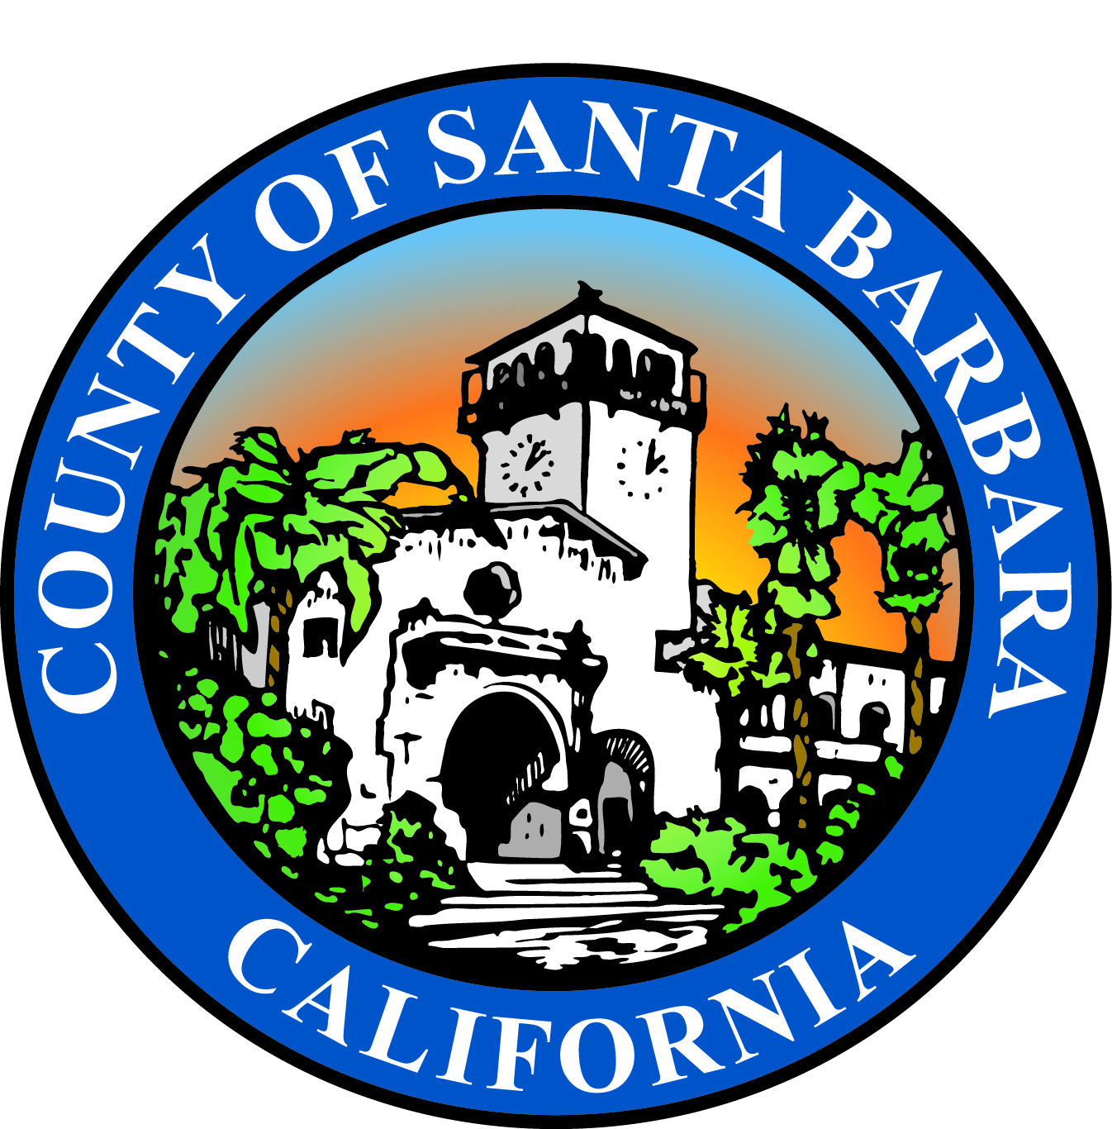

PUBLIC HEALTH DEPARTMENT
300 N. San Antonio Road • Santa Barbara, CA 93110
(805) 681-5102 • FAX (805) 681-5191
www.countyofsb.org

MEDIA ADVISORY
Contact: October 10, 2017
Susan Klein-Rothschild, MSW
Deputy Director
(805) 681-5435, cell: (805) 896-1057
sklein@sbcphd.org

SANTA BARBARA COUNTY WIC BREASTFEEDING PEER COUNSELING PROGRAM AWARDED LOVING SUPPORT

EXCELLENCE GOLD PREMIERE AWARD
By The U.S. Department of Agriculture (USDA), Food and Nutrition Service (FNS)

WHAT: The Santa Barbara County Public Health Department Women, Infants, and
Children (WIC) Program will receive a high level award presented by the USDA.

WHY: Santa Barbara County WIC has some of the highest breastfeeding rates in
California and the United States. The award was based on high breastfeeding rates, first of its kind Gen Y friendly and internationally recognized two way texting program, a high number of lactation educators and consultants, great California WIC policies, procedures, and handouts, and our amazing community partnerships. Six WIC agencies in the United States received this award level this year. Santa Barbara County was the only one recognized in California.

WIC is a go to place for breastfeeding education and help.
Breastfeeding is the norm for WIC.

WIC is a nutrition program that helps low income pregnant women, mothers with infants, infants and young children eat well, be active, and stay healthy. WIC provides nutrition and health education, education and support for breastfeeding babies, help in finding health care and other community services, and monthly checks to buy healthy foods.

WHEN: Thursday October 12, 2017 1-1:30pm at the Public Health Department
Auditorium located at 300 N. San Antonio Rd. Santa Barbara, CA 93110

WHO: Janet Wolf, USDA, and State WIC Staff, PHD Administration, Key Partners

OTHER: On site Contact Meg Beard MPH, MCHES, RDN, IBCLC, Breastfeeding Coordinator for WIC at (805) 448-4115 or meg.beard@sbcphd.org

PHOTO USDA Award and only WIC Agency in California to receive this national
OP: award. Some of the highest breastfeeding rates in California and the United States.
-30-

