**SCECINA PARENTS**

Key Club is a **fun** way for your child to earn service hours and learn about leadership.

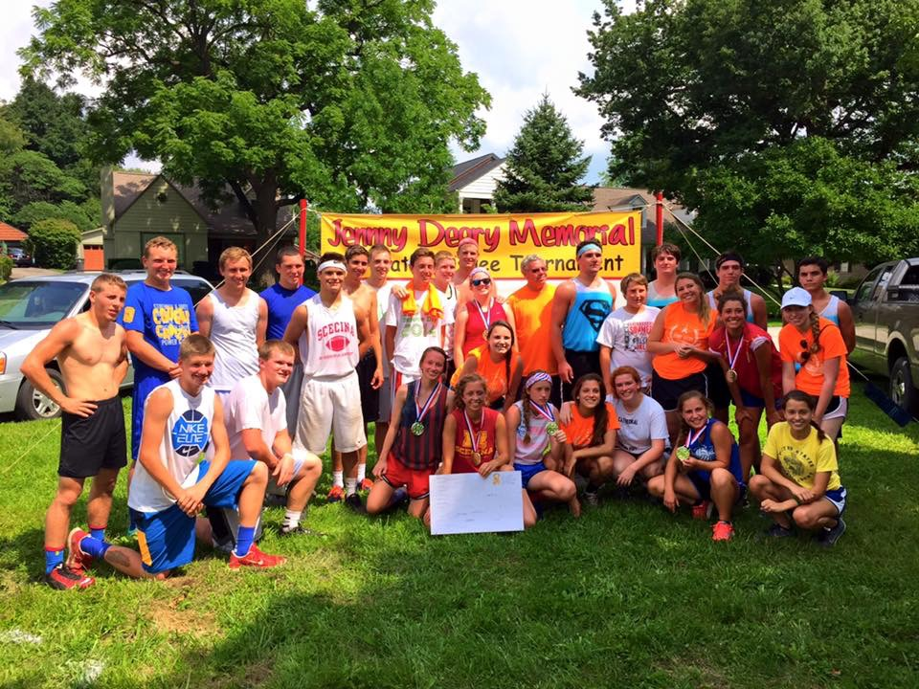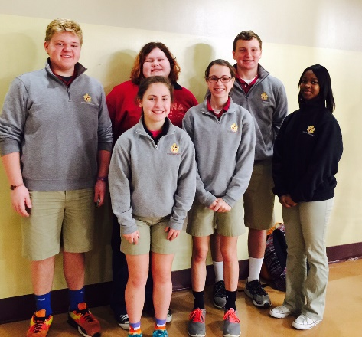

Key Club members get out and do service in the community and our school. We learn about leadership. And we have fun with friends working on causes we care about. Weekly meetings are Tuesdays at 7 a.m. in the cafeteria. Email questions to [alyssachaserebein@gmail.com](mailto:alyssachaserebein@gmail.com).

**CALLOUT MEETING FOR STUDENTS IS TUESDAY, 9/13, 7 a.m., SMHS cafeteria**

**For parents…five reasons your teen will love Key Club**

**1. It cultivates leaders.**Key Club is led by students, not adults. Advisors are there to support the students in their work. So students in Key Club get “on-the-spot” opportunities to come up with ideas and put them into action. Along the way, they learn about project management, fundraising and collaboration. Each Key Club elects officers each year. Elected officers can include a president or co-presidents, one or more vice presidents, secretary, treasurer, editor and one director from each class.

**2.  It’s all about service.** Key Club gives teens a chance to serve in their communities—from the Scecina community to the local East Indy community to our country and the community of the world. The Scecina Key Club recently raised nearly $1,000 for the Leukemia Society. Through service, students in Key Club expand their personal horizons beyond their immediate peer group—and they never get behind on their service hours.

**3. It’s international.** Key Club is student-led at many levels—at Scecina, in the Indianapolis area, in the [Indiana district](http://www.inkeyonline.org/), and internationally. The Key Club organization gives students opportunities to go beyond their local communities and interact with other Key Club students at events, service projects and [conventions](http://www.keyclub.org/events/convention.aspx).

**4. It inspires great college essays.**There’s no secret formula to help students stand out on college and scholarship applications. But it does help to be well-rounded. In a [Forbes article](http://www.forbes.com/2006/09/13/college-admissions-myths-lead-careers-cx_de_college06_0914myths.html) on college admissions, Yale's dean of undergraduate admissions Jeffrey Brenzel cites "academic excellence, evidence of leadership and integrity, and evidence of high personal impact on others" as important qualities. Key Club offers students an opportunity to develop all of those—within a club environment that builds students’ leadership skills over time. Several of our recent SMHS graduates won scholarships based on essays inspired by their work in Key Club.

**5. It’s inclusive.**Key Club gives Catholic-school students an outlet to apply their spiritual values in the broader world as they interact with students from different high schools with different backgrounds than their own.Key Club’s spirit of inclusiveness is a value we share in our own Catholic faith.

Also, Scecina Key Club members have the opportunity to apply for the Mason Bell scholarship, a $1,200 award offered by our sponsoring Kiwanis Club.