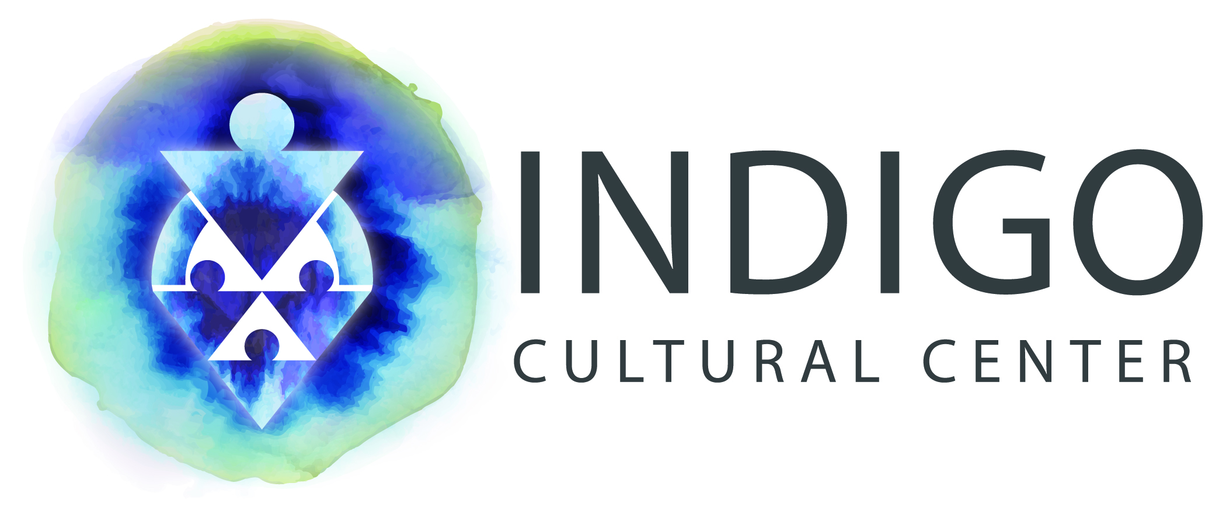


Eva Marie Shivers, J.D., Ph.D. is the executive director of Indigo Cultural Center, a non-profit action research firm located in Phoenix, AZ. Dr. Shivers’ work at Indigo Cultural Center focuses on the developmental niche of early childhood development and education to explore the evolution of frameworks for understanding families’ culturally adaptive responses to poverty, systemic racism, and historical marginalization.

Prior to relocating to Arizona, Dr. Shivers was a faculty member in the School of Education at the University of Pittsburgh. She received her Ph.D. from UCLA’s Department of Education, Psychological Studies in Education. Dr. Shivers also holds a law degree from Howard University School of Law, and a BA in English Literature from Arizona State University.

Dr. Shivers has numerous peer-reviewed publications, and presents her research on equity, child care, mental health consultation, and other professional development initiatives throughout the country.

She currently provides early childhood racial equity training and consultation to early childhood mental health community agencies and state departments around the country.

For the past fifteen years, Dr. Shivers has provided child care research policy consultation to federal, state and local government agencies and administrators. She also provided early childhood racial equity policy consultation to the Obama administration.

Contact Information:
Indigo Cultural Center, Inc.
2942 N. 24th Street
Suite 114-321
Phoenix, AZ 85016
(602) 424-5723
eshivers@indigoculturalcenter.org
http://www.indigoculturalcenter.org

