Congregation Beth Israel Sivan-Tammuz 5778

June 2018

SHOFAR

Monthly Newsletter of the Monterey Peninsula Jewish Community

www.carmelbethisrael.org



**Sunday, July 29th is the 31st Jewish Food Festival**

We are less than 2 months away from this year’s Jewish Food Festival and preparations are well underway. I wonder if the founders knew what they were starting back in 1988. From what I hear the first Jewish Food Fair was 3 tables in the upper parking lot. Who would have thought it would evolve to an event that our patrons and members wait for all year.

Not only is the Food Festival great food. It’s also outreach to the greater Monterey Bay Area. It’s a time for CBI to put a face on the Jewish Experience. We have over 3000 people in our home and it shows off in an extraordinary light. From Latkes to Sanctuary tours, from Jewish Music to Pastrami Sandwiches, from Story Telling to Blintzes, we have something for everyone.

Thanks to Laura Arnow and Donna Shore, The JFF has been awarded the designation as a Zero Waste Event from Waste Management. We use compostable service-ware and recyclable items. We had 99.3% compostable and recyclable discards and very little trash.

Not only is this outreach, but in a way it’s “inreach”. Almost every member of our congregational community is involved in one way or another. This event has so many opportunities to get involved and work side by side, together.

# Summer Fun at the Theater Starts Next Month

# 

# Once again CBI members will enjoy wonderful social gatherings attending our local theater. We have limited reserved tickets (at discounted rates) for each show. Please purchase your tickets through the CBI office in advance to assure yourself seats. July 7 is “The Curious Incident of the Dog in the Night Time.” The August 11 is “Million Dollar Quartet.” On the afternoon of August 26 we will enjoy Disney’s Little Mermaid. Look for details about the October 6th show in future bulletins. Please call the office for locations, pricing and reservations.as the theaters require us to make our group reservations well in advance.

**Distinguished Women:**

**Speakers Series**

CBI is proud to announce the following three speakers and their topics that will occur this summer.

We will provide more information in emails and announcements in upcoming weeks. All events are free with light refreshments..

**June 28th 7:00 PM** Rabbi Leah Novick “The 1970’s, the Women's Movement and Bella Abzug"

**July 25th 7:00 PM** Marcia Rosen "A Jewish Gangster’s Daughter"

**August 9th 7:00 PM** Darcie Fohrman "Daniel's Story - Establishing Holocaust Memorial Exhibits “

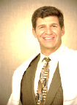From the Rabbi’s Desk…

As I write this article, I am still adjusting my internal time clock and trying to catch up to all my emails, snail mails, and phone calls. Last week at this time I was leading a group of 33 of us around the old city of Jerusalem with our Israeli guide. The memories of the trip include dozens of special moments. Let me share just a few highlights of our trip with you.

Our first few days were spent in Tel Aviv. Shortly after visiting the Hall of Independence where David Ben Gurien announced the creation of the State of Israel we went to the Ayalon Institute. Other than a small welcoming center it looks like a small, old Kibbutz. But hidden under the old bakery building and the laundry room is a secret underground factory. Our group learned about the dedication of a daring group of young men and women, many who were new immigrants to the future state, who worked in this hidden ammunitions factory near a British headquarters. Without their work, which included risking their lives, Israel could not have won the war of Independence. While we spent less than an hour in the cramped underground facility, they spent day after day, month after month with no sunlight under challenging, stressful conditions.

From Tel Aviv we headed north to the Golan Heights region. I loved our experience in Northern Israel visiting the Hula Valley and the little lake. Millions of birds migrating from Africa to Eurasia often rest at the tiny lake in this region. Our group divided into bikes and golf carts and spent a fabulous hour viewing birds and other water life as we enjoyed a gorgeous sunny morning.

I also enjoy returning to the Dead Sea. It is hard to explain the sensation, feeling like you are in an inner tube with both your arms and legs in the air while floating on the surface. At one point about 20 members of our group formed a floating circle and began singing Hava Nagila while “dancing” the hora. Our voices filled with both song and laughter made this a moment I will never forget.

While one can find spirituality in any location, for me just being in Israel raises my sense of closeness to God. Entering Jerusalem increases that sense of holiness. Finally, entering the Old City and standing at the Kotel, the Western Wall, the foundation of the biblical Temple always brings me to a new level of awareness of God’s presence in my life. Something shifts inside my consciousness as I touch the stones and rest my head against them.

On Friday, just a couple hours before Shabbat began, our group arrived to Jerusalem. Our bus took us straight to the Old City gate closest to the Western Wall. After going through security, we stood in the plaza before the Kotel. The plaza was filled with Yeshiva students and tourists and others who had come to welcome the Sabbath. I shared a few words with the group and suggested they spent time at the wall before we regathered about 45 minutes later. I quickly left for my own time at the wall. I knew we would be back there in a couple of days so I wasn’t worried about preparing any notes to leave in the wall. After taking time for my own personal prayers, I returned to where we had agreed to meet. I watched as people returned. Some were joyful and talkative; others quiet, appearing deep in thought. One person from our group came back completely overwhelmed by the moment. Tears flowed as she hugged me. It took some time for her to calm herself. Shabbat dinner at the hotel later that evening had a different feel than previous meals.

Each day in Israel was filled with wondrous sites and experiences. I have already begun thinking about when I might return again. Hopefully you will join me.



From our President

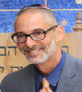*Todd Hornik, President, Board of Trustees*

**Wow! Just wow!**

I want to thank everyone who had a chance to participate in the past weekend’s Torah reading. I can’t begin to explain how really good I feel about the project, how it went and all of you who helped to make it happen. Better than I could have ever imagined. The whole event was even greater than all of the marvelous details that made it so spectacular. Thanks first and foremost to David. You have been there since the idea initially arose and your efforts at the alter were second to none. Such a truly unique experience. Of course, Rabbi Bruce, your tireless cheerleading leading up to the event and your tireless performance during the reading reminds me (and all us us) how inspiring leaders can be. Scott, Donna, Ruth, Rikki, Ellen, Cantor Alisa, Rabbi Leah, Jeff, Cantor Margaret, Cara, Rick, Mark, Dan, Yotam, Jacobo, Alex, Laura, Rosemary, Donna, Galena, Peter, Aaron, Miriam, Shifrah, Louise, Catherine, Michael, Cary, Elan, Malina, Ilana, Rena, Riddle…all of you are truly amazing!

Thank you. My wish is that you all share in the accomplishment and cherish the memory.

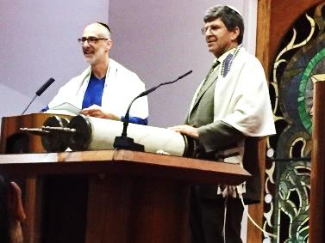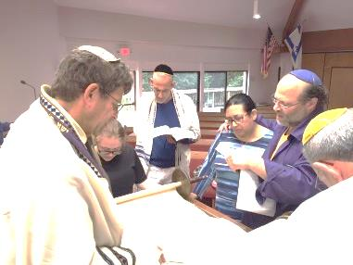

**Help Wanted** – **Jews Apply**

Looking for interested, interesting Jews. (how’s *that* for an opening line?) People who want to share their expertise, their enthusiasm and their passion for Jewish life and turn those feelings into positive actions, interesting events and good times. The Board of Trustees for Congregation Beth Israel is looking for people, old and young, with a little or a lot of time to contribute their thoughts, voices and interests into strengthening our community. Interested in art? We’ve got a spot. Interested in finances? We’ve got a spot. Interested in ritual practice? We’ve got a spot. How about building? Or Planting? We can do that too. And here’s the best part. You can do all these things, meet like-minded folk, maybe even make a few new friends and help create a lasting impact on CBI for you and your family now and for the future. (Oh, and there’s almost always something to eat). Become a part of the eternal chain, stretching back and building on those who helped establish this community at CBI before you even knew it existed. Full disclose though, the pay (in monetary terms) is terrible. Nonexistent really. But in terms of personal satisfaction, of being a part of this fabulous group of People we know as Congregation Beth Israel, the benefits are immeasurable. So, what do you say? Would you like to come in? Would you be willing to step forward and volunteer a part of who you are for the improvement of all of us? I’m looking forward to hearing from you soon.

Todd

**Best Years Favorite Event: Lunch Out!**

Join us on Thursday, June 28 at noon as we enjoy what is clearly the most popular Best Years event, lunch together at the Baja Cantina. Meet us at Baja at 7166 Carmel Valley Road or call the synagogue to car pool with the rabbi. This free lunch, paid by the CBI Senior Endowment Fund is always a delicious meal. Please bring ideas for future Best Years events. Do you have a suggestion for a movie or speaker or event? Enjoy visiting with other members and feast on delicious Mexican/American foods. Drinks are included as well! To RSVP for this program call the CBI office at 624-2015. Please let us know if you need a ride for this event.

# Lunch with the Rabbi

This month join Rabbi Greenbaum at Café Stravaganza on June 14 as he leads a discussion on “Life After Death.” Do you believe in reincarnation? Why do some people believe we might burn in hell? Does how I live today determine what happens to my soul after I die? Will I be with my pre-deceased relatives again? What does Judaism teach about what happens after I die? Come prepared to discuss, question and debate. Lunch costs only $20. Call the CBI office at 624-2015 to RSVP.



**Lord’s Prayer**

**By Gary Simon**

Our Father, who art in heaven, hallowed be thy name. Thy kingdom come, Thy will be done....

... and on and on. So how come a nice Jewish guy like me can recite the Lord’s Prayer correctly, word for word?

There’s a simple answer. I went through a public school system, and this prayer was part of the regular morning ritual. We had a Bible reading, the Lord’s Prayer, and the Pledge of Allegiance.

For the upper grades, a student was asked to select a few Bible verses and read them in front of the class. In our school, perhaps 10% of the students were Jewish. The student selected to do the reading, whether Jewish or not, often chose a psalm. I got to hear the theologically safe 23rd psalm many, many times. Old Testament passages were also safe. New Testament passages were done too, but never selected by Jewish students.

Somehow, we all knew to stay away from awkward parts of the Bible. We did not do the Song of Solomon, so we missed out on chapter 1, verse 13: “My beloved is to me a sachet of myrrh between my breasts.” No one ever chose a selection involving circumcisions, and the topic comes up many times in both Old and New Testaments.

Our Christian classmates, when selecting a New Testament section, were gracious enough to avoid anti-Jewish verses. This is from Matthew 6:5: “... do not be like the hypocrites, for they love to pray standing in the synagogues and on the street corners to be seen by others.” Yes, there are many anti-Jewish parts to the New Testament.

There must have been a desire to avoid the boring and ridiculous parts of the Bible. I do not believe that anyone ever selected a chapter from Chronicles. For instance, First Chronicles, chapter 2, verses 10 to 12: “Ram was the father of Amminadab, and Amminadab the father of Nahshon, the leader of the people of Judah. Nahshon was the father of Salmon, Salmon the father of Boaz, Boaz the father of Obed and Obed the father of Jesse.”

At the conclusion of the Bible reading was the Lord’s Prayer. Everyone sat quietly, with heads slightly bowed. We could speak the words or we could just remain respectfully silent. Over time, I learned the Lord’s Prayer just from hearing it.

We then stood for the Pledge of Allegiance, hand over heart. I am old enough to remember the insertion of “Under God” into the pledge. It was done as a counterpoint to the official atheism of the Soviet Union.

The freedom of religion concept eventually took prayer out of the schools. However, I cannot say that these morning rituals harmed me in any way. Public schools, I believe, do a great good in putting together students who are not all exactly the same. We need to be with people who are different in order to understand each other. There was much for me to learn from all those who were so unlike me: Methodists, Presbyterians, Catholics.

We were all tolerant of each other. I think of my classmates now and then. We are not really very different after all.

**Todah Rabah**

**Endowment Pledges**

Robert Feller

Lewis A. & Sandra Leader

Susan Schwartz in memory of Zad Leavy

**General Donations**

Anita Artstein-Dunsay In loving memory of Richard Dunsay

Ken & Debby Baseman

Barry & Randi Brookstein in memory of Julia Brookstein

United Way of Monterey County

Sharon & David Goldenson In memory of Zad Leavy

Joyce Olcese in honor of the CBI Writing Group

Lawrence & Ruth Rosen in memory of Simon Israel

Diana Rosenthal in memory of Robert Rosenthal & Willy Rosenthal

Lester & Wendy Tockerman in honor of Jonathan Rothfield, in memory of Zad Leavy, Oneg donations

Martin & Karen Wiskoff in honor of Estella Leavy on the occasion of her Bat Mitzvah

**Carmel Jewish Film Festival**

Leonard Laub & Yvonne Ascher

Bill Pardue & Barbara Mitchell

**Jewish Food Festival**

Daniel & Beverly Nussbaum

Bill Pardue & Barbara Mitchell

**Wall of Remembrance**

Lewis A. & Sandra Leader in Loving Memory of Rita Leader

**Social Action Donation**

Susan Schwartz in honor of Louise and Riddle's Anniversary

**Eitan Biblarz Campership Fund**

Susan Schwartz in honor of Samara Leader and in memory of her grandmother, Rita Leader

**Cantorial Fund**

Victor & Sylvia Krimsley, Lewis A. & Sandra Leader , Laela Leavy and Matthew Schuss & Charlene Webber-Schuss in honor of Alisa Fineman

Both Abra and CBI thank all those who contributed in honor of Abra’s birthday.

**Rabbi's Discretionary Fund**

Victor & Sylvia Krimsley in memory of Zad Leavy

Laela Leavy with gratitude for Rabbi’s comforting presence during our time of mourning

**Gifts in Kind**

Gale Barish

**A Message from Your Caring Committee**

The Caring Committee is here to serve you.  Many of your fellow congregants have volunteered to help after surgery or illness by providing meals or transportation, or just visits and friendship.   Because of HIPPA laws which protect your privacy only the person in need or their representative can request help.  When you want the help of the Caring Committee call the Rabbi or office staff.   This is the only way we will know of your need.

Should you be mourning we can help by providing a minyan, food, or other services.  But again, you must let us know.

**CBI Writers’ Group**

The CBI Writers’ Group will meet on June 7 and June 21

All meetings are from 10:30 – Noon at CBI.



**CBI Book Club**

June 12, 1:30 PM, Congregation Beth Israel Classroom. Book: THE WEIGHT OF INK by Rachel Kadish

July 10, 1:30 PM. Home of Faye Mueller-Delia ([fayemuel@pacbell.net](mailto:fayemuel@pacbell.net))  Book: FOUR MOTHERS by Shifra Horn

**Thank You to Our Oneg Hosts**

**We are grateful to the following people who helped make our May & June Onegs a beautiful experience:**

May 4: Alex & Galena Bordesky in memory of Galena’s Father David

May 11: CBI Board in honor of Alisa’s ordination & Lester Tockerman in memory of Vicki Levitan

May 18: Friends & Family of Jacob Carlyle in honor of Jacob becoming a Bar Mitzvah

May 25: Friends & Family of Estella Leavy in honor of Estella becoming a Bat Mitzvah

June 1: Bee Epstein-Shepherd in memory of her father Paul Singer.

June 8: Friends and Family of Holden Pereles in honor of Holden becoming a Bar Mitzvah.

June 15: Friends and Family of Evan Vitiello in honor of Evan becoming a Bat Mitzvah.

June 22: Lester & Wendy Tockerman in loving memory of Lester’s mother Helen.

June 29: Matthew & Charlene Schuss in honor of their 25th Wedding Anniversary & Matthew’s Birthday

Please help keep this wonderful tradition alive by hosting an Oneg in memory of a loved one or in honor of a special person or life cycle event.

Call the CBI office to schedule this simple yet meaningful mitzvah.





**Congregation Beth Israel**

**5716 Carmel Valley Road**

**Carmel, CA 93923**

**(831) 624-2015**

**E-mail: shalomcbi@aol.com**

**Website: www.carmelbethisrael.org**

Chartered in 1954 as the Jewish Community of the Monterey Peninsula, Congregation Beth Israel today serves the spiritual, educational, and social needs of Jews on the Peninsula. We derive programming and administrative strength from our affiliation with the Union for Reform Judaism and offer traditional programming to meet the needs of most Jews on the Monterey Peninsula. The Congregation sponsors weekly worship services on Shabbat evening and Shabbat morning; observances of all holidays and festivals; and formal educational programs from toddler through adult. We operate our own school on weekend mornings and midweek afternoons, and we also maintain a Judaic library.

**Senior Staff**

Bruce Greenbaum *- Rabbi, D.D.*

Alisa Fineman *– Cantor*

Louise Riddell–Kaufman – *Director of Education,RJE, MARE*

Julie Chase- *Administrator*

Abby King*- Administrative Assistant/Facility Use Coordinator*

Ruby Cohan *- Bookkeeper*

**Board of Trustees**

**5778 (2017)**

Todd Hornik, *President*

Cara Lieb, *President Elect (1st Vice President)*

Cary Stiebel, *2nd Vice President*

Rich Ader, *VP Finance/Treasurer*

Laura Arnow, *Secretary*

Dan Nussbaum, *Adult Education*

Abra Teitler, *Buildings/Grounds*

Rena Feuerstein, *Communications/Marketing*

Malina Breaux*, Fundraising*

Bee Epstein-Shepherd, *Member Services*

Susan Schwartz, *Social Action*

Vivi Fenwick, *Youth Activities*

Open*, Youth Trustee*

Ben Kaatz*, Volunteer Coordinator*

Rich Gerber*, At Large/Israeli Action*

Ilana Entin, *At Large*

Bee Epstein-Shepherd*, Honorary Life Trustee*

Herb Stern*, Honorary Life Trustee*

Torah Connections

***Vol. 122 June 2018, 5778***

**Darkness and Light**

Are people basically good or bad? This is a question each of you have probably heard or discussed many times in your life. To answer this question, we can look to the very beginning of the Torah.

***“In a beginning God created the heavens and the earth. And the earth was astonishingly empty with darkness upon the surface of the deep, and the presence of the Divine hovered upon the surface of the waters. And God said Let there be light, and there was light. God saw that the light that it was good, and God separated between the light and between the darkness.”*** [Genesis 1:1 thru 1:4]

Notice that right after God created the heavens and the earth, the earth was ***empty and dark***. God, then, created light, and ***the light*** was the first thing identified as ***‘good’***. Another way to interpret this is that the natural state of things is ‘empty and dark’, and one must put energy in to create the ‘good’, the light.

****In the physical universe, where the laws of physics are operational, there is the law of entropy. Our understanding of this law is that things on their own will become less organized, things become more chaotic. This may relate to how we understand human nature.

The natural state of mankind may follow this same pattern, where humans are empty and dark, and slowly become more disorganized, more chaotic. To do ‘good’ we must make an affirmative decision to create ‘light’. In other words, goodness can result when we strive for it, but on our own we are part of a dark universe.

Mankind, physically being part of the physical universe, shares some attributes with this universe. Our physical nature is toward entropy. The light that God creates could be thought of as having something to do with the spiritual universe, or the moral universe. Mankind can lift itself up by harnessing this light, by putting energy in to rise up, out of the emptiness and the darkness.

God created humans with the unique ability to exist in both universes at the same time. We are not merely physical animals who exist in the physical universe, the universe which is empty and dark. Humans also are in the spiritual universe, the universe where God created the light, and God created that light where it may be able to exist in both universes.

Humans therefore may ***not*** be either intrinsically ***good or bad***, but rather we are vessels ***that have a choice***. We are unique creations in that we exist in both the physical and the spiritual universes. If we allow ourselves to be dominated by the physical universe, its natural state is ‘empty and dark’, and that will be what influences us. On the other hand, if we allow ourselves to access the spiritual universe, the light and the good, then we will be able to rise out of the darkness.

Consider that each person can harness this light and reduce the emptiness, and the darkness. Also, the nature of light is that it can spread to others, since a little light, as you all have experienced, can change the ***nature*** of darkness. Imagine our world if each of us tried to spread just a little bit of light each day.

*If you have any comments regarding ‘Torah Connections’, please e-mail a note to: mlwaxer@sbcglobal.net.*

*Torah Connections is the sole opinion and property of the author, and it specifically does not necessarily reflect the position of Judaism, CBI, and/or the Board of Trustees.*

**New Men’s Discussion Group**

A newer member to CBI would like to start a small men’s discussion group with a plan to meet monthly at member’s homes. The group will be limited to no more than 10-12 participants. Before each monthly session a nonfiction article from a recent New Yorker Magazine will be selected by the group for discussion. If interested please contact Peter Levin at: pjlmph65@gmail.com









I-HELP Outreach

CBI Sponsored. . . **I-HELP:** Interfaith Homeless Emergency Lodging Program

**I-HELP for Men**

**May** – The May 6th dinner was sponsored by the CBI Board and coordinated by exquisite chefs Malina Breaux and Abra Teitler. Under their direction, the meal was prepared by our Religious School students as part of Mitzvah Day. Malina and Abra led the students in making corned beef stuffed cabbage, garlic and rosemary new potatoes, garlic carrots, green salad and garlic bread with homemade cupcakes for dessert. The meal was absolutely delicious. The men came back for multiple helpings, each time expressing how wonderful dinner was and how touchingly special that the students made the meal. In conjunction with the mitzvah of cooking for the hungry during Mitzvah Day, K-3 students also had a mitzvah lesson in welcoming the stranger and sheltering the homeless. Students created messages on placemats and banners sharing their good wishes and appreciation for the men joining us at CBI. The men truly felt valued and part of our CBI community. It was a blessing for all who participated.

**June** – The June 3rd I-Help meal will be sponsored by the Que Syrah Havurah and coordinated by Jennifer Stone. This group has sponsored many times and it is with great appreciation that we thank them in advance for their help. Thank you.

**August – Sponsor still needed** – If your family or group is interested in sponsoring the August meal please respond to Matthew Schuss. This is an important mitzvah and we can’t meet this monthly community need without help from others in our congregation. Thank you. If you have any questions about I-HELP or interest in supporting the program, please contact Charlene or Matthew Schuss at [cnmne3@comcast.net](mailto:cnmne3@comcast.net) or call 250-7170. Thank you!

**High School Recognition Awards 2018**

Congregation Beth Israel awarded 2 high school juniors, Jeremy Isack and Gabriel Lipow, with the High School Recognition Award for Outstanding Contribution to the Jewish Community. All of these deserving students received a certificate and a $50 check, thanks to the generosity of the Greenbaum Youth Enrichment Fund. The recognition occurs at this point in the teens’ high school years so that they may list the honor on their college applications.

The criterion for this award is evidence that the CBI community maintained a place of priority in the student’s life, despite all of the pressures and demands of the secular world. This is demonstrated through involvement in the madrichim (Religious School teacher assistants) program, involvement with our previous Confirmation class or current Sababa program or in aspect of our congregational community.

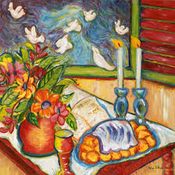**Community Shabbat Dinner -Join us on Friday, June 29**

Join with us for our monthly community Shabbat dinner, prepared by Malina Breaux and her entourage of assistants.  
Savor a sense of community and food worthy of celebration.    
Join us as we offer blessings for the bread and wine and sing traditional music to begin our gatherings.  
Children are welcome. Evening services follow, if you wish to attend.  
Call the CBI office for reservations to enjoy our lovely community Shabbat meals. Members $12.50 non-members $20



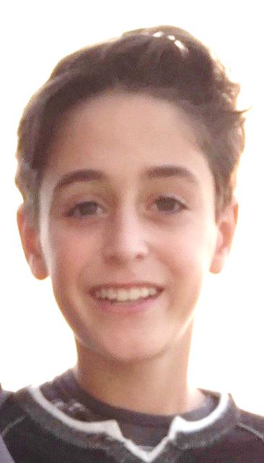

**Mazel Tov, Holden!**

Holden Andrew Pereles, son of F. Scott and Lauren Pereles will be called to the Torah to become a Bar Mitzvah on June 9, 2018.

Holden is an honors student at Carmel Middle School completing the 7th grade.  He competes in both the school and local travel soccer teams as well as on the CMS golf team.  Holden is a member of the California Junior Scholarship Federation Honor Society.   He enjoys spending time with his parents, older brothers Jake and Griffin, friends and dog, Lugano.    
 An outgoing young man with a great sense of humor, Holden has a compassion for others, especially those less fortunate than he.  He delights in being a teacher’s aide at CMS helping 6th grade students with their Language Arts assignments, specifically essay writing.  Holden is an avid reader, so for his Mitzvah project he has collected gently used books to donate to schools in North Salinas.  He feels that all kids should have access to books and be able to enjoy the pleasures of reading.    
 The highlight of his Bar Mitzvah will be during his Torah portion when he will wear the same Tallit that was worn by his ‘Opa’/grandfather for his Bar Mitzvah which took place in 1937 in Germany.  Thankfully, Opa, as well as many extended family members, will be present to witness this joyous occasion.   
 Holden’s family is so proud of his accomplishment and diligent Hebrew studies and we congratulate him on becoming a Bar Mitzvah!

**Mazel Tov, Evan!**

Evan Emuna Makeila Vitiello will be called to the Torah on June 16, 2018. This young lady has taken it upon herself to re-prioritize her life to follow the path of Judaism. With a rigorous schedule of 8th grade homework, dance and religious studies, her friends and family are proud, but not surprised, that she is a talented dancer, honor student and will soon become a Bat Mitzvah.

Evan’s Hebrew name, Emuna, embodies who she is as a person, because she “believes” in herself and has “faith” in others.  She is a great friend and source of calm and confidence. Evan has learned a lot from the accomplishments of her older sisters, Melissa and Lindsey, and appreciates the kindness and humor of her brother, Nico.

In her thirteen years, Evan has seen two of her dear friends battle cancer, sadly her friend Rhys will remain 13 forever in our hearts. For Evan’s Mitzvah project she is helping her friend and survivor, Ava Mae, raise money to help children with cancer through the [www.theavamaefoundation.com](http://www.theavamaefoundation.com/). Evan will be having bake sales, placing money jars and encouraging friends and family to help Ava in her quest to help children fighting cancer.

Evan’s parents, Mike and Leslie could not be more proud of their daughter and would like to welcome the congregation to celebrate her Bat Mitzvah.

**Mark Your Calendar!**

**Upcoming Religious School Dates**

**Note: We will not mail out ANY forms –all information, forms and registration fees MUST be initially set up online. Your child will not be registered until this process is completed.**

**Mark your calendars:**

**June 15** **School and Youth Group Registration Forms available on-line at**  <http://www.carmelbethisrael.org/learning/school>

**August 6** Early Bird Registration ends

**August 26** 1:00 p.m. - 4:30 p.m. Faculty Orientation – Required for all Teachers and Madrichim

**August 27** Late Fees for Registration begin

**September 23** First day of Religious School for all grades

**September 26** First day of Hebrew School

**September 28** Last Day to submit Religious School Scholarship Applications

The Religious School operates on a budget that is primarily funded through tuition, but over 20% of the cost of running the school is subsidized by the general fund. Because CBI’s general funds underwrites this significant amount of the cost of our Religious School, we maintain a sharp distinction between the tuition rates assessed for members vs. non-members. All non-members are charged an additional $200 fee for their child’s education.

**Note: We will not mail out ANY forms –all information, forms and registration fees MUST be initially set up online. Your child’s will not be registered until this process is completed.**

If you have a question, please contact me or the CBI office at 624-2015.



**Matzah Tots - Jump into Summer**

On **Saturday, June 16, from 10:30 - 12:00,** (note date change)children ages 2 1/2 - 5, with a parent, are invited to welcome in summer with Chinanit Kershner **in our playground** behind the building. The children will have fun playing, listening to a PJ Library story and a making a craft. Pre- registration is very helpful for the purchasing of materials. The fee is $5 with pre-registration or $10 at the door. To preregister, email [directorlouise@aol.com](mailto:directorlouise@aol.com).

**Jewish Family Ideas - June 2018**

* **Learning about the Jewish Calendar:** While the seasons are measured by the Earth’s relation to the sun, the Jewish calendar is based on the phases of the moon (and just a little on the sun). It follows a lunar calendar, correcting with a “leap year,” which periodically contains two months of Adar. Each Jewish calendar month begins with a new moon. Mid-month (the 15th) corresponds with the full moon. (from PJ Library.org)
* Everyone loves birthday celebrations, so why not celebrate twice this year? Celebrate both the Hebrew and Secular dates you and your children were born. <https://www.hebcal.com/converter/> can help you find your Hebrew birthday.
* Book Suggestions: *I Say Shehechiyanu:* Written by Joanne Rocklin, Illustrated by Monika Filipina.

Life is a series of firsts -- first steps, first words, first teeth, first day in a new year of your life! Jewish tradition has a special prayer, the Shehechiyanu that recognizes the importance of each and every first.  Ages 3 - 7

# *The Rabbi and the Twenty-nine Witches*: Written and Illustrated by [Marilyn Hirsh](https://smile.amazon.com/Marilyn-Hirsh/e/B001H6SGCA/ref=dp_byline_cont_book_1). A clever rabbi is finally able to overcome the witches that frighten the villagers once each month, when the moon is full. Ages 6 -9.

# *Here is the World:* Written by Leslea Newman, Illustrated by [Susan Gal](http://www.morgangaynin.com/artists/gal/). The cycle of the Jewish year is a world of joy, significance, and wonder. As the leaves turn gold, flutter to the ground, and are ultimately replaced by fresh green buds, we follow the Jewish year from one milestone to the next.  Ages 3 - 6.

Note: *To sign your children, ages 6 months – 8 years, up for a FREE Jewish book of the month club go to: PJLibrary.org. For children ages 9 - 11, PJ Our Way allows them to choose their own chapter book each month. Go to PJOurWay.org to sign up your child.*

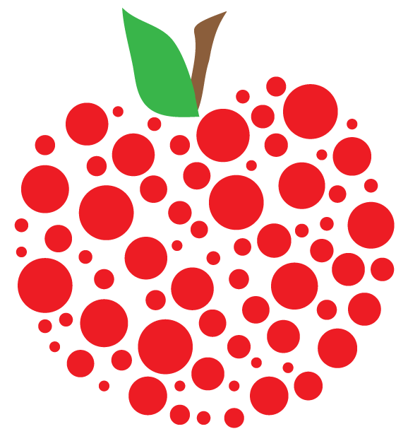

**Appreciation of our School Faculty**

There is an old, and to many of us very familiar, Talmudic story about Honi the Circle Maker.

One day, Honi the Circle Maker was walking on the road and saw a man planting a carob tree. Honi asked the man, "How long will it take for this tree to bear fruit?"

The man replied, "Seventy years."

Honi then asked the man, "And do you think you will live another seventy years and eat the fruit of this tree?"

The man answered, "Perhaps not. However, when I was born into this world, I found many carob trees planted by my father and grandfather. Just as they planted trees for me, I am planting trees for my children and grandchildren so they will be able to eat the fruit of these trees."

The wise man that Honi encountered was an ecologist and a teacher. He was willing to plant saplings, water and feed them, and tenderly care for them as long as he was able, knowing he might never know for sure if his trees actually bore fruit.

The same is true for teachers. Week after week they carefully plan each lesson, lead class activities, and tend to the individual students, as they hope that the cherished seed of Jewish connection will blossom. Many of our teachers return year after year, in some cases for more than 20 years, to tend to the next year’s crop of young sapling students. They give of their time and their hearts to pass our Jewish heritage onto the next generation. From one week to the next, and often from one year to the next, they do not know if the seeds of knowledge and love of Judaism that they have planted will take root and eventually bear fruit. They lovingly do it anyway.

There is another tale that we tell our students each year. If you plant parsley at Tu B’Shevat, it will be ready for the seder plate. This timely reward is also true for teachers. Our children mature and blossom during the course of a year. “Teaching moments” are found and critical connections take place in young minds. Carefully planned lessons really work the way they were envisioned. Curriculum is learned one week and recalled at a later date. Kindness is witnessed; the seeds of a mensch begin to sprout. These faster blooming plantings bring smiles to our teacher’s faces and encourage them to return to the classroom week after week.

I want to thank all of our faculty who plant and nourish the seeds of Judaism in our students. The faculty is composed of communities within larger communities. As a staff, we support each other and the school as a whole. Each classroom is a team of teachers and madrichim taking turns teaching and working together to balance the demands of their personal lives with the needs of their students. In addition to Judaic & Hebrew teachers, we incorporate specialists in Jewish culture into our weekly curriculum

****K/1 **Chinanit Kershner** & **Talia Elazar**

**Joely Kaatz & Evan Vitiello**

2nd/ 3rd - **Erikka Grosskopf, Jillian Heisman, Liz Heff , Sage Lang** & during the fall **Debra Givner** **Talia Awerbuck & Gabriel Schmidt**4/5 A **Elizabeth Baseman** **& Dennis Niekro  
 Jeremy Isack & Madison Lipsig**

6th **Rena Feurestein & Bari Tolliver**   
 **Ryan Fenwick & Gabriel Lipow**

Office Assistant –**Rachael** **Carroll**

Art – **Ilana Entin**  
 **Zane Stiebel**  
Israeli Dance –**Talia Awerbuck**  
 **Madison Lipsig**  
Cooking – **Larry Solow  
 Gabriel Garguilo & Gabby Rosenberg**

Shira - **Cantor Alisa Fineman**

Hebrew Through Movement **- Vivi Fenwick**Kitah Aleph - **Tani Greenbaum**  
Kitah Bet - **Jane Bednar**  
Kitah Gimmel - **Talia Elazar**  
Kitah Dalet - **Rabbi Bruce Greenbaum**  
B’nai Mitzvah - **Cantor Alisa Fineman**  
Hebrew Madrich - **Lawson Marshall**

My Munchkin & Me **- Monica Browning & Megan Felthoven**

**Gabriel Garguilo & Joely Kaatz**

Gesher - **Elizabeth Baseman, Rabbi Greenbaum, Rena Feurestein & Bari Tolliver**

Sababa - **Erikka Grosskopf**

I would also like to acknowledge the room parents whose volunteer efforts behind the scenes keep our school running. If you are here this morning please join us.

K/1 - Jillian Heisman  
2/3 - Lisa Averbuch  
4/5A - Xochital Kolinsky  
4/5 B - Wendy Rosenthal  
6 - Wendy Schmidt & Angelica Blatt  
Gesher - Deb Kosmont

Bagel pick-up - Jaime Shoemaker

**COLLEGE SCHOLARSHIP NEWS**

# The CBI College Merit Scholarship Committee is happy to announce the recipients of our 2018 Scholarship Awards: Rachael Carroll of Carmel High, and Lauren Marshall of York School. The students were honored at the CBI Senior Shabbat service May 11 and will receive recognition at their high school awards ceremonies. These outstanding students earned merit scholarships by meeting stringent criteria which is based on GPA, leadership attributes and a quality essay about the influence of his or her Jewish heritage carried throughout his or her life. This is a wonderful honor and we salute them both.

We have now awarded 89 scholarships since 1993 when we first started this mitzvah. We are grateful to those of you in the community who have contributed to our fund and hope more of you will realize the need to recognize our Jewish children at the high school level. It is important in this small community that the Jewish community be represented equally with the other faiths that give substantial scholarships to their youth. If one of your children has been honored in the past with an award, please consider a donation now in his or her honor in order to perpetuate the fund. If you would like to honor someone else’s children or grandchildren, marriage, life cycle event or special teacher, this is the fund that provides lasting impact. If you believe in the importance of highlighting the accomplishments of our

Jewish youth, this is the fund to contribute to.

Applications are available yearly in January at the CBI office, on the web site, and at the Career Centers of the local high schools. The notification of applications also appears in the Shofar annually in the February and March editions. Remember, our Jewish children are the congregants of tomorrow. Please help us maintain the ability to show our Jewish children and the larger Monterey Peninsula that there is a strong Jewish presence here. Send your contributions addressed to College Scholarship Fund, Attention Judy Masliyah, Chair, CBI.

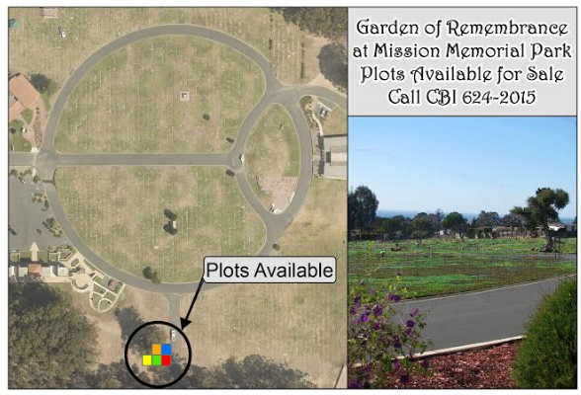

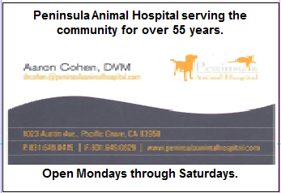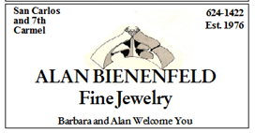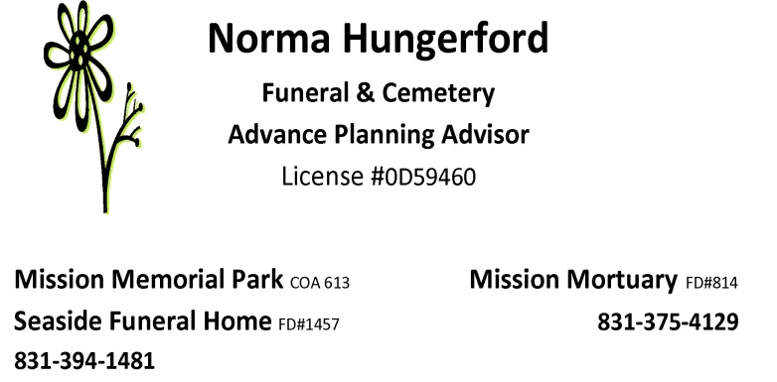



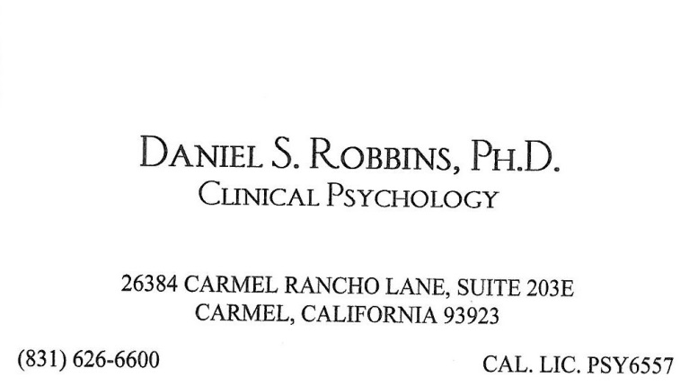



**(831) 375-1910**

**eganeles@gmail.com**

-Individual

-Business

-Income Taxes

-Compilations

-Estate & Trust Accounting

-Payroll Service

-Consulting

-Controller Services

-Quickbooks Support

-Pick-up & Delivery



*Part 2*

❖Do you have **graphic design skills** that you would like to contribute to CBI?  We're hoping to find a talented member willing to help us redesign the Shofar and create a template to simplify production.

****❖Join our team of **on-call office assistants**.  From time to time we have mailing, collating and filing projects that could benefit from a few extra hands extra hands.  If you're willing to join us on short notice for several hours of work and conversation please email or call the office and let us know.

❖If you're available to sort the July **Shofar mailing** we will be working on it on Tuesday, June 26, from 9:30 - 11:00.  Just stop by the CBI Library.

❖Is **furniture painting** your hidden talent?  The shelves and cubbies by the side door could use a facelift.  If you're interested please give the CBI office a call or email.

**Calling all Bakers, Cooks, Novice & Completely Inexperienced!**

This Sunday starts are Jewish Food Festival Baking Days.  Everyone is invited to participate.



10-Jun Sunday 9:30am Rugelah  
24-Jun Sunday 11am Challah  
8-Jul Sunday 9:30am Madelbrot   
15-Jul Sunday 9:30am Knish  
22-Jul Sunday 9:30am Kugel

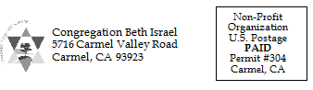

**Parshiot**

**June 2, Beha’alotecha**

**T: Numbers 8:1-12:16**

**H: Zechariah 2:14-4:7**

**June 9, Shelach**

**T: Numbers 13:1-15:41**

**H: Joshua 2:1-24**

**June 16, Korach**

**T: Numbers 16:1-18:32**

**H: 1 Samuel 11:14-12:22**

**June 23, Chukat**

**T: Numbers 19:1-22:1**

**H: Judges 11:1-33**

**June 30, Balak**

**T: Numbers 22:2-25:9**

**H: Micah 5:6-6:8**