Gathering of Watershed Groups Takes Place in Martinsburg
Submitted by: Suzy Campbell, WV Conservation Agency
Did you know that approximately 60% or more of the human body is composed of water? It is one of our most precious non-renewable resources and is vital to the life of every cell in our bodies. Protecting water is about more than preserving the environment. Protecting water is protecting you, your children, and your children’s children by ensuring that they have clean drinking water. There is a large effort in place in the Eastern Panhandle to protect the water that you drink, swim, fish, and play in. On May 23rd, many of the people involved in this effort attended the “Eastern Panhandle Watershed Group Gathering” in Martinsburg at the Blue Ridge Community and Technical College where 33 representatives from local nonprofits, state and federal agencies, and local governments convened to share resources, ideas, and strategies to achieve their common goal of protecting water and improving local water quality. This event is held annually by the Eastern Panhandle Conservation District (EPCD) and is geared towards local Watershed Groups (nonprofit organizations whose mission is partially or wholly focused on protecting and improving a specific waterway and its feeder streams). The gathering acts as a forum to provide these groups with tools and information that will assist them in their work, provide a platform for them to showcase their programs, and encourage conversation between all attendees so that new working relationships can form that will strengthen the overall effort to protect our water. Communication amongst these individuals is key to effectively and efficiently achieving their common goals.
Jim Michael, Morgan County Supervisor for EPCD kicked off the gathering by welcoming everyone and thanking them for their hard work and dedication to preserving our natural resources. He highlighted EPCD’s and USDA Natural Resource Conservation Service’s work with local farmers to address natural resource concerns and aid them in making their operations and farming techniques more effective, profitable, and environmentally sound.
Following the welcome, watershed groups and other agencies provided updates on their work over the past year. We learned that there is a new watershed group on the block called “Friends of the Bullskin” working to protect the Bullskin Run in Jefferson County. Sleepy Creek Watershed Association in Morgan County has been keeping busy with rain gardens, tree plantings, septic pumping/repairs, and stream restoration. Warm Springs Watershed Association has put up pet waste stations throughout Berkeley Springs encouraging folks to pick up after their pets in addition to installing a rain garden and planting many trees. The WV Department of Environmental Protection reported that West Virginia is on track to meet its Chesapeake Bay “pollution diet” and is nearing or exceeding many of the 2017 targets set for reducing the amount of nutrients and sediment flowing into our streams and rivers. The WV Department of Agriculture briefed the audience on their many water quality monitoring stations throughout the Panhandle and what they test for. Cacapon Institute had a successful program year for both CommuniTree and PHLOW (Potomac Headwaters Leaders of Watersheds) planting trees in public spaces and installing rain gardens at schools. We also learned that the WV Division of Forestry is still very hard at work increasing the amount of tree canopy and riparian forest buffers (forested areas adjacent to streams and rivers), despite recent budget cuts and loss of staff.
Next up was a panel discussion on a very hot topic: [Drinking] Source Water Protection. As a result of the 2014 Elk River chemical spill that left over 300,000 residents of southern WV without access to potable water, Senate Bill 373 was passed, requiring public water systems across the state to draft or update source water protection plans in order to prevent and mange pollution from general sources that could pose a threat to drinking water supplies. Panelists Barbara Humes from Harpers Ferry Water Works, Monica Whyte from the Bureau of Public Health, and Terri Burhans from WV Rivers Coalition discussed local source water protection planning efforts, efforts to engage the public, and the need for water utilities to collaborate with watershed groups who share their goal of protecting the water. Humes indicated that some of the greatest operational costs of her water utility come from dealing with chronic pollution issues, such as high turbidity and suspended sediments in the water.
The entire room was eager to learn from Alana Hartman from WV DEP about the ins and outs of several grant funding sources that they could potentially apply to for project funding such as the Chesapeake Bay Implementation Grant, Clean Water Act Section 319 Funding, WV Stream Partners Grants, and National Fish and Wildlife Foundation Grants.
Last, but certainly not least, Chad Thompson from the WV DEP showcased new Chesapeake Bay Land Cover data, which is available to view on an interactive map at https://Chesapeake.usgs.gov. Thompson demonstrated the online interactive map for the audience and displayed landcover maps for all 8 counties of the Potomac Valley and Eastern Panhandle of WV.
All of this and more was accomplished within a short three hours! The gathering is short and to the point, respecting that attendees lead busy lives and travel from all over the panhandle. The Eastern Panhandle Watershed Group Gathering is held once a year every spring in the Martinsburg area. If you are interested in receiving announcements for future gatherings, contact Suzy Campbell, Chesapeake Bay Manager for the WV Conservation Agency at scampbell@wvca.us. If you’d like to subscribe to the WV Chesapeake Bay Newsletter to stay in the loop on water quality related efforts and events in the panhandle, visit http://www.wvchesapeakebay.us/ and click on “Quarterly Newsletters.”
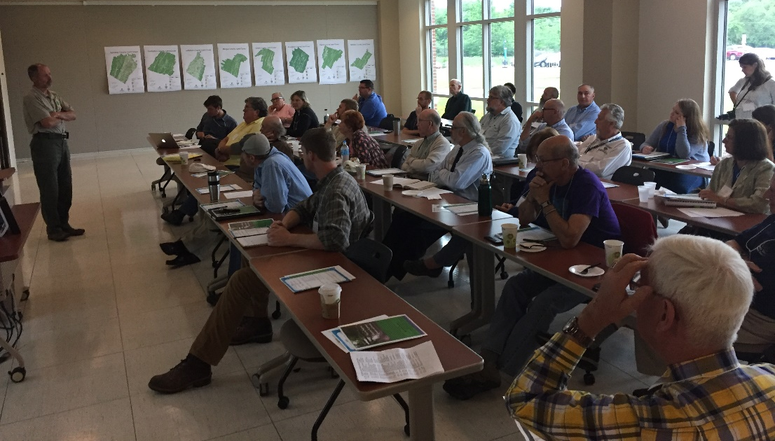
Figure 1. Herb Peddicord, WV Division of Forestry discusses efforts to increase riparian forest buffers

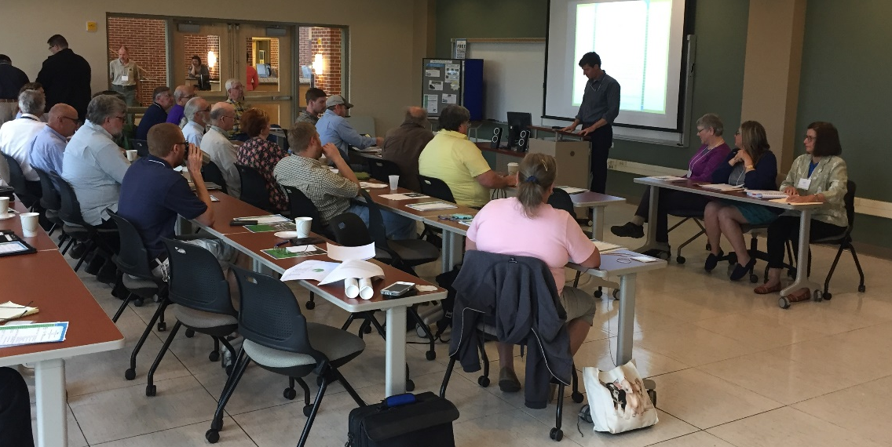
Figure 2. Matthew Pennington, Region 9 Planning and Development Council, poses questions to the Source Water Protection panelists

