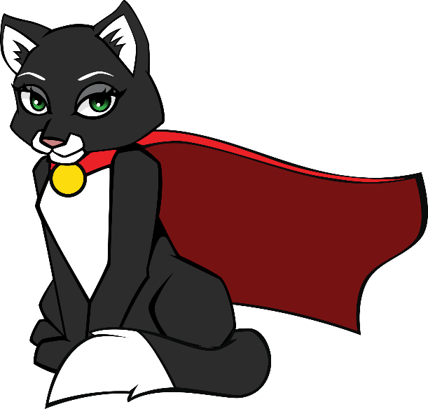

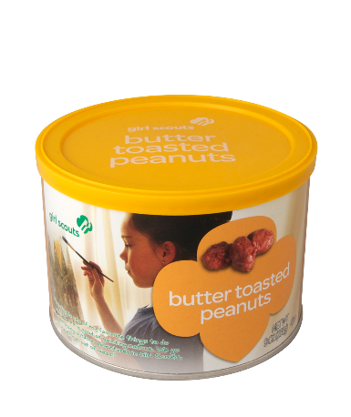
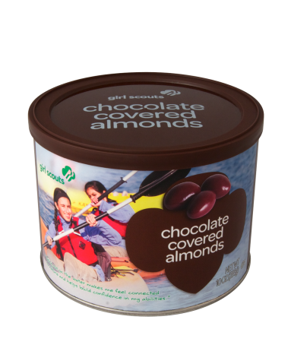

Dear Girl Scout Family,
Girl Scouts of Silver Sage will be hosting a Fall Product Program September 29 - October 15, 2017. During the sale, Girl Scouts will have the opportunity to sell nuts & candy and online sales of magazine subscription items to raise troop funds and earn awesome rewards.
The general look and feel of the Fall Product Program will be like the “Initial Order” part of the Cookie Program. In mid-September Troops will hold a Family Meeting to distribute materials and teach girls and their parents about the Fall Product Program; be sure to ask your Troop Leader when and where your specific Family Meeting will take place. Each Girl Scout must have a signed permission slip returned to the Troop Leader or Troop Product Manager to participate.
Girls will then be equipped with Order Cards for the nuts and candy (Ashdon Farms) part of the sale and have an individual online account for magazine sales and the nut and candy online store (QSPGAO). Girls will take nut and candy orders and point customers to order items online September 29 – October 15. Go to girlscouts.qspgao.com/silversage to register for online sales.
Here are important dates to remember:
Dates | Fall Product Program
Mid-September, 2017 | Fall Product Program Family Meeting
Sept 29 – Oct 15, 2017 | Fall Product Program Sales
October 16, 2017* | Turn in Order Cards to Troop Leaders
November 8, 2017* | Nut and Candy Delivery
November 13, 2017* | All money due to Troop Leaders
*Dates are subject to change from troop to troop. Please contact your Troop Product Manager for any questions regarding the Fall Product Program
Thank you,
Girl Scouts of Silver Sage Council
Why participate in the
Fall Product Program?

The Girl Scout Fall Product Program is part of the Girl Scout Leadership Experience, which is girl driven. Never do for a Girl Scout what she can do for herself! The Fall Product Program helps to reinforce and grow the financial literacy skills they learned during the Cookie Program; skills that will help them grow into leaders in their own lives, leaders in business, and leaders in the world.

Goal Setting: Your Girl Scout sets goals and creates a plan to reach them!

Decision Making: Your Girl Scout helps decide and carry out every part of her own business, furthering her critical thinking and problem solving skills that will help her in many aspects of her life.

Money Management: Your Girl Scout takes orders, handles money, and gains valuable and practical life skills around financial literacy.

People Skills: Your Girl Scout learns how to talk to, listen to, and work with all kinds of people while participating in the Fall Product Program.

Business Ethics: Your Girl Scout is honest and responsible at every step of the sale. Her business ethics reinforce the positive values she is developing as a Girl Scout.

In addition to learning all these valuable skills the Fall Product Program will also allow your Girl Scout’s Troop to earn money – $1 for nut and candy items and $3 for magazine items – for activities, materials, and supplies that support her Girl Scout Leadership Experience…
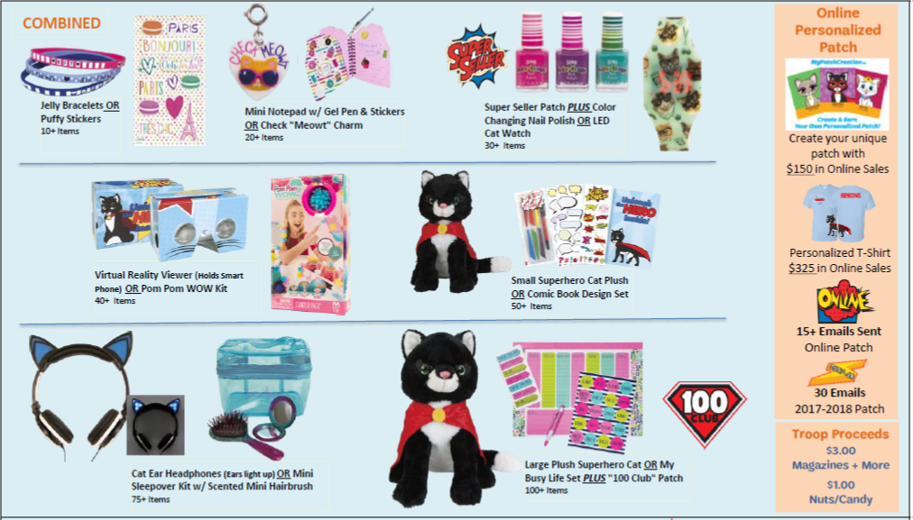
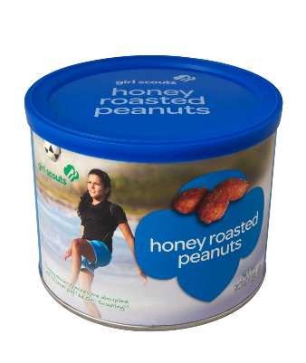
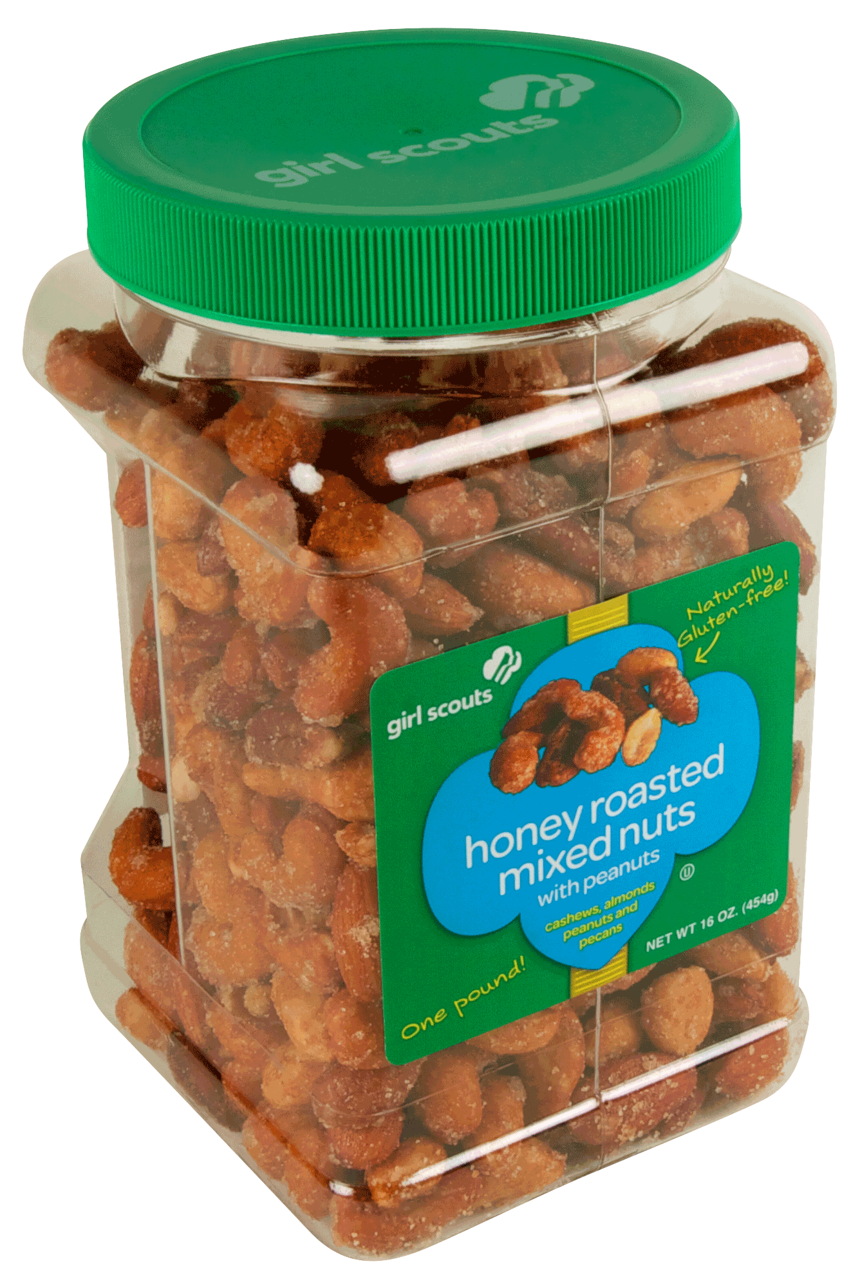
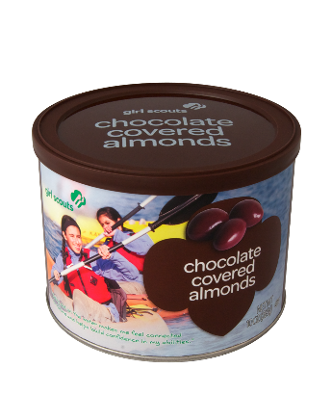
And your Girl Scout could earn some of these great rewards!

