2017 WA State Assistive Technology Conference
February 16, 2017, 9:00 a.m. to 5:00 p.m.
Event webpage: http://events.constantcontact.com/register/event?llr=6ajwdndab&oeidk=a07edlrartu7b2ed264

AGENDA
(Each Breakout session is 1.25 hours and represents 1.0 clock hours of training)
Event Agenda, Feb 16, 2017
730-830 am Set up, Expo, etc.
830-900 Registration and Expo Open
915-1015 Keynote
1015-1030 BREAK
1030-1145 Breakouts #1
1145-115 pm LUNCH on own
115-230 Breakouts #2
230-245 BREAK
245-400 Breakouts #3
400-415 BREAK
415-500 Closing Forum: WA State Call to Action

Keynote  915-1015 | From the Person to the Possible  Kristen Rytter, Ph.D., Sage-Within-Us (Will join remotely)  Katherine Carol, Tango Results  Tom Keating, Ph. D., Cognitopia
Breakouts | #1: 1030-1145 | #2: 100-215 | #3: 230-345
Room 302A | Technology for Independence  Curt Johnson, WATAP | Funding Sources Available for AT  Jack Brummel, NW Access Fund and  Susan Harrell, WISE | From Duct Tape to Computer Access  Curt Johnson, WATAP
Room 302B | Smooth Talkers: An Innovative Social Group for Young AAC Users  Rachel Nemhauser,  Arc of King County | Families at the Forefront of Technology, Katherine Carol, Tango Results | ARC of WA Smart Home and Technology Project  Marsha Threlkeld, PIVOTAL Consulting
Room 303A | AT Needs Assessed Through Person Centered Planning  Marsha Threlkeld, PIVOTAL Consulting | Cognitopia Connect  Tom Keating | Augmentative and Alternative communication: Free Apps and the Cheap Cellphones  Shaun Wood
Room 303B | Assistive Tech: Work, Home and Play!  Brian Johnson, Jason Curtright, & David Van Hook, Living Opportunities | The 21st Century Employment Specialist: Utilizing Assistive Technology Kathy Moeller, CBIS  Bill Youngman, DVR  Ryan Farrow, WISE | Seven Keys to Technology Partnerships Workshop Katherine Carol
Room 300E | OPEN | APPLE? | Microsoft?
Closing Forum  415-500 | WA State Call to Action  What are the unspoken roadblocks and opportunities? What is our call to action (Vision and to whom)?

Keynote:
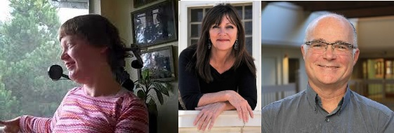
Kristen Rytter, Ph.D., Sage-Within-Us (Will join us via Hologram)
Katherine Carol, Tango Results
Tom Keating, Ph. D., Cognitopia
Our keynotes will tell their riveting personal stories about how Assistive Technology (AT) has transformed their lives and those of their family, their supports and their community. AT has powerfully shaped their work and their future and their stories will ground us, excite us and show us what IS possible!

Breakout Sessions:
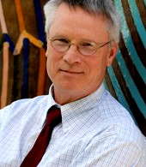
Curt Johnson
Consultant
Washington Assistive Technology Act Program (WATAP)

Technology for Independence
This session will focus on today’s rapid changes in emerging technology and its impact on all individuals. Some of the newest technology, not created specifically for people experiencing disabilities, offers the most significant possibilities. From home environment control to hands free digital assistants, our world is changing rapidly. Technology previously discussed as being an exciting possibly is now becoming practical and more importantly possible. This presentation will explore emerging technologies and demonstrate devices that provide solutions that move between home, school and work.
Learning Objectives:
- Identify three types of emerging technologies that assist with home independence.
- Identify differences between low, mid and high tech devices.
- Identify three activities that can be completed through use of a digital assistant.
From Duct Tape to Computer Access
This session will promote creativity and problem solving interests by stepping out of the box. Many individuals have been solving their independent living, work or educational problems through their own ingenuity and materials they find available at home or locally. We will expand on that and explore improvements in positioning, stabilizing or affixing assistive devices that range from "high tech" to "low tech". With funds becoming more difficult to obtain commercial devices, it becomes imperative that individuals and families become knowledgeable and share these low cost solutions. We will focus on functional outcomes through use of local resources when funds are not available for the high tech options.
Learning Objectives:
- Identify 3 locally available materials to improve stabilizing devices
- Identify 3 local resources to obtain low cost materials
- Identify 3 strategies to improve positioning of commercial devices

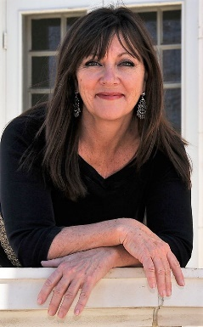
Katherine Carol
Tango Results

Families at the Forefront of Technology
Explore how current and emerging technologies assist people to live in their homes, hire, train and manage their support teams and manage their schedules with the use of universal and assistive technologies. We will discuss how to blend your technology to leverage multiple systems and make them more effective. We will also peek into the future to see what we need to do to prepare for it.
Learning Objectives:
- Through video examples, participants gain knowledge on how certain apps can be used to help individuals with brain injury live more independently, how a woman with cerebral palsy interviews, hires and trains her support team and how a personal website can set the culture of inclusion for that team.
- Participants learn how to integrate various systems such as iPad, communication apps, Siri and other smart home technology to maximize communication, reduce dependence on support staff allowing people with disabilities to explore, discover and manage their lives increasing self-determination and inclusion opportunities.
Seven Keys to Technology Partnerships Workshop
Let’s face it; we don’t know where the future of funding technology stands. However, the need for technology doesn’t change because funding might. Learn how to discover and cultivate new partnerships with innovators, businesses and communities to expand opportunities for people with disabilities and become valuable partners that nurture the future for all of us.
Learning Objectives:
- Learn how five moms and their families in Colorado connected with companies such as Apple, Google, 3D Printing innovators and venture capitalists influencing future innovations in technology.
- No money, no system support? No problem! Learn how to take your passion for 21st Century Inclusion strategies to the streets to engage new partners in insurance, banking, hotels, spas and other families to support technology education and training efforts in local communities.
- Learn the seven critical components of successful resource development!

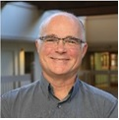
Tom Keating, Ph.D.
Cognitopia

Cognitopia Connect
This session will introduce participants to Cognitopia Connect (http://www.cognitopia.com), a new suite of universally designed web applications for life management , designed to increase independence for individuals with cognitive disabilities while improving the ability of parents, teachers, and others in caregiving, job coaching, or instructional positions to provide support. We'll focus primarily on three applications that provide support in the areas of executive functioning, digital storytelling and IEP self-direction, and video modeling for task accomplishment: Goal Guide, MyLife, and ScanDo.
Learning Objectives:
- Learn how to use three new life management applications designed for individuals with cognitive disabilities such as autismand intellectual disabilities.
- Generalize to participants' own practice from three case study examples of virtual support, team collaboration, and task prompting.

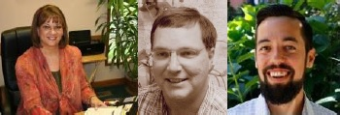
Kathy Moeller, BA, CBIS
Bill Youngman, MSW, DVR
Ryan Farrow, WISE
The 21st Century Employment Specialist: Utilizing Assistive Technology to fade supports and reduce reliance on human job coaches
Come explore the various types of easy-to-use technology tools Employment Specialists are using in the field. In this session, we will share technology interventions you can use now with your customers by using assessment tools you already have. Technology is just one more tool you can look to when supporting someone to be more independent and productive. Join us in the conversation about what the future holds for assistive technology in our field.
Learning Objectives:
- Learn about the various types of assistive tech you can put into place now.
- Learn how to assess where assistive technology supports can be put into place
- Exit the session with a list of assistive apps

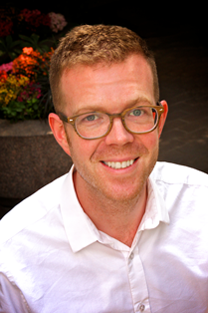
Shaun Wood, BCBA, M.ED.
WISE

Augmentative and Alternative communication: free apps and the cheapest cellphones you can buy
In this workshop, Shaun will share the basics of setting up augmentative or alternative communications (AAC) systems for people who use limited or no words to communicate. We will focus on the first steps in assessment and implementation of AAC. Additionally, we will survey the low cost options available on Android and Apple platforms. Finally, we will look at how you can tune your device to create a personalized voice. All examples will be based on free or low cost apps that can use on the cheapest of android or apple devices. Bring your device!
Learning Objectives:
- Participants will be able to identify precursor skills and conditions for AAC
- Participants will be able to identify free or low cost AAC options for popular computing platforms
- Participants will be able to adapt devices so that they can create personalized supports

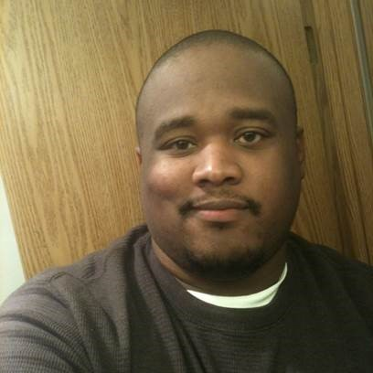
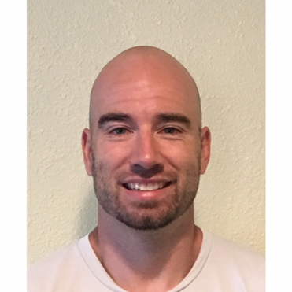
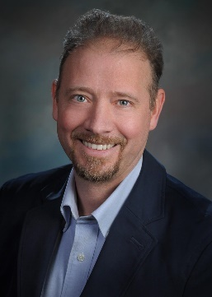
Brian Johnson, Director of Consulting, Living Opportunities
Jason Curtright, Program Manager and AT Consultant, Living Opportunities
David Van Hook, Program Manager and AT Consultant, Living Opportunities
Assistive Tech: Work, Home and Play!
Living Opportunities Consulting presents a few examples of how AT has expanded opportunities for individuals at work, home, and play in the community. Come visit our vendor table for hands on experiences.
Learning Objectives:
- The learner will be able to identify software applications and/or hardware that will increase, maintain, or improve the functional capabilities of persons with disabilities.
- The learner will be able to assist individuals experiencing disabilities in identifying and implementing software and/or hardware that will increase, maintain, or improve their functional capabilities.

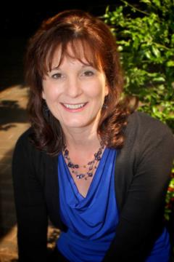

Jack Brummel, Northwest Access Fund
Susan Harrell, WISE
Funding Sources Available for AT (working title)
This session will provide information about how to find financing for assistive technology, the NW Access Fund's low interest loan and matched savings programs, and their provision of financial capability services. Susan will explore a variety of other funding sources which can be braided together to purchase and access technology. Included will be the IDA program, First Choice option, and Social Security work incentives such as PASS and IRWE.
Learning Objectives:
- Learn sources of AT financing
- Learn about services and programs offered by the Northwest Access Fund
- Learn about ogther sources for funding from IDA, First Choice, and SSA Work Incentives

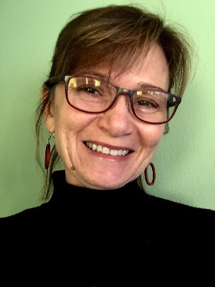
Marsha Threlkeld
PIVOTAL Consulting and Training

ARC of WA Smart Home and Technology Project
Hear how individuals in a Residential Program in the Olympia area are equipping themselves and their home to increase independence and expand access to the world. An earlier project equipped people with handheld devices, the internet, and communication strategies to support them as they live in Adult Family Homes, Residential Programs and their family home.
Learning Objectives:
- Participants will learn smart home technology to assist individuals to be more independent in their homes.
- Participants will learn how to support residential staff to promote use of equipment.
AT Needs Assessed Through Person Centered Planning
Learn how Person Centered Practices and Planning can formulate how people are assisted and what equipment they might want. We also look at how they learn about their equipment and who can assist them on an ongoing basis.
Learning Objectives:
- Participants will learn considerations in Person Centered Practices in assessing assistive technology wants and needs.
- Participants will learn how to use Person Centered Planning to plan equipment needs, supports, and implementation.

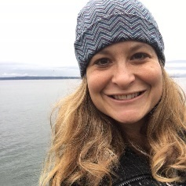
Rachel Nemhauser
Arc of King County

Smooth Talkers: An innovative social group for young AAC users
Modern technology has created so many new opportunities for people with disabilities to communicate with the world around them. However, many children and their families who use AAC often struggle to integrate their device into day to day life, and rarely find opportunities to interact with other children and families who also use AAC. Smooth Talkers is an informal and fun monthly meet-up group in King County for AAC users to socialize, play, chat and connect with other AAC users and their families. It is also an inexpensive, easy to plan program that could easily be replicated in other communities. Join Rachel Nemhauser, P2P Coordinator from the Arc of King County and creator of Smooth Talkers, to learn more about this innovative program, along with how to start a similar program in your area.
Learning Objectives:
- Participants will gain a better understanding of the challenges individuals and families face when learning to incorporative an AAC device into their lives.
- Participants will gain knowledge of strategies and supports available to individuals and families to assist them in incorporating AAC devices into their lives.
- Participants will be introduced to Smooth Talkers, a new program designed to address the challenges faced by young AAC users, and will learn what it takes to launch their own program in their local communities.

Presenter Biographies and Contact Information
(in alphabetical order)

Jack Brummel, Northwest Access Fund: Jack spent 26 years with the Washington State Senate, primarily as lead staff for committees addressing economic development, financial institutions, commerce, labor, and workforce development issues. While with the Senate Jack developed legislation relating to employment of people with disabilities, creating individual development accounts, and supporting micro-enterprise development. Prior to work with the Senate, Jack was the Administrator for the Northwest Intertribal Court System and the National Director of the Law Students Civil Rights Research Council. Jack serves as the Chair of the Board for Evergreen Business Capital, a non-profit development company certified by the US Small Business Administration. Jack’s education includes a BA in Political Science from Washington State University, a JD from the University of Washington, and a Masters in Public Policy from the University of California, Berkeley. jbrummel@nwaccessfund.org
Katherine Carol, Tango Results: Thought leader, innovator, provocateur are just a few words which capture Katherine Carol’s passionate persistence to improving the lives of people with disabilities. Katherine and her daughter, Mikelle have been advocating technology as a necessity for people with disabilities to experience full and prosperous inclusion in the 21st Century community. Katherine and Mikelle have been informing and mentoring families on successful transition practices on their www.TheShiningBeautifulSeries.com . They are founding members of Families at the Forefront of Technology, an organization started and run by families dedicated to working with technology innovators such as Apple and Google to shape 21st Century Rehabilitation strategies and solutions. Contact Info: tangoresults@gmail.com/cell:720-771-6535/www.TheShiningBeautifulSeries.com, www.FamiliesForefront.org, www.KatherineCarol.com
Jason Curtright, Living Opportunities: Jason has worked in the Developmental/ Intellectual Disabilities field for nearly 7 years. Jason came to Living Opportunities while schooling for Criminal Justice. After spending 1-year as a DSP for a Supportive Living Program he realized he found his calling. Soon after he was promoted as the Program Manager of a Residential Program. During his time at his current residential program he and his staff have implemented assistive tech with phenomenal results! Jason’s passion for supporting others in their personal pursuits of independence lead him to serving on the Living Opps Assistive Tech [in house] Committee and outside Consultancy. Jason firmly believes that every individual can benefit greatly from the use of assistive tech and finds great satisfaction in helping others find what tech works for them.
Ryan Farrow, WISE: Currently serving as Program Manager for the Washington Initiative for Supported Employment (WISE), Ryan’s career has included consulting, job coaching and job development services, as well as providing technical assistance to consumers and employment specialists with respect to worksite accommodations and building natural supports. He has presented at a number of assistive technology conferences and trainings, offering his experience on topics such as video resume creation, assistive mobile apps and iOS native accessibility features. He has facilitated Apple Accessibility Workshops at Apple stores both in Oregon and Washington, and has served as a teacher’s assistant for the Highline College Employment Specialist Certification program.
Susan Harrell, WISE: Susan has worked with and on behalf of people with disabilities through direct service, service agency management, and governmental and agency consulting since 1985, with a specific focus on employment as an essential component to assure community integration, financial stability, and quality of life. Susan specializes in the following consultation and training topics: Job Development; Job Coaching; Social Security and Medical Benefits; Work Incentives; Individual Resource Development; Person-Centered Planning; and Policies and Regulations Related to the Self-Sufficiency of Individuals with Disabilities. Susan lives in Olympia, WA, where she enjoys spending time with her family, playing golf, gardening, and working on home improvement projects.
Brian Johnson, Living Opportunities: As Director of Consulting with Living Opportunities, Brian leads the teams that specialize in Behavior Consulting, Assistive Technology, and Employment Consulting. With 25 years of experience managing teams working on diverse projects, he became inspired to help find ways for people to use technology to access more of their own potential. Brian has a Bachelor’s in Sociology and a Master’s Degree in Teaching and Learning with Technology.
Curt Johnson, WATAP: Curt provides training and demonstration of assistive technology. He recently retired as a Rehabilitation Counselor II at the University of Washington Medical Center where he worked since 1996. Mr. Johnson received a BS in Vocational Rehabilitation from the University of Wisconsin-Stout (1972) and a MS in Vocational Rehabilitation from the University of Arizona (1976). His primary area of expertise focuses on assessing disability barriers, identifying solutions and when appropriate designing/fabricating functional means to resolve those barriers. In resolving independent living/vocational barriers he has focused on use of low tech solutions and community resources combined with direct input from patients and their families.
Tom Keating, Ph. D., Cognitopia: Tom is co-founder and CEO of Cognitopia, home of the Cognitopia Connect platform for life management applications for people who see the world a little differently. Tom also holds a position as Adjunct Research Faculty in the Computer and Information Sciences Department of the University of Oregon. Tom has been focused for the past 20 years on research and development of self-management and community living applications for individuals with cognitive disabilities including autism, intellectual disabilities, traumatic brain injury, and cognitive decline due to aging. He developed the Picture Planner™ visual calendaring system and the ScanDo video modeling application and has been principal investigator on over 20 federally-funded technology development projects with over 10 million dollars in funding. His perspective in all of his work has been strongly influenced by his experience of over 30 years as a caregiver for a brother who experienced autism.
Kathy Moeller, BA, CBIS: Kathy is a Certified Brain Injury Specialist who has been inventing, teaching and supporting low-tech and high-tech assistive technologies for cognition since 1992. Since that time, Kathy has been a service provider and vendor to five state Vocational Rehabilitation Agencies and three Veterans Affairs Medical Facilities. She has held positions as a Compensatory Skills Trainer, Job Coach and Job Developer. Kathy has presented at numerous regional, state and national Brain Injury Association and disability conferences, including the 2012 National Autism Works Conference and RESNA’s annual conference in 2015 on the topic of “Outsmarting Brain Injury with Assistive Technology – from Soup to Nuts.” Her company, Cognitive Harmonics, Inc. distributes the assistive technology known as My Bionic Brain® and My Job Coach™. She currently serves as Vice-Chair for RESNA’s Cognition and Sensory Loss Special Interest Group.
Rachel Nemhauser, Arc of King County: Rachel is the parent of a 12-year-old son who is an AAC user and has a developmental disability. She is also the Parent to Parent coordinator at the Arc of King County. She has been on the Washington State Developmental Disabilities Council for the past 4 years, and is the creator of Smooth Talkers, a monthly meet-up group for AAC users and their families in King County. She is a passionate advocate and supporter of parents raising children with special needs.
Kristin Rytter, Ph.D., Sage-Within-Us: Kristin obtained a doctorate in developmental psychology to enhance children’s learning, so they can reach their full potential. Since she has lived with a physical and a speech disability for her whole life, she gives families of people with disabilities a valuable perspective, emotional support, guidance, and hope. Her new business, called Sage Within Us, offers families, educators, and therapists the following services:
- Guidance that prepares children birth-5 to learn how to read and write in school
- Recommend fun activities to promote language and literacy development
- Teach effective teaching strategies to use with children
- Help school age children become responsible learners
- Teach parental skills regarding children birth-5
- Work with adolescent parents on the above areas
- Promote acceptance of disabilities in a variety of situations
- Speak on a wide variety of topics regarding language development, working with parents, self-advocacy, and self-determination.
Marsha Threlkeld, PIVOTAL Consulting: Marsha presents on Apple handheld devices and apps, with government agencies, employment specialists, school-to-work transition programs, Voc Rehab, families, and job seekers. She has collaborated with Ron Ustach of Apple Inc on accessibility needs and solutions, and has they worked on the Arc of WA Smart Home Project. Marsha has built in-person iPad Learning Cohorts and virtual online cohorts bringing together employment professionals, transition teachers, and others to learn to use and introduce the equipment to others. She has a Certificate in Assistive Technology Applications from California State University, Northridge, and is a Subject Matter Expert with the Office of Disability Employment Policy at the U.S. Department of Labor. Marsha worked at WISE prior to creating PIVOTAL Consulting and Training. Marsha.threlkeld@icloud.com
David Van Hook, Living Opportunities: David has over nine years of experience in the field of Developmental/ Intellectual Disabilities. He spent four years working as a DSP and Assistant Mgr. for Living Opportunities’ Supported Living Program. For five years, he has been working as an I.T. Manager and is one of the leads for Living Opps’ Assistive Tech [in-house] Committee and outside Consultancy. As one of the Lead A.T. Consultants, David’s primary focus is to stay at the forefront of A.T. and to maintain the philosophy, quality and compliance aspects throughout the areas of Assistive Technology for the Organization.
Shaun Wood, BCBA, M.Ed., WISE: Shaun is a community developer who is passionate about social justice and equality of opportunity, and has worked to support people with disabilities since 2002. Since then, he continues to work in schools, people’s homes, and job sites helping to build inclusive communities. Shaun is a Board Certified Behavior Analyst (BCBA) and a certified Employment Specialist. He served in the United States Peace Corps in Bulgaria and surrounding countries and has both his M.Ed. in Applied Behavior Analysis and his B.A. in Political Science and Human Rights from the University of Washington. Shaun is particularly interested in using ABA, emerging technology, reflective processes, and mentorship to drive employment outcomes. When he isn’t working, he enjoys tending to his garden, drinking black coffee, staring at his topical fish tank, and jogging circles around his small hometown of Burien, Washington.
Bill Youngman, MSW, DVR: Bill has been an Assistive Technology Specialist for the Division of Vocational Rehabilitation, Washington State, since 2007 and has had previous experience as a Vocational Rehabilitation Counselor and Job Coach. He has special training in assistive technology from the University of Wisconsin, Stout. Bill served as the chair of RESNA’s Special Interest Group for Cognition and Sensory Loss from 2013 to 2016.

