Press Release
For Immediate Release: Sept. 20, 2017

Contact: Carrie Reed
Phone: (740) 443-7118

Wastren Advantage, Inc. Named One of America’s Safest Companies

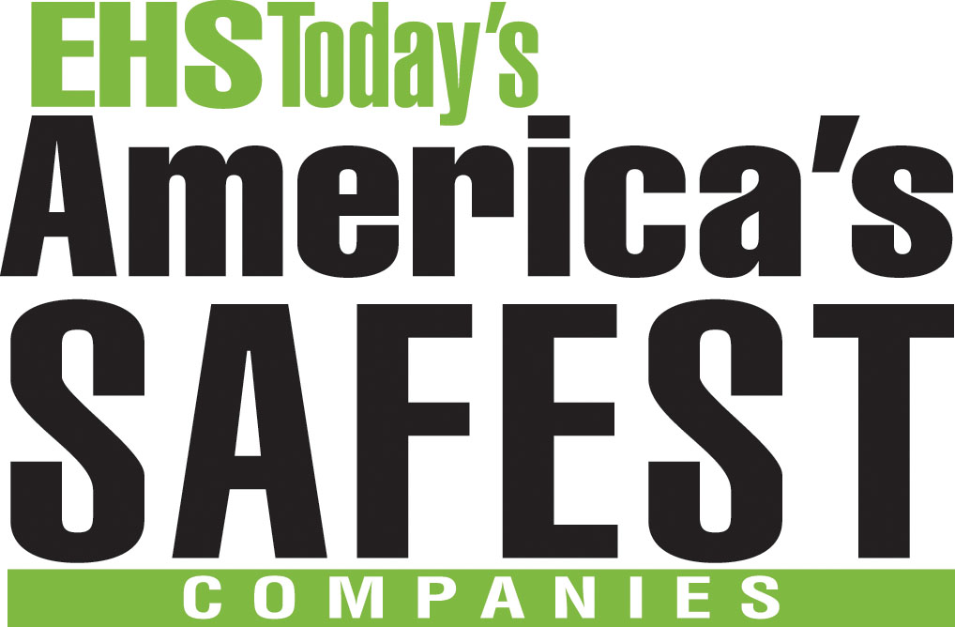
PIKETON, OH — Wastren Advantage, Inc. is one of 13 companies on the list of America’s Safest Companies (ASC), selected by EHS Today, a national environmental, health and safety magazine.

The editors of the magazine focused on the “ownership of safety” at the more than 100 companies nationwide that applied for the “America’s Safest” designation.

“We realized that for the winning applications, despite their diverse industries and size, one message resonated loud and clear: every employee at these companies – from the CEO to the newest hire – plays a role in safety, has ownership of safety,” said EHS Today Content Director Sandy Smith.

All of the 2017 America’s Safest Companies demonstrated support from management and employee involvement; provided innovative solutions to safety challenges; reported injury and illness rates significantly lower than the average for their industries; supported comprehensive training programs; believed that that prevention of incidents is the cornerstone of the safety process; integrated safety into their corporate culture and communicated the value of safety to employees and customers; and substantiated the benefits of the safety process.

WAI is a facilities operations and remediation services company headquartered in Piketon, with project sites around the country, including Hanford, Washington; Idaho Falls, Idaho; Oak Ridge, Tennessee; and Paducah, Kentucky.

One operation that WAI highlighted for the ASC application was its Hanford 222-S Laboratory, an analytical lab facility that uses state-of-the art techniques to perform waste characterization. A specific example of WAI’s management support of employee-based safety improvements took place at the 222-S Lab, where a WAI chemical technician developed a plexiglass “jig” for holding/moving small sample cups, thus reducing the radiological dose. Those jigs are now in use at the lab.

WAI specializes in the disciplined management of complex operations in high-hazard environments, and uses a project management approach to lower risk to its clients and perform work safely. Clients include the U.S. Department of Energy, U.S. Department of Defense, U.S. Department of Agriculture, U.S. Air Force, the federal Bureau of Reclamation, and numerous commercial clients.

America’s Safest Companies was founded in 2002 by EHS Today Magazine. In that time, more than 200 companies have been named to the list. For the complete list of 2017’s safest companies, visit www.ehstoday.com

For more information on WAI, visit www.wastrenadvantage.com.

