 | Forsythia
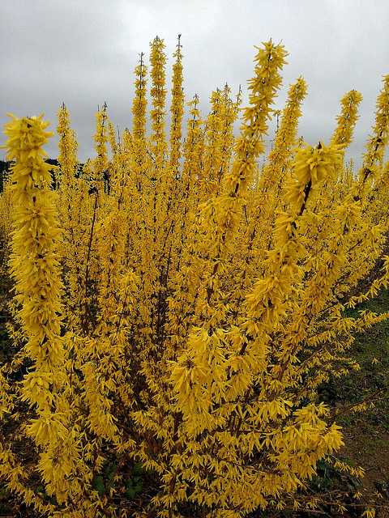 | 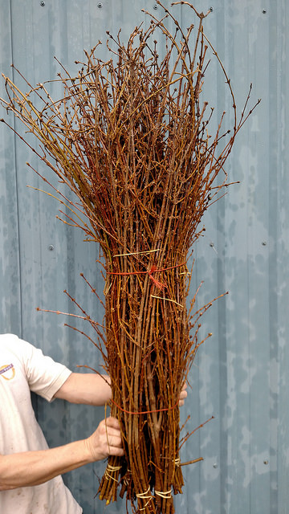 | 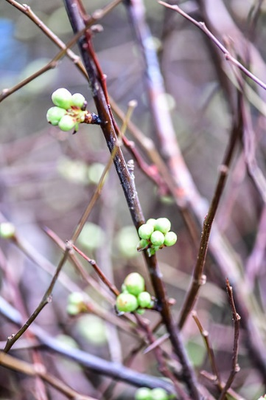  Forsythia - Jan. 1 to mid-Feb.  Tips, 24-40”, 8 stems/bch avg.  Medium 40-60”, 8 stems/bch avg.  Tall 60-72”, 3 stems/bch avg.

 | Quince
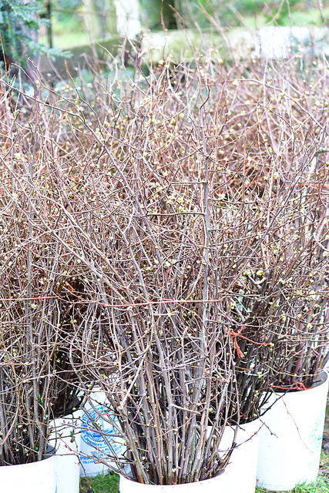 | 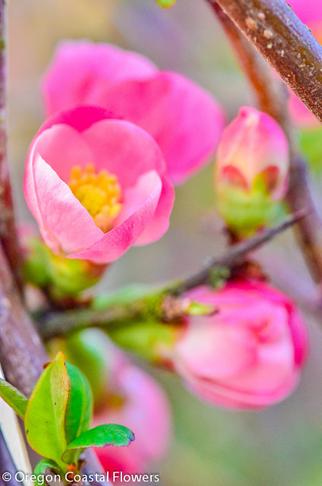 | 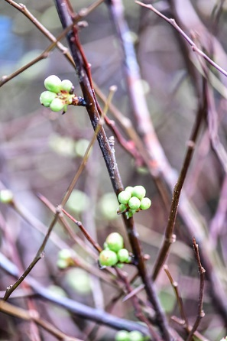  Quince - Jan. 1 to end of Feb.  Tips, 24-30”, 4-5 stems/bch avg.  Medium 30-42”, 3-4 stems/bch avg.  Tall 42-60”, 2-3 stems/bch avg.

 | Tulip Magnolia
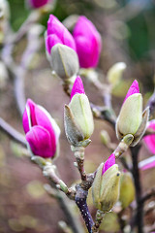 | 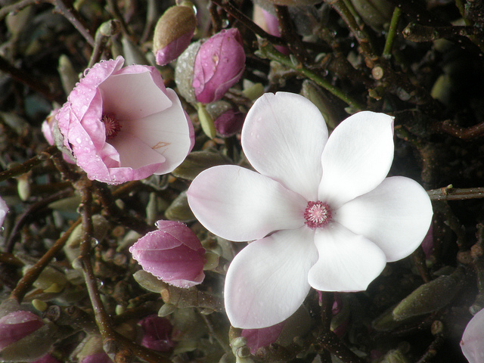 | 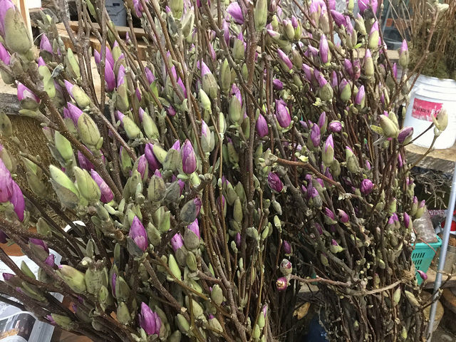  Tulip Magnolia - Jan. 1 to March/April.  Tips, 24-30”, 4-5 stems/bch avg.  Medium 30-48”, 2-4 stems/bch avg.  Tall 48-60”, 1-3 stems/bch avg.

 | Peach
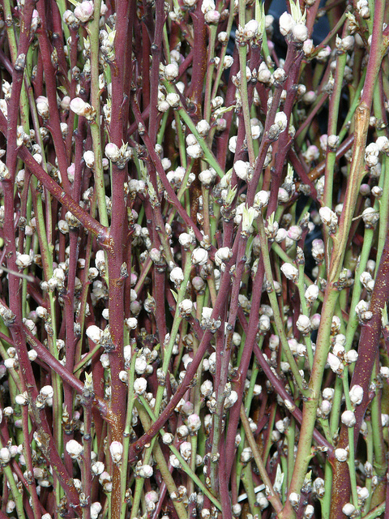 | 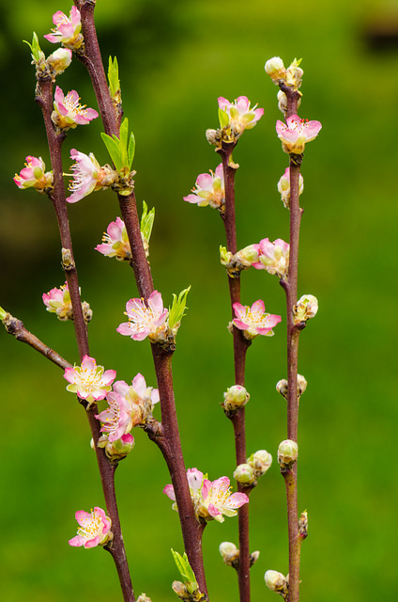 | 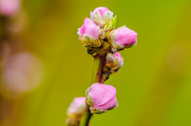  Peach - Jan. 1 to March/April.  Medium 48” avg., 4-5 stems/bch avg.  Tall 60” avg., 2-3 stems/bch avg.

 | Pussy Willow
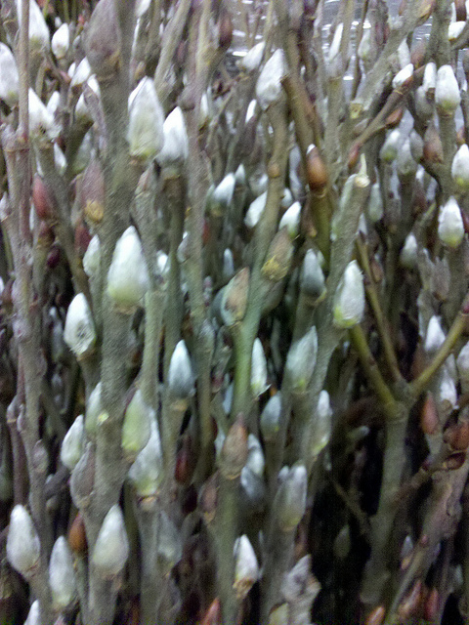 | 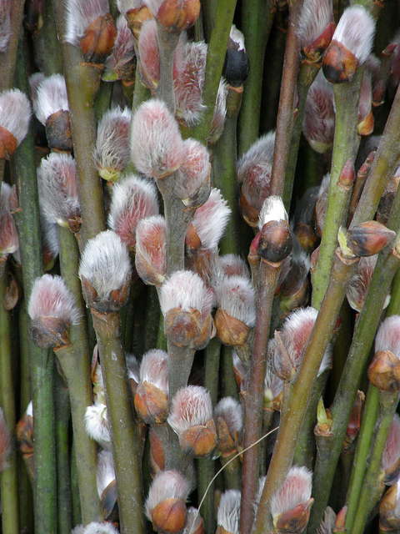 | 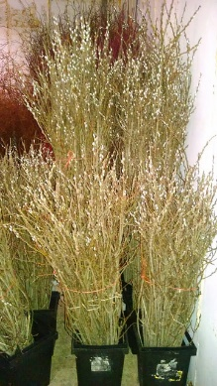  Pussy Willow - Jan. 1 to March/April.  Tips 24-30” avg. 10stems/bch  Medium 36-48” avg., 6-8 stems/bch avg.  Tall 60-72” avg., 3-6 stems/bch avg.

 | Cherry, Pink & White
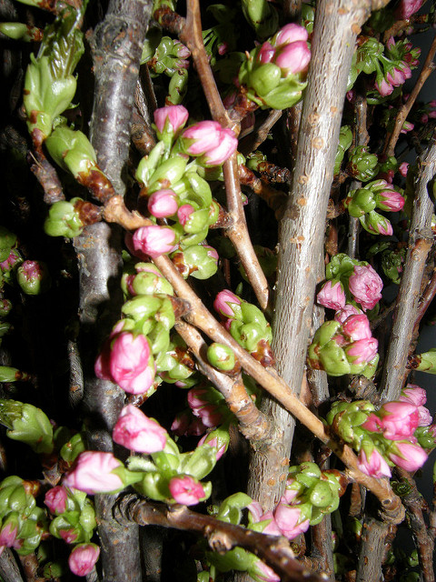 | 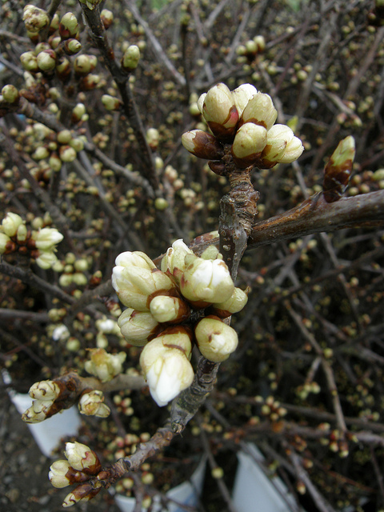 | 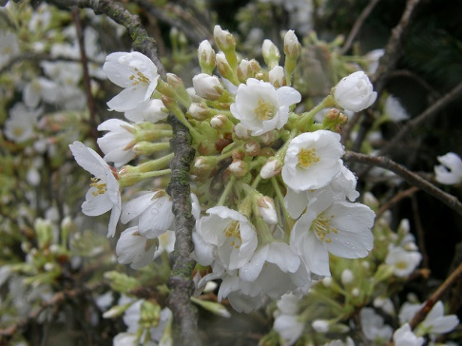  Cherry – end Jan. 1 to April/May.  Tips 24-30” avg. 8-10 stems/bch  Medium 36-48” avg., 6-7 stems/bch avg.  Tall 60”avg. , 4-6 stems/bch avg.  Xtall 72” avg., 2-3 stems/bch avg.

Prunus | Flowering Dogwood | Pieris japonica
Avail. Feb.-March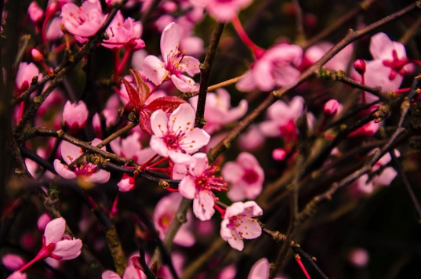 | Avail. April-May  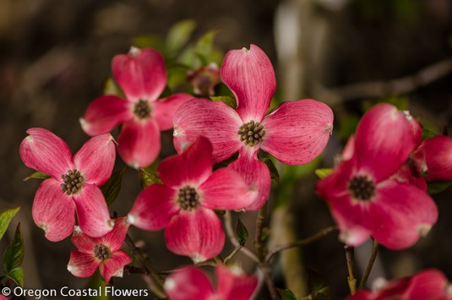 | Avail Mid-Feb-March  