CDC- INFO On-Demand – Publications
Public Ordering Page

Instructions for Ordering Publications:
Go to CDC-INFO On-Demand – Publications public ordering page: https://wwwn.cdc.gov/pubs/CDCInfoOndemand.aspx.
- From drop down menu for “Programs” select “National Center for Health Statistics”
- Use filters on homepage to search for publication(s) you want to order. You may also enter the name of publication(s) in “Search for Text.”
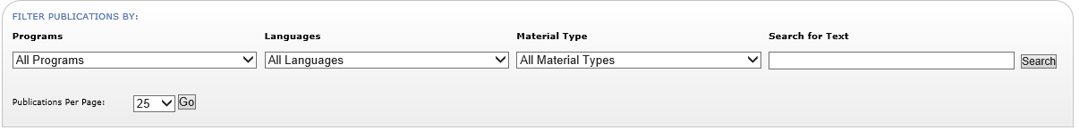

- Once you locate publication(s) you want to order, in “Order Amount” type requested number of publications.

We restricted order amount limit for the general public to fifty (50) copies.

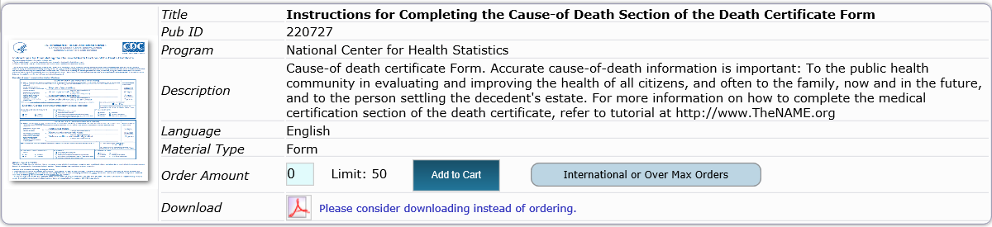
To order amounts over the “Limit” see step 5.
Out of Stock:
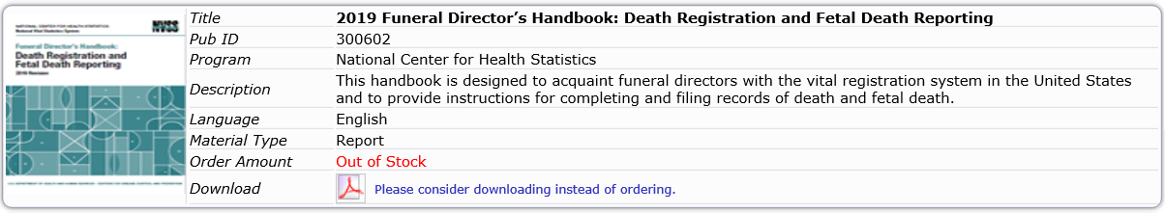
Sometimes, a publication(s) is/are “Out of Stock”. However, they can still be accessed online by clicking “Download” under “Order Amount”.

- To order amounts over the limit click on “International or Over the Max Orders.”

- A pop up window will appear. Fill in the amount and all fields for your “Over the Max Order”.

