Getting to know
the birds of Georgian Bay
by Brooks Greer, Land Protection Program Manager, and Sarah Koetsier, Communications Director, GBLT

It’s hard to imagine Georgian Bay without its birds. They are ancient and integral inhabitants of our coastal ecosystem, and an indispensable part of the human experience of the Bay. Songbirds let us know when it’s time to wake up in the morning, and the calls of loons and whip-poor-wills remind us to relax and breathe on a quiet night. Solitary herons guide our canoes, and ducks and geese entertain us with their fluffy young families. But there is also much more to the bird world than these daily interactions, and a whole host of species that make their homes and carry out their lives in Georgian Bay’s natural areas.

The widely varying landforms and diversity of vegetation communities on the Georgian Bay coast provide nesting or foraging opportunities every year for up to 300 bird species, of which 170 actually breed in the area. Each spring ushers in huge bird activity and movement as the migrants return, making it the ideal time for birdwatching. By the middle of
June, all the further-northbound birds have flown over and we are left with our actual local nesting species, carrying out the work of raising their young.

The variety of bird families and bird “guilds” supported by Georgian Bay is very broad. The open lake itself is the main summer home for our loons, gulls, and mergansers. The many coastal wetlands provide cover, feeding and nesting grounds for the herons, rails, egrets, and bitterns. The pine and mixed forests are the domain of the many songbird species, the flycatchers, the nightjars, thrushes and sparrows. Rock barrens and junipers are favoured by the specialist Prairie Warbler, cliffs and crevices are home to Ravens and several birds of prey.

Like so many migratory birds, a number of Georgian Bay’s species are experiencing alarming population declines. The reasons are complex and vary by species, but they include
habitat loss, fragmentation, and pollution; collisions with human-made structures; and decreased availability of insects and other food sources due to pesticide use and climate change. Climate change is also responsible for increasing lethal extreme weather events during migration. There are many
steps that we must take to protect these birds, and one positive thing that the Georgian Bay Land Trust can do is to protect land that will provide birds with undisturbed nesting grounds, and also provide places where they can stop and refuel during their monumental annual journeys. The importance of high- quality, interconnected habitat for the survival of our breeding birds cannot be overstated. To help prioritize our conservation efforts, the GBLT is participating in the Motus wildlife tracking program and supporting related scientific studies aimed at better understanding the migratory patterns and specific habitat requirements of our Georgian Bay bird species.
This issue of the LandScript is intended to familiarize the reader with some of Georgian Bay’s birds, and explore the ways we can interact with and support them. Turn to pages 8 and 9 for an introduction to 20 characteristic Georgian Bay species, and an opportunity to put your ID skills to the test on Victoria Day weekend. Accomplished birder Peter Wood has given us a closer look at the wood warbler family on page 12, and nursery owner Kate Harries provides some tips for native gardening to support birds and pollinators on page 7. For more information about migratory bird tracking and the GBLT’s participation in the Motus wildlife tracking
program, please consult the Winter 2018 LandScript, available at gblt.org. Stay tuned to future LandScripts for updates on the research this program supports, including a study of the breeding success of Eastern Whip-poor-wills and Common Nighthawks in the Georgian Bay area beginning this summer.

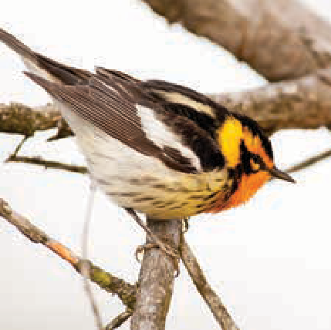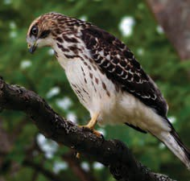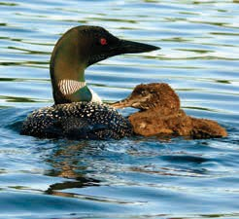
Blackburnian Warbler by Tim Stewart Juvenile Broadwinged Hawk by Cecile Gambin Loons by Peter McPh

Who’s that flapping past?
A Primer of Georgian Bay birds
Below is a selection of bird species you can expect to see on (and around) the shores of Georgian Bay. Visit gblt.org/birds for more bird descriptions and links to the songs and calls for each species:

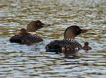
Common Loon
The classic Georgian Bay and Ontario lake country bird, the Common Loon’s haunting “wail” call is used to communicate its whereabouts to other loons.
Photo: Thom Morrissey
Almost all Common Loons summer on fresh water but overwinter on salt.

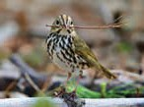
Ovenbird
A large ground-nesting wood warbler whose nest shape gives it its name, the Ovenbird delivers
Photo: Tom Murray
a loud “teacher-teacher-teacher” song. The ground nest makes its young vulnerable to predation by
chipmunks, and it is also a target for brood parasitism from Brown-headed Cowbirds.
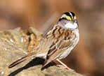
White-throated Sparrow Provider of another familiar and favourite cottage country birdsong, “Swee-eet Canada Canada Canada”, the White-throated Sparrow
Photo: Henry T. McLin
has been known to interbreed successfully with the Dark-eyed
Junco, related only in that it too is a sparrow.

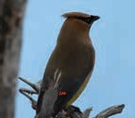
Cedar Waxwing
Arguably our most beautiful local bird, Cedar Waxwings are one of few North American birds that specialize in eating fruit. They typically forage in groups while calling back and forth in their high, thin whistle.
Photo: B. Harper

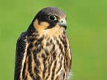
Merlin
Small and aggressive falcons, Merlins have been known to hunt in pairs; one will frighten and scatter a flock of songbirds, the other will then dive in to exploit the resulting chaos. Similar in
Photo: Flicpicpete
appearance to the smaller Kestrel, Merlins occupy old nests of other raptors and crows, preferably on islands or peninsulas providing good vantage points for intercepting winged prey.

Osprey
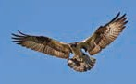
A population recovery success story, Osprey were on the verge of extinction until a ban was imposed on DDT and concerted human efforts were mounted to restore
Photo: A. Evans
their numbers. This includes the heroics of our own Georgian Bay Osprey Society (GBOS).

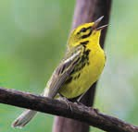
Prairie Warbler
Known by local enthusiasts as the signature Georgian Bay songbird, the rock barrens and junipers of the central Georgian Bay coast are the absolute northern extreme of this bird’s range. There are only an estimated 300 breeding pairs of Prairie Warblers on Georgian Bay.
Photo: Sandy Sutherland

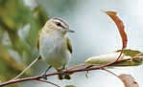
Red-eyed Vireo
This very common eastern forest bird is a formidable singer–a single male can deliver its brief song more than 20,000 times over the course of a day. Much more often heard
Photo: John Sutton
than seen, Red-eyed Vireos “glean” caterpillars and invertebrates from the forest canopy.

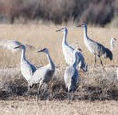
Sandhill Crane
Enjoying a huge local population increase, the large size and shape of these wading birds are both striking, and unlike any other Georgian Bay bird. Their call is an unmistakable staccato “bugling” and they will often call during flight.
Photo: Brian Ralphs

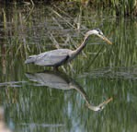
Great Blue Heron
A common sight in lake country, Great Blue Herons are colonial nesters. Despite their impressive size, individuals weigh in at a scant 5 or 6 lbs. Great Blue Herons have specially adapted neck vertebrae that allow for their lightning fast prey strike.
Photo: Marilyn Kreisel

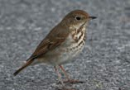
Hermit Thrush
Photo: Vitalii Khustochka
A ground-feeding bird, the Hermit Thrush has a beautiful, flute-like call. Hermit Thrushes in western North America build their nests in trees while their eastern counterparts do so on
the ground. Hermit Thrushes will sometimes shake bits of grass with their feet in order to attract insects.

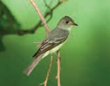
Eastern Wood Pewee
Known by its distinctive and frequent “pee-a-weeee” call, this is a member of the flycatcher family. Pewees employ the classic flycatcher hunting technique whereby they will perch on an exposed branch
Photo: Jeff Bryant
and then “sally out” after flying insects.

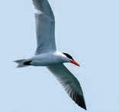
Caspian Tern
The larger, gull-sized tern of the Great Lakes, birders enjoy what they call its angry-sounding “go-to-hell” call. These are bold and aggressive birds who will actively defend their colonies; unwary trespassers run the risk of a pecked head.
Photo: Bryce Bradford
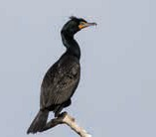
Double-crested Cormorant Considered a pest by many, the local Cormorant population has peaked and is now subsiding.
Photo: Ashley Tubbs
Decimated in the Great Lakes by contaminated fish in the
1950s and 60s, Cormorants then more than recovered, assisted by the introduction of non-native
baitfish. Cormorants began colonizing the Great Lakes in the early 1900s.

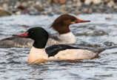
Common Merganser
True to its name, the Common Merganser is the most frequently sighted “fish duck”, typically a female leading a flotilla of young. Drakes are much less conspicuous once
Photo: Eric Ellingson
breeding is over in late June. Like most mergansers, Common Mergansers are tree cavity nesters.

Eastern Whip-poor-will
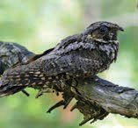
A bird whose unmistakeable call is heard less and less, the Whip-poor-will is incredibly well camouflaged. Like other nightjars, it is an “aerial insectivore” that nests on
Photo: Tom Murray
the ground. Whip-poor-wills synchronize their clutch’s
hatching to coincide with a full moon; this allows all-night foraging to feed their voracious chicks.

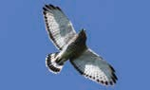
Broad-winged Hawk
A small buteo raptor favouring dense forest for nesting, Broad- wings are carnivorous generalists feeding on anything from other birds to snakes. Broad-wings
Photo: Andy Reago
gather into huge flocks or “kettles” in the fall for their lengthy migration to South America.

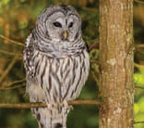
Barred Owl
Probably Georgian Bay’s most common owl, along with the much smaller Northern Saw- Whet Owl. Barreds are big, handsome, and elusive birds. Barred Owls are a non-migratory species and can be attracted to nesting boxes.
Photo: Andrew Reding

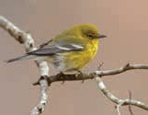
Pine Warbler
The “Pine” in this bird’s name isn’t casual; Pine Warblers
Photo: Rick Alabama
are seldom seen on any other vegetation. Known as the only warbler that will eat seeds, these birds will even visit backyard feeders on their wintering
grounds. The bulk of their time in this area is spent feeding high in the pines.

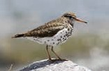
Spotted Sandpiper
Photo: Amy McAndrews
One of Georgian Bay’s few shorebirds, when feeding the Spotted Sandpiper can be seen moving quickly from place to place with distinctive short, stiff wingbeats. Gender roles
are reversed in this species; the female establishes and defends territory while the male tends to the eggs and chicks.

Thanks to Donald Sutherland and Donald Fraser for their expert ornithological consulting.
Look out for birds on Victoria Day weekend!
Springtime is when many migratory birds return to Georgian Bay, and when all sorts of species are actively mating and nesting. This May long weekend, keep an eye (and ear) out to see how many of these birds you encounter on Georgian Bay. Then tell us who you saw! Visit gblt.org/birds to report your sightings and be entered for a chance to win some bird-related prizes.

