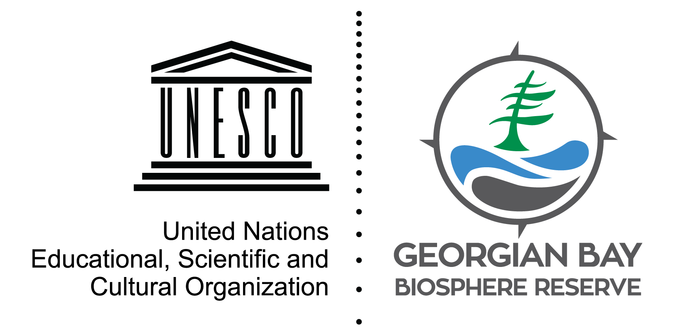
State of the Bay: Climate Change I

According to scientists and NASA, burning fossil fuels and other human activities has increased the carbon dioxide in the atmosphere from 280 ppm to 400 ppm in the last 150 years. As these gases accumulate, sunlight and heat are trapped in our atmosphere, changing the climate. Scientists agree on these facts, making climate change no longer a “theory” but an international scientific consensus.

The planet's average surface temperature has risen about 1.1°C since the late 19th century. As global temperatures rise, polar ice melts, shrinking the white reflective area and expanding the dark surface area that absorb the sun’s rays.

By looking at ice cover data for Georgian Bay from the Canadian Ice Service, we can see that there is considerable variation from year to year, but a long-term warming trend. Results from water temperatures show a similar trend. Since 1970, the average water temperature in Lake Huron has increased by 1°C per decade.

Unfortunately, well-funded climate denial campaigns confuse the public about very simple facts: climate change is occurring right now and we are causing it. We must act quickly to avoid catastrophic effects, or our grandchildren will be the victims of our lifestyle and consumption of unsustainable energy. Visit stateofthebay.ca for a Climate Change Checklist to see how you can help.

David Bywater is the State of the Bay Project Manager for the Georgian Bay Biosphere Reserve, a not-for-profit dedicated to environmental and community well-being. He can be reached at conservation@gbbr.ca

