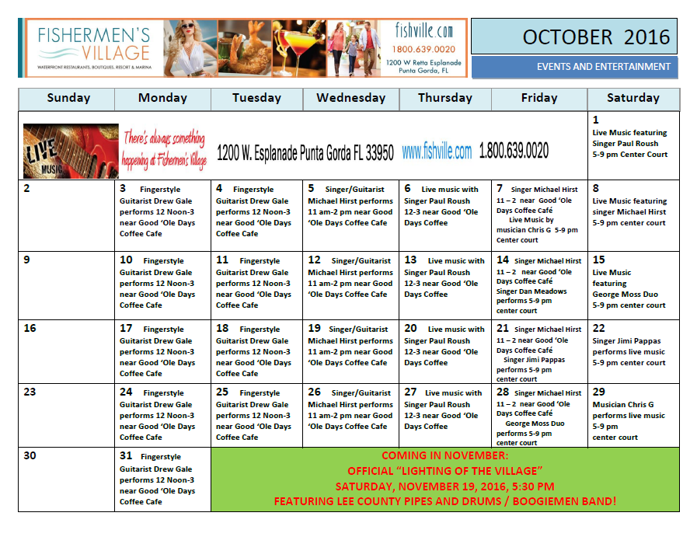**October Events, 2016**

**Animal Welfare League Needs Your Help!!!**

**October Calendar for the Yoga Sanctuary**

**Restorative Yoga in the Tradition of BKS Iyengar**

Sunday, October 16th  1 – 4pm $50

The Yoga Sanctuary, 112 Sullivan St, Punta Gord

Join The Yoga Sanctuary as we welcome Fort Myers-based Iyengar teacher, Kandy Love for this very special event. When BKS Iyengar traveled the world to teach and lecture, he was expected to function at a high level soon after his arrival. Legend holds that first he would calm, balance and energize himself through restorative practice. In his words: “Yoga allows me to find an inner peace that is not ruffled and riled by the endless stresses and struggles of life.” In this 3-hour exploration, Kandy will guide you through one of his sequences which she has taught for more than a decade. Previous yoga experience and an understanding of prop use is recommended.

**The Yoga Sanctuary’s Teacher Training Program 2016/17**

Free Information Session

Wednesday, October 19th 5:30 – 6:30pm FREE

The Yoga Sanctuary, 112 Sullivan St, Punta Gorda

If you are interested in becoming a yoga teacher—or simply in deepening your own practice—join The Yoga Sanctuary for an informal Q&A about their upcoming 200-hour Teacher Training Program. TYS’s Yoga Alliance Certified Teacher Training Program brings together an incredible group of students and teachers in a fun but intensive immersion into asana, yogic philosophy, teaching methodologies, and more. Ideal for aspiring yoga teachers, health care practitioners, or anyone who simply wishes to delve into his/her own practice. Open to all interested students; tea and snacks provided!

**Yoga for Tennis**

Sunday, October 23rd 1 – 3pm $35

The Yoga Sanctuary, 112 Sullivan St, Punta Gorda

Play tennis? Practice yoga! Enhance your game with a yoga practice designed specifically for tennis players. Improve your reach, increase your power on the court, and avoid injury by learning how to find your best game through relaxation rather than muscle tension. Learn poses to increase your flexibility and strength, as well as meditation and breathing techniques to refine your focus and help you step into “the zone” more frequently. Margit Bannon is a certified Tennis Professional (USPTA) and yoga teacher who loves combining her passion for the two disciplines. No yoga experience required.

**Sea Grape Gallery’s Artists of Month for October, 2016**

Until November 3, 2016 Sea Grape Gallery will be featuring two of their artists, Anne Tuttle, Colored Pencil Artist, and Bonnie Benande, Stoneware Potter. Anne Tuttle became interested in drawing when she and a group of artists began exploring the emerging medium of colored pencil. She then realized she prefers drawing to painting and appreciates the simplicity and versatility that working in colored pencils has to offer an artist. Anne spent most of her life living by the shoreline in Connecticut where she loved painting boats, beaches and other maritime themes. Since moving to Florida, she has been inspired by the natural beauty in this area and often finds subject matter in her own yard. Anne strives for a minimalist approach, and a clean, uncluttered look in her artwork. As Anne says, “I enjoy the satisfaction I get from successfully completing a piece of art for others’ enjoyment”. In addition to working in colored pencil, Anne creates delicate Silverpoint drawings using a technique that dates back to the Old Masters.

Bonnie Benande realized her love and passion for pottery while living in North Carolina where she took classes at the Greensboro Arts Council. After many years preoccupied with a corporate career, Bonnie had to wait until her retirement life in Florida to pursue her interest again in working with clay. After working to learn new techniques in the art of pottery from several Florida potters, she decided again that this is the art medium she wanted to pursue. Inspired by the flora and fauna of Florida, often her art incorporates palm trees, shells, dragon flies, turtles and other creatures of the wild. While often working on the potter’s wheel, Bonnie has recently been producing colorful and unusual hand-built designs using clay slabs. Each piece is designed to be functional in addition to decorative.

Many of Anne’s color pencil drawings and Bonnie’s pottery are prominently on display at the Sea Grape Gallery. In addition, more of their art and the artworks of all Sea Grape artists can be viewed at [www.seagrapegallery.com](http://www.seagrapegallery.com).

Sea Grape Gallery has been awarded the Punta Gorda Chamber of Commerce’s Special Recognition Award; has consistently won the Charlotte Sun Newspaper’s Readers’ Choice Award for Best Art Gallery; and is a past recipient of the Arts & Humanities Council of Charlotte County‘s Charlie Award for Outstanding Contribution to the Arts. Come visit the Gallery and its many talented award winning artists who are on hand to welcome and assist visitors.

Sea Grape Gallery is located at 113 W. Marion Avenue, Punta Gorda and can be reached at 941-575-1718. The Gallery is always open until 8 p.m. on the third Thursday of the month for Gallery Walk.





**Burnt Store Presbyterian Church:**

***A SPECIAL PLACE, ADULT DAY CARE***

Burnt Store Presbyterian Church group respite program offers high quality day care for Alzheimer’s and other dementia clients while providing necessary time off for their caregivers. Under the direction of a registered nurse, trained volunteers engage participants in a variety of activities that provide: Dignity, Independence, Happiness, Reassurance, Music, Crafts, Social Activities, Games, Stories, Exercise and Friendship

**YOUR LOVED ONE RECEIVES:**

.The opportunity to socialize in a group format

. Individualized care

. Recognition of their strengths, needs and interests

. A nutritious snack

Plus much more.

Adult Day Care **9:30-1:30** at a cost of $20.00. For more information, contact Carol Lucas, RN Program Coordinator 255-9192, or contact the church office at 639-0001 during normal business hours, 9am to 4:30pm Monday through Friday, or by e-mail to office@bspconline,org.

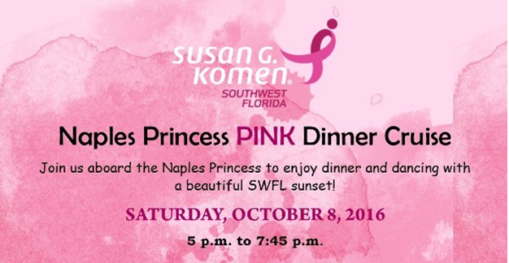

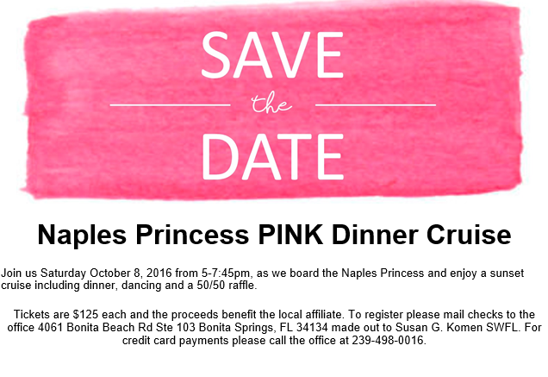

[**Go to komenswfl.org**](http://southwestflorida.info-komen.org/site/R?i=N4jjcm2ke0FfHIdXwGgicA)









|  |  |
| --- | --- |
|  | **SOUTH FLORIDA FLATWOODS**  **QUAIL FOREVER YOUTH DAY2016** |

**What: Fishing for Catfish in Stocked Pond; Swamp Buggy Rides with Bird Dogs, Interactive Walking Bird Dog Demonstrations, Clay Pigeon Shooting and 3D Archery with FWC Certified Hunter Safety Instructors, Kayaking; (safety equipment provided) Free Lunch with Hot Dogs/Burgers Chips and Drinks Provided(1 free lunch ticket per attendee).**

**When: Saturday, October 15, 2016**

**Time: 8:00 AM - 12:30 PM Check-in: 7:30 AM - 8:00 AM**

**Where: Boy Scout Camp 12 miles east of Punta Gorda, 38751 Bermont Road**

**For Youth Ages 9 – 16 (Cost: Free) Sturdy Shoes, Outdoor Attire and Sunscreen Recommended**

Please fax or e-mail registration form to: Fax: 941-637-1963 or Email: cayocostadentalinfo@gmail.com . Pre-registration recommended. Walk-ins taken on first come/first serve basis only. Parent or guardian must be present during youth participation in this event. Sign-up forms available at [www.qfflatwoods.org](http://www.qfflatwoods.org)

For further information contact: Frederick Fox (QF Youth Coordinator) 941-916- 2466(cell) or www.qfflatwoods.org

**Oct. 15th  A fund raising event benefiting the Virginia B. Andes Volunteer Community Clinic** The Virginia B Andes Volunteer Community Clinic will host its annual fall fundraiser event “Country for a Cause”. From 6 pm to 10 pm on October 15th at the Charlotte Community Foundation, 227 Sullivan Street, Punta Gorda. Live music will be provided by the Ben Allen Band. A down home country cooked meal will be provided, along with a cash bar. Tickets are $50.00/person. R.S.V.P by October 10th, call 941-276-9570. Proceeds will be going toward patient care and no cost medical clinic and pharmacy. [www.volunteercare.org](http://www.volunteercare.org)

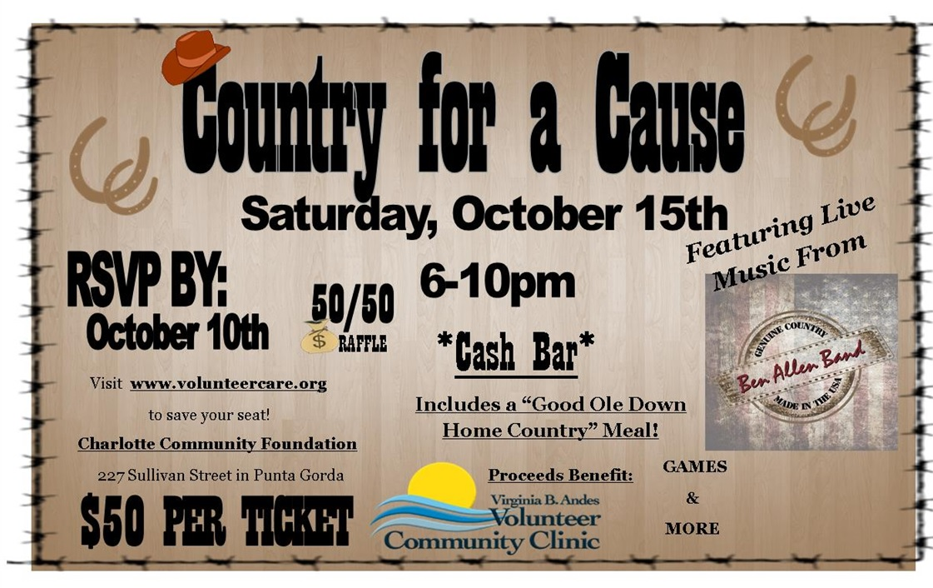

***October 15: The Foot Landing*** *- October is Breast Cancer Awareness Month*

*Our Senior Students are back from CTC in honor of breast cancer awareness month.*

*$10 Pedicures all day Saturday October 15th.*

*Call and make your reservation or just stop by - 941-347-7751*

***Pink sales*** *going on all day at the Foot Landing.*

**Annual "Airing of the Quilts" at Edison Ford**  
On **October 15 from 10:00 a.m. to 2:00 p.m**., Edison & Ford Winter Estates will host the annual "Airing of the Quilts" with a clothesline quilt show. Dozens of quilts from the Quilters Guild will be on display, suspended from clotheslines between the palm trees on Thomas Edison's estate. Antique quilts from the 1880s to 1920s will also be on display inside the homes and area antique car clubs will bring cars for viewing. Quilters Guild participants will have quilts available for sale and artist, Marie Dyer will demonstrate and teach silk scarf painting. Living history characters of Thomas Edison and Henry Ford as well as their wives will be on site for photo opportunities.  Henry Ford and his wife, Clara, collected quilts and other historical objects that were created and used by ordinary people from all across the United States. The quilts were often made from modest scraps of material which demonstrated the resourcefulness of American women. "Airing of the Quilts" is included with general admission. Tickets are $20 for adults, $15 for teens ages 13 to 19, $11 for children ages 6 to 12 and free for children 5 and under. The event is free for Edison Ford members. For more information, call 239-334-7419 or visit [www.edisonfordwinterestates.org](http://edisonfordwinterestates.us1.list-manage1.com/track/click?u=0b01d78b75a393693e00467a5&id=ff58c7670c&e=0b758c891b).

**FGCU’s Office of Continuing Education & Off-Campus Programs Presents “ESL: English as a Second Language for Professionals”**

The Office of Continuing Education & Off-Campus Programs at Florida Gulf Coast University (FGCU) hosts a professional development workshop, “ESL: English as a Second Language for Professionals.” The program costs $295 and will be offered **Oct. 17 through Nov. 10** (Mondays and Thursdays), 6 p.m. to 8:30 p.m. at FGCU Naples Center, 1010 5th Ave. South, Naples.   This intermediate level ESL course provides learners the opportunity to develop speaking, listening, reading and writing English language skills in the workplace, whether communicating with management, colleagues or customers. The course is designed for employees, managers, or professionals who either already use English in their work or hope to find a job by improving their English; participants may be currently employed or seeking employment.

 The program’s instructor is Barbara White Crockett, a TEFL/ESL certified career counselor and English language coach. As founder and principal of BWC International, a global executive recruiting and human resources consulting firm, she has over 30 years of corporate experience and has hired top talent for major organizations worldwide.  For registration information, call (239) 425-3270, email [continuinged@fgcu.edu](mailto:continuinged@fgcu.edu), or go online at [Upcoming FGCU Professional Development Programs](Upcoming%20FGCU%20Professional%20Development%20Programs) at <http://www.fgcu.edu/CEd/professional_development_programs.html>.

 FGCU’s Office of Continuing Education & Off-Campus Programs is committed to satisfying the professional development needs of Southwest Florida workers through affordable and diverse learning opportunities.

****For Immediate Release

Contact: Bevin Holzschuh

(941) 766-4361

[bevin.gallo@bayfronthealth.com](mailto:bevin.gallo@bayfronthealth.com)

**Breast Cancer Deaths Decline Thanks to Prevention and Early Detection**

PORT CHARLOTTE, FL (October 1, 2016) –Across our community and the entire country this month, we will celebrate the brave women who have done battle with breast cancer. It’s a time of reflection and celebration for many women, as they bond together to celebrate a precious victory and to support causes designed to eradicate the disease. But October can also be a difficult time for some, as we are encouraged to remember friends or loved ones who lost their battle with breast cancer – some of them at a very young age.

But perhaps most importantly, October traditionally provides opportunities to educate millions of women on the importance of screening and prevention. Between 1990 and 2013, the death rate from breast cancer decreased by 37 percent, or nearly a quarter of a million lives. The decrease is certainly due in large part to women declining hormone therapies during and after menopause, but also to aggressive campaigns encouraging women over 40 to be vigilant about mammograms. Today, 67% of women over age 40 report having had a mammogram in the past two years, totaling nearly 39 million mammograms per year. While mammograms aren’t perfect, the digital diagnostic tools of today can detect changes in the breast years before a tumor develops. And statistics tell us that the five-year survival rate is nearly 99% when breast cancer is detected in the early stages.

While recommendations have changed through the years regarding who should get screened and when, the general standards for women at average risk remain the same:

* Starting at age 40, all women can choose whether to start annual screening with mammograms.
* Women age 45-54 should have a mammogram every year
* Women age 55 and older should switch to mammograms every 2 years, but can choose to continue annual screenings
* Screening should continue as long as a woman is in good general health, and is expected to live 10 more years or longer

Some women are at higher risk of developing breast cancer based on family history, genetic mutations and some prior health conditions and therapies. If you fall into this category, it’s important to talk with your doctor about more aggressive detection measures and whether they’re right for you. Today, our hospital offers technologies like ultrasound, breast MRI and genetic testing, giving those who are most vulnerable to this disease the best chance to detect it early and survive.

Of course, it’s vitally important to remember that – like any cancer or other disease – prevention is absolutely the best medicine. One in eight women will be diagnosed with breast cancer during their lifetime. Minimize your risk by following these general rules to supercharge your immune system:

* Keep a healthy weight, with a BMI at or below 24
* Engage in physical exercise at least four hours each week
* Get eight hours of sleep most days – preferably during nighttime hours
* Limit alcohol consumption to no more than one drink per day
* Avoid exposure to chemicals that can cause cancer – you can find a detailed list of known carcinogens at the [www.Cancer.org](http://www.Cancer.org) website
* Limit exposure to radiation, using X-rays, CT scans and PET scans only when medically necessary
* Before taking any type of hormone replacement or birth control therapy, ask your doctor to ensure you are balancing the risks and benefits
* If possible, breastfeed any children you may have

Our teams at Bayfront Health Port Charlotte, Bayfront Health Punta Gorda and Bayfront Health North Port look forward to celebrating Breast Cancer Awareness Month with all the survivors, families and advocates here in our community. We have physicians and staff available to speak at your next club, business, school or other community organization gathering on steps to take to have a plan to detect, what to expect if diagnosed, and treatment. We are also hosting the following:

**Tuesday, October 18, 11:30 a.m. to 1:00 p.m. – Breast Cancer Awareness**

Speaker: Jerome Sturm, M.D., F.A.C.O.G., Gynecologist and Obstetrician

Punta Gorda Isles Civic Association, 2001 Shreve St., Punta Gorda

Free. Call 941-637-2497 to register.

**Thursday, October 20, 4:00 to 5:00 p.m. – Understanding Breast Cancer**

Speaker: Jennifer D’Abarno, M.D., F.A.C.O.G., Gynecologist and Obstetrician

The Springs of South Biscayne, 6235 Hoffman St., North Port

Free. Call 941-637-2497 to register.

If you need to find a physician, visit http://www.Comprehensive-WomensHealthCare.com/ or call 941-766-0400. To schedule a mammogram, call 941-423-5000 for North Port, 941-766-4321 for Port Charlotte and 941-637-2449 for Punta Gorda.

***About Bayfront Health Port Charlotte and Punta Gorda*** *Bayfront Health Port Charlotte and Punta Gorda are Joint Commission Accredited hospitals part of a regional network of seven hospitals and more than 70 clinics along the I-75 corridor. Our Port Charlotte campus consists of a 254-bed full-service facility offering comprehensive services in emergency care, primary stroke center, orthopedics and the only licensed obstetric and pediatric units and Level II neonatal intensive care unit in Charlotte County. The on-campus Southwest Florida Heart Center is an accredited chest pain center with PCI offering comprehensive cardiac services. Our Punta Gorda campus is a Joint Commission Top Performer on Key Quality Measures****®***  *for pneumonia, surgical care and immunization, and consists of a 208-bed facility offering an award-winning, accredited primary stroke center, the Joint Commission Certified Joint and Spine Academy, an accredited chest pain center, and emergency care services. Additional on-campus services include adult inpatient psychiatric care at Riverside Behavioral Center and rehabilitation and wellness services at the Wellness and Rehabilitation Center. To learn more, visit* [*www.BayfrontCharlotte.com*](http://www.BayfrontCharlotte.com)*.*

**October 20, 2016 the Annual Republican of the Year Dinner** will honor State Committeewoman Jane Sturges. This event sponsored by the **Charlotte County Republican Party** salutes an outstanding Republican and community leader. After serving as our State Committeewoman since 2000, Jane is retiring.  Jane Sturges is a past president of the Peace River Federated Republican Women’s Forum, Precinct 41 committeewoman; and current precinct 64’s committeewoman. She is a founding member of the Charlotte County Republican Club and a current member of all five Charlotte County Republican Clubs.  Ms. Sturges is a leader in the community as well as in the Republican Party. She was on the Punta Gorda Isles Civic Association Board of Directors; Board of Directors of the Isles yacht Club; a member of the Punta Gorda Kiwanis Club; and a member of the Yah Yah Girls. Ms Sturges has served her party and her community with honor, integrity, and devotion. Please join the Charlotte County Republican Party in honoring Ms. Sturges at the Isles Yacht Club for a prime rib dinner and celebration in her honor. Tickets are $80/person for the reception (cash bar) at 6 PM and dinner at 7 PM. For Tickets or more information contact John Hitzel 941-286-6281; [johnjack1634@gmail.com](mailto:johnjack1634@gmail.com) or Charles Counsil 941-575-8997, [ccounsil1@comcast.net](mailto:ccounsil1@comcast.net)[@gmail.com](mailto:mkjollett@gmail.com)









**Visual Arts Center:** Don’t miss Fine Arts Festival events and workshops happening **Oct 24 – Nov 11**, find details under events at: [www.VisualArtCenter.org](http://www.VisuaalArtCenter.org). Mayhem, Chaos & Confusion on display until Nov 4 and Opposites Attract on display until Oct 26. Exhibits are always free and open to the public. While you’re here, find gifts crafted by local artists for all occasions in our Gift Shop and browse art books and more in our Library! The Visual Arts Center is located at 210 Maud St in Punta Gorda. Hours: M-F, 9am – 4pm & Sat, 10am – 2pm.

**Let's Go Fishing!**

An introductory course in Florida Fishing is being offered at the PGI Civic Association on Shreve Street in Punta Gorda. Topics to be covered include fishing techniques, tackle selection, rigging, knot tying, lures, baits, cast nets, fish identification, tides, and fishing regulations for fishing in fresh and salt waters of Southwest Florida.  Rods, reels, lures, nets and other fishing equipment will be demonstrated during the class and there will be a number of useful hand outs issued to students.  The class is geared towards beginning anglers, but more experienced fishermen will pick up helpful tips as well.  The instructor is long time local fishing guide Capt. Ralph Allen who might even reveal the locations of a few local hotspots!  The course is open to all members of the public and is held on **Wednesday evenings from 7:00 p.m. to 9:00 p.m. for six weeks beginning on Wednesday October 26.** The cost for the class is $45 and advance registration is recommended by calling 941-637-1655.

**October 26: Foot Landing**

Costume Run & Roof Top Halloween Party

Wednesday, October 26, 2017 at 6:00 pm

Halloween themed run with a one-of-a-kind roof top finish and party!   
  
In order to rent the parking garage roof top (a city park) we are asking for a $5.00 per adult or $10 per family donation, due no later than one week before the event. You can come by the Foot Landing or call [941-347-7751](tel:941-347-7751) to give your donation. Also, please RSVP on the Facebook event to give us a head count.   
  
Free water and beer will be provided but we ask that you bring a dish to pass!   
  
Runners & Walkers will meet at 6PM at The Foot Landing.  
The route will be approximately 2.1 to 3.1 miles in length with a Roof Top Finish & party! Runners and walkers of all abilities are welcome.   
  
1st wave... (walkers/strollers) will leave at 6:15pm  
2nd wave (runners) will leave at 6:30pm  
  
The dynamic of the run will be very laid back and costumes are encouraged. No timing will be involved. This is a great opportunity to have fun with other local runners and walkers in a relaxed, fun atmosphere.  
  
Costume contest will be held at the finish, with prizes going to the best male, female and kid costume.   
  
Free public parking is available in the city parking garage above The Foot Landing but do not park on the top floor to leave room for the party.  
  
We hope that you can join us for some Halloween Fun!

--

[941-347-7751](tel:941-347-7751)

[www.thefootlanding.com](http://www.thefootlanding.com)

[www.facebook.com/TheFootLanding](http://www.facebook.com/TheFootLanding)

**St. Vincent de Paul, Sacred Heart Conference Harry Chapin Mobile Food Pantry coming to Punta Gorda**

The Harry Chapin Mobile Food Pantry will be in Punta Gorda **Thursday, October 27**, and Thursday, December 22, offering healthy food for the needy. The mobile pantry, assisted by volunteers from St. Vincent de Paul, Sacred Heart Conference, will be located in the Sacred Heart Church parking lot, 211 W. Charlotte Avenue, from 10 a.m. to noon.   Fresh produce and other healthy food will be distributed. Recipients are asked to bring a bag or box to carry their food. The Harry Chapin Food Bank solicits, collects and stores quality food for distribution to families in need through a network of nonprofit agencies in Lee, Collier, Hendry, Charlotte and Glades counties. These agencies, including St. Vincent in Punta Gorda, provide food to thousands of people monthly. St. Vincent is an international Catholic lay organization founded in 1833 to serve the poor, regardless of religious affiliation. It provides food, clothing, home furnishings, and financial assistance to individuals and families in need.

**The Englewood-on-the-Gulf Chapter of the Women’s Council of Realtors** will hold their 4th Annual Fashion Show **Thursday, October 27, 6-9 p.m**. at the Englewood Event Center on McCall Road. Live entertainment, dinner, chance, and silent auction items. A portion of the proceeds will benefit Charlotte Arts. Tickets: $50. Call Priscilla Borci at (941) 661-8477 or [priscilla@beckyborci.com](mailto:priscilla@beckyborci.com).





**Film Screening and Exhibit Opening at Edison Ford**

**On October 28, Edison & Ford Winter Estates** will bring back the outdoor movies under the stars with the film screening of "Wind Across the Everglades." This 1958 classic about the tragic era of bird plume hunting in the Florida Everglades will be shown on the Ford lawn. Gates open at 5:30 p.m.   
The film's main character is a game warden hired to enforce conservation laws in Florida, but finds himself up against a group of bird poachers. The story is based on Guy Bradley's life -- the game warden who was shot and killed by plume hunters in 1905.  
The movie was filmed on location in Everglades National Park in technicolor. It's filled with nature footage of birds roosting and flying, plus alligators and other Everglades wildlife.    
The characters depict what life was like in South Florida at the turn of the century and how hunters would not let anyone get in their way of collecting the bird feathers that at the time were reportedly worth more money than gold.   
The cast includes Burl Ives, Christopher Plummer, Chana Eden, Peter Falk, Emmett Kelly and Gypsy Rose Lee. Renowned screenwriter, Budd Schulberg supervised editing and completed film direction and production.   
K. C. Schulberg, a third-generation film executive and nephew of Budd Schulberg, the original screenwriter, will speak about the film's production.  
Visitors are also invited to see the new exhibit, "Birds of Southwest Florida" in Edison's Caretaker's House. Historic photographs, artwork and other objects will be on display.   
Tickets for the movie and exhibit are $20 for non-members and $10 for Edison Ford members. Refreshments will be available for purchase. A limited number of chairs will be provided; however, guests may bring a chair.   
For more information, call 239-334-7419 or visit [www.edisonfordwinterestates.org](http://edisonfordwinterestates.us1.list-manage1.com/track/click?u=0b01d78b75a393693e00467a5&id=a95c762c71&e=0b758c891b).

***Drug Free Charlotte County***

*On* ***October 28th*** *there will be a very important lunch event for local businesses. It is an opportunity for any local business to “Ask the Expert” questions on strategies to reduce the potential liability impacts related to employee use of marijuana as medicine. The State Legislature has already legalized the use of marijuana as medicine under some circumstances. While the roll-out has been slow, dispensaries are beginning to open across the state, and in our region. It is important that businesses become pro-active and understand the potential consequences now – and prepare for situations of employee use. As part of Drug Free Charlotte County’s annual day of events to honor the role of our community in substance abuse prevention, we have arranged for Monte Stiles, a former U.S. Attorney and Federal Prosecutor and subject-matter expert, to address the questions of our local businesses on strategies to reduce liability impacts related to employee use of marijuana as medicine. Mr. Stiles has worked with businesses all over the country to create drug-free workplace policy and address the impact of marijuana legalization. On the suggestion of our Honorary Event Chair, Commissioner Bill Truex, we are asking our Chambers of Commerce to help us with getting the word out and encouraging their membership to attend this critical and informative event. Also, we ask for your help to gather the questions of local businesses in advance, so that we can be sure to address as many as possible at the event. We also have a link to submit questions with the event announcement- this link is* <https://www.surveymonkey.com/r/Question4Business> *The event will be held at noon at Hurricane Charley’s in Punta Gorda. A lunch selection will be provided for pre-order at the cost of $15 –RSVP’s are required by October 24th (PreventionDay@drugfreecc.org). The event announcement is attached. We truly believe this can be a very beneficial event for businesses of all sizes – and welcome any assistance or suggestions you may have to offer. Please do not hesitate to contact me for any questions.*

