Areas of Refuge

Areas of refuge as defined by the Building Code is an area where persons unable to use stairways can remain temporarily to await instructions or assistance during emergency evacuations. The area of refuge is equipped with a two way communication system that would allow occupants to communicate with emergency services. The requirements for areas of refuge were first adopted by the State of California as part of the 2007 California Building Code which adopted the 2006 International Building Code. Buildings permitted for construction after January 1, 2008 would be required to comply with the requisites for Areas of Refuge. All Stanford buildings comply with the requirements for the Areas of Refuge.

An approved area of refuge includes the following features: Access to a stairway or an elevator; sufficient size to adequately accommodate two wheel chairs; a two-way communication system; and separation from the remaining floor areas by a one-hour rated separation designed to minimize the intrusion of smoke. Approved areas of refuge are also required to be adequately labeled.

Since most buildings on campus do not have an approved area of refuge, consideration must be given to those occupants that may not be able to use the stairs in an emergency since the elevators will not be available. Preplanning what do for those occupants that will not be able to effectively use the stairs is critical.
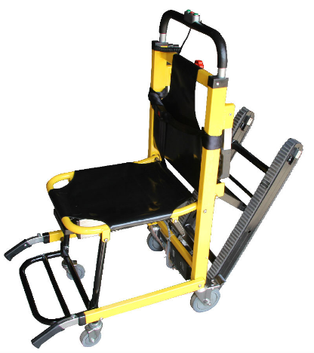
One of the easiest ways to help those occupants that cannot evacuate on their own would be to help them seek shelter in an enclosed stairway and then have other occupants alert the emergency responders to the location of the occupant that needs assistance in evacuating. Another option would be to purchase a stair evacuation chair which would allow other occupants to help evacuate those in need of assistance.

If you have any questions or have suggestions for future topics please feel free to contact me at mvonraesfeld@stanford.edu

For more information, see Areas of Refuge

