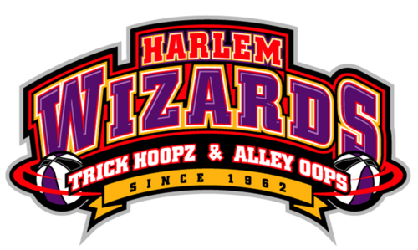
Ticket Order Form

Presented by Paterno Orthodontics and the Harrington/Hartford PTO

Order Your Tickets Now online only
Go to https://harlemwizards.thundertix.
Sunday
March 25th
2–4 pm
Doors open at 1:15
Lenape HS
com/events/123973
or http://www.harlemwizards.com/
schedule-tickets/
Lenape HS –
North GyM

General admission ticket@ $12.00 each

Reserved Admission Tickets@ $20.00 each

Court Side Plus Tickets @ $35.00 each

***PAY TO PLAY*** One lucky fan (Mom? Dad?) will be chosen to join the team to play against the Wizards! Winner will be announced at the start of the game so come ready to play! No experience necessary; just be prepared to have fun! Must be 18 or older to enter and play.

Name of Player_________________________________ ___ # of chances @ $1.00 each Total $ ________

THIS IS NOT A DROP OFF EVENT – STUDENTS MUST BE ACCOMPANIED BY ADULT!

