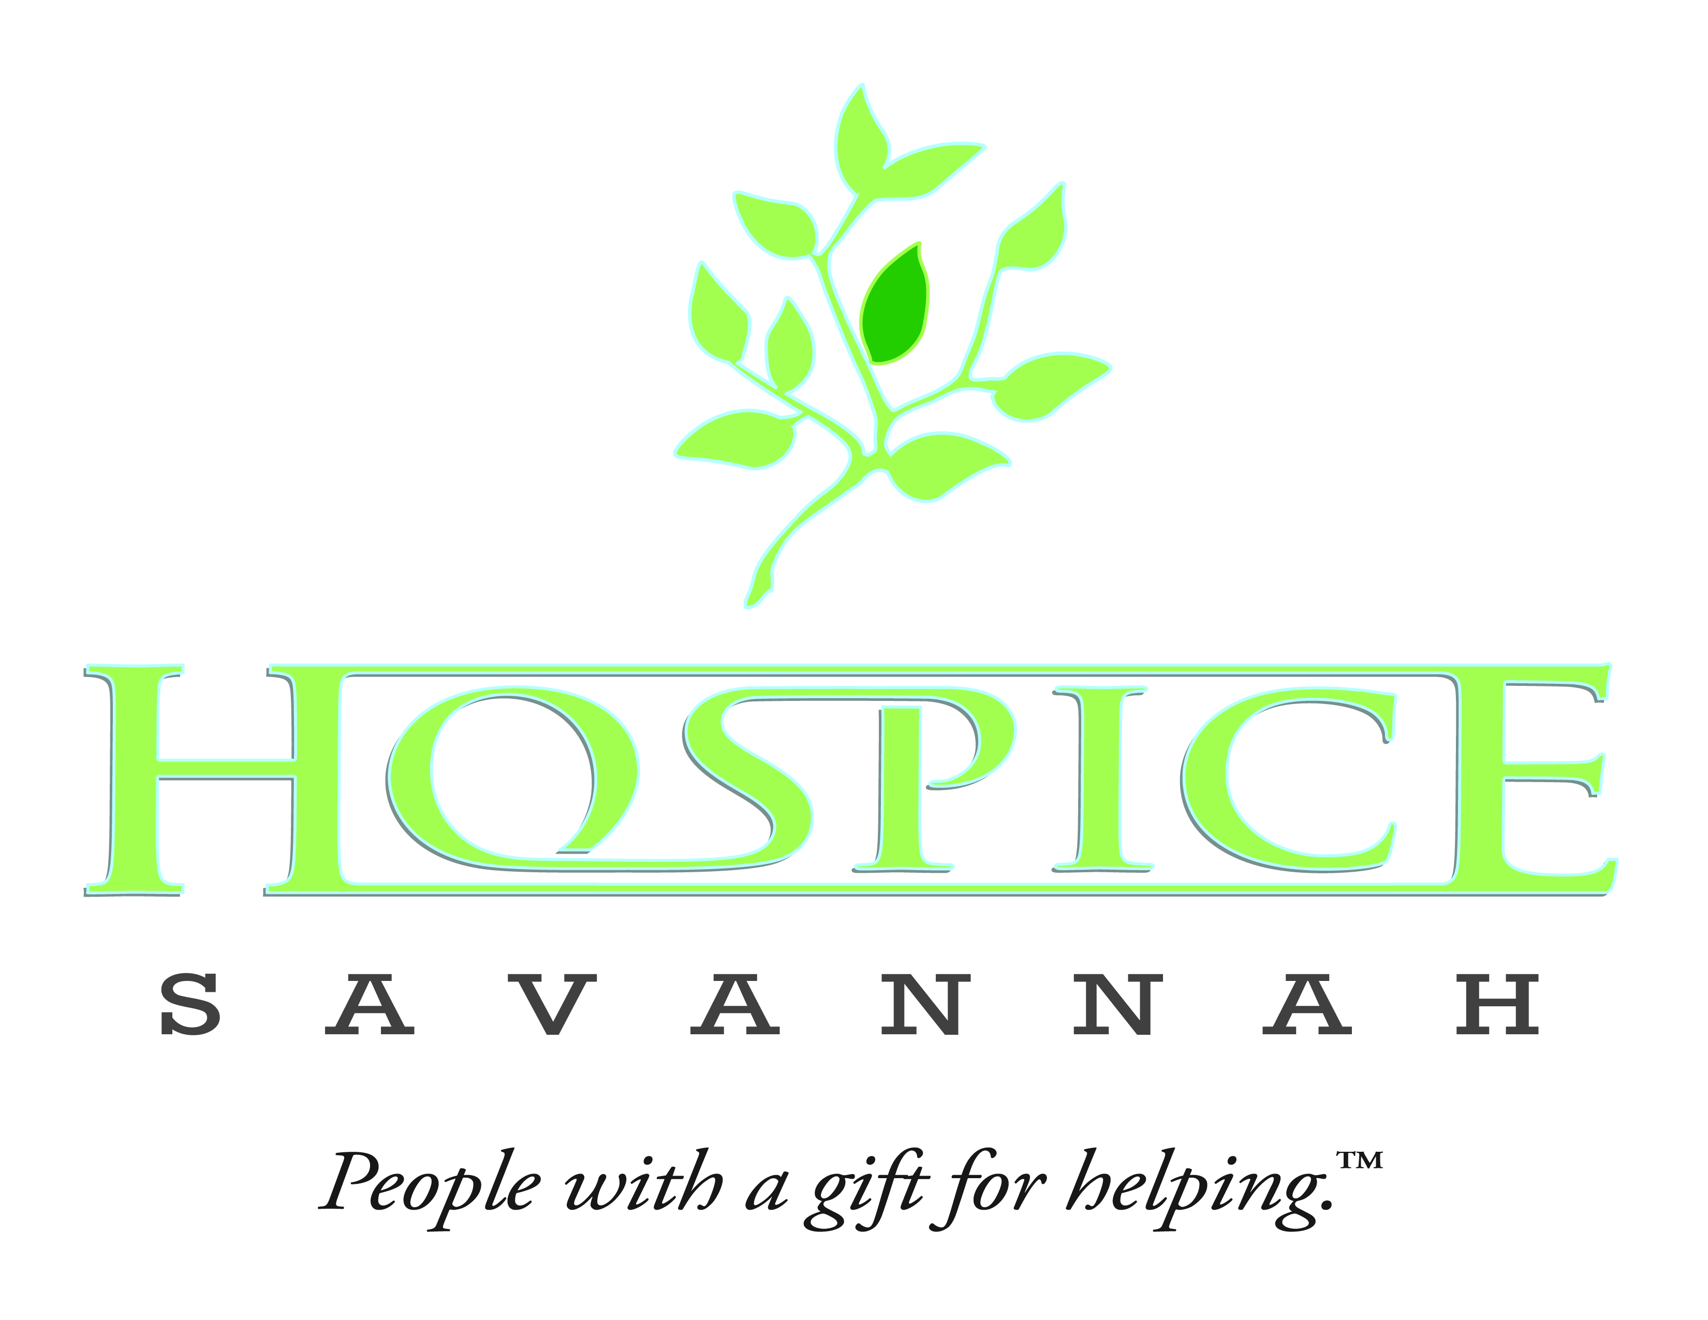

FOR IMMEDIATE RELEASE

Hospice Savannah’s Full Circle awarded grant to help children affected by violence

SAVANNAH, GA (January 11, 2017) – The New York Life Foundation has donated a $100,000 grant to Hospice Savannah, Inc. to fund a two-year initiative entitled We the Living: A Community-based Children’s Grief and Violence Support Network The grant supports developing specialized services to address the urgent and unique bereavement needs of 200 low-income, predominantly African-American children and youth in Savannah-Chatham County who have experienced the death of a loved one as a result of the escalating rates of homicide and gun violence.

Savannah-Chatham Metropolitan Police Department Chief Joseph Lumpkin, Barbara O’Neal, founder of Mothers of Murdered Sons, and other community leaders today announced the major initiative which will be spearheaded by the bereavement counselors of Hospice Savannah’s Full Circle. A series of grief counseling support groups staffed by specially trained bereavement counselors will be offered within the familiarity and accessibility of the neighborhoods in which the children live. In addition, 100 neighborhood-based bereavement volunteers will be identified and trained to serve as a new network of ongoing and sustainable support.

Using proven clinical interventions and incorporating art, music therapy, personalized music, yoga and mindfulness, support groups will help children to understand and express grief, address specific issues of traumatic loss, develop skills to cope with grief and stress, and model positive alternatives to violence. Without intervention, children who have lost a loved one to violence are highly likely to experience a more complicated pattern of grief including post traumatic stress, higher hyper vigilance, school truancy and fear.

Because these children face significant access barriers such as isolation, poverty, lack of transportation, and institutional mistrust, neighborhood partnerships will be instrumental to the success of this program. The following organizations are partnering with the Full Circle counselors in identifying and reaching out to children and youth who have lost a loved one to violence, in identifying community leaders, family members, staff or others to participate in training to become bereavement support volunteers, and/or in sharing support group meeting space:
- Frank Callen Boys & Girls Club, which serves more than 1000 predominantly low-income and/or minority children and youth in Savannah in neighborhoods directly impacted by gun violence
- Mothers of Murdered Sons of Savannah – a grassroots support, awareness and advocacy group of parents of children, youth, and young adults who have been murdered
- Savannah-Chatham County Public Schools guidance counselors, with whom the staff of Full Circle have an ongoing relationship for in-school support groups and referral to our other grief and bereavement services
- Asbury Memorial United Methodist Church, a diverse congregation located in the heart of downtown Savannah with an active outreach program to their neighborhood which is directly impacted by violence
- The Dream Campaign – a faith-based mentorship program working with at-risk youth in the inner city
- Loop It Up Savannah – a grassroots, community creative arts outreach program engaging children from low-income neighborhoods through arts and crafts.

Volunteers interested in participating in the “We the Living” project may contact Full Circle Grief and Loss Center at 912.303.9442.

Key staff leading the training includes:
- Bereavement Counselor Betsy R. Kammerud, LCSW, who will supervise the clinical aspects of the program. Betsy is credentialed as an Advanced Hospice and Palliative Care Social Worker (ACHP-SW) as well as a Military Service Member, Family and Veterans Clinical Social Worker (MVF-CSW). Betsy has worked as a bereavement counselor with children and adults for the past 6 ½ years directing clinical programming for Hospice Savannah’s Full Circle’s Camp Aloha (a children’s grief and loss camp), a children’s support group, and individual counseling programming at Full Center for Grief and Loss.
- Bereavement Counselor Barbara Moss-Hogan, LCSW, who will coordinate and facilitate the proposed support groups. Barbara, who has more than twenty years’ social work experience, provides bereavement counseling to children and adults throughout Full Circle’s five-county service area, including coordinating children’s grief support groups within the Savannah-Chatham County Public School system and serving as Director of Campers for our Camp Aloha weekend and day grief camps for children and families. Barbara also has past experience helping children and adults in critical situations as a Crisis Intervention Specialist with the New Orleans Police Department.
Both Betsy and Barbara have been trained in the STARFISH treatment program developed to assist children with trauma and grief support after 9/11 and in Crisis Intervention Training (C.I.T.) to assist law enforcement in suicide prevention and aftercare.
- Bereavement Coordinator Holland Morgan, MDiv, who will coordinate the administrative aspects of the program and the train-the-trainers sessions. Holland has 16 years experience in grief and bereavement support, and coordinates Full Circle Grief and Loss bereavement programs at Hospice Savannah, including individual and group counseling for children and adults, and serves as Director of Camp Aloha weekend and day camps for children and families.

Full Circle Grief and Loss Center offers a full array of bereavement support groups and individual counseling to any child, teen or adult in Bryan, Chatham, Effingham, Liberty and Long counties at no charge. Services are available regardless of the nature of the loss: death with or without the support of hospice care, suicide, or violence. Funding for Full Circle is provided through the generosity of donors and is administered by the Hospice Savannah Foundation, Inc. More information can be found at www.HospiceSavannah.org/GriefSupport or by calling 912.303.9442.

Beth Logan, Director of Marketing. 912.355.2289 blogan@HospiceSavannah.org

###

