Plant Allies Herbal Apprenticeship – Level 1
with
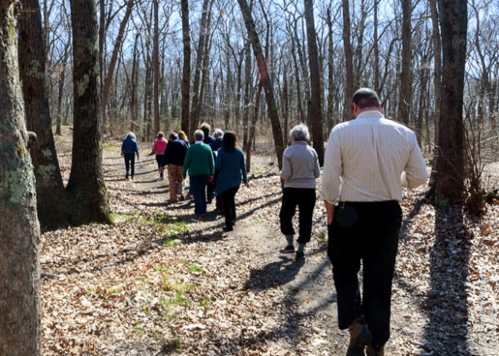
Susan Clements

April-October 2017*

One Sunday per month, 10-4:30

Spring...plants returning to life, providing nourishment and cleansing after the long winter. Summer...the beauty of the flowers and seashore plants. Autumn…gathering the harvest in preparation of winter. This program guides us through three seasons, honoring our plant allies which lovingly grace our Mothers Earth and Ocean.

Program emphasis focused on:

*Wild plant identification in different ecosystems
*Intimate monthly experiences with wild plants current to calendar
*Sustainable wildcrafting
*Herbal First Aide
*Wild foods

*Medicine making to include tinctures, salves, infused oils, liniments, teas, oxymels, syrups
*Digging roots
*Formulation
*Medicinal actions and terminology of herbs

*Developing a spiritual and intuitive relationship with the plants
*Doctrine of Signatures
*Elemental Signatures
*Flower Essences
*Seaweed
*Natural skin care

This program will provide a foundation for a student to: identify and work with a variety of local, non endangered wild plants, make simple medicines for self and family, and proceed forward into additional studies if so desired.

Program will be held in Southern RI, close to seaside, in fields and woods, all supporting varied and numerous plant species. Class size is limited to 10 individuals, with a minimum of six participants. A Certificate of Completion of Level 1 will be awarded providing students meet program requirements.

Registration Information: Cost of this program is $775. A $200 non-refundable, non-transferable deposit is required to hold a space. This fee includes all field trips, handouts, materials for hands-on projects during class. It does not include recommended books (we use two for class), materials for products made outside of class, or meals. Remainder of program fee is due by first class date. Deposit for program should be made payable to Susan Clements, and sent to 330 Ten Rod Rd., North Kingstown, RI 02852.

Program Refund Policy: After first weekend, 50% of tuition may be refunded. After second weekend, 25%. If program is cancelled prior to start date, all deposits will be refunded.

*More information: Please call Susan at 401-369-4297, web Earthoceanherbals.com, on Facebook via Earth Ocean Herbals & Wellness, or email susan.e.clements@gmail.com. Dates: 4/23, 5/13, 6/18, 7/9, 8/13, 9/17, 10/15

SUSAN CLEMENTS has been a practicing Herbalist since the 1980’s, is a licensed holistic Esthetician and Reflexologist. The exploration and identification of local wild plants, combined with a deep connection to the healing ways, led her to a deep passion for educating and supporting others on their wellness journeys. For 16 years she was the original owner and visionary of The Herb Wyfe, formerly in Wickford, RI, has led numerous herbal apprenticeship programs and taught at various centers around New England. She has been been NE regional educator for Herb Pharm and MyChelle Dermaceuticals, and currently maintains a practice in North Kingstown, RI seeing clients for wellness consults, holistic skin care and reflexology.

