Solana Beach ECO Rotary Club
visits Cambodia
(sponsored sanitation project)

This past November four members of the Solana Beach ECO Rotary Club visited the latrine construction project the club had sponsored in Cambodia. Dick and Lynn Stevens, and Carl and Andi Kosnar were in the Khos Khel region South of Phnom Penh along with members of the Cache Valley Morning Rotary Club of North Logan, Utah.

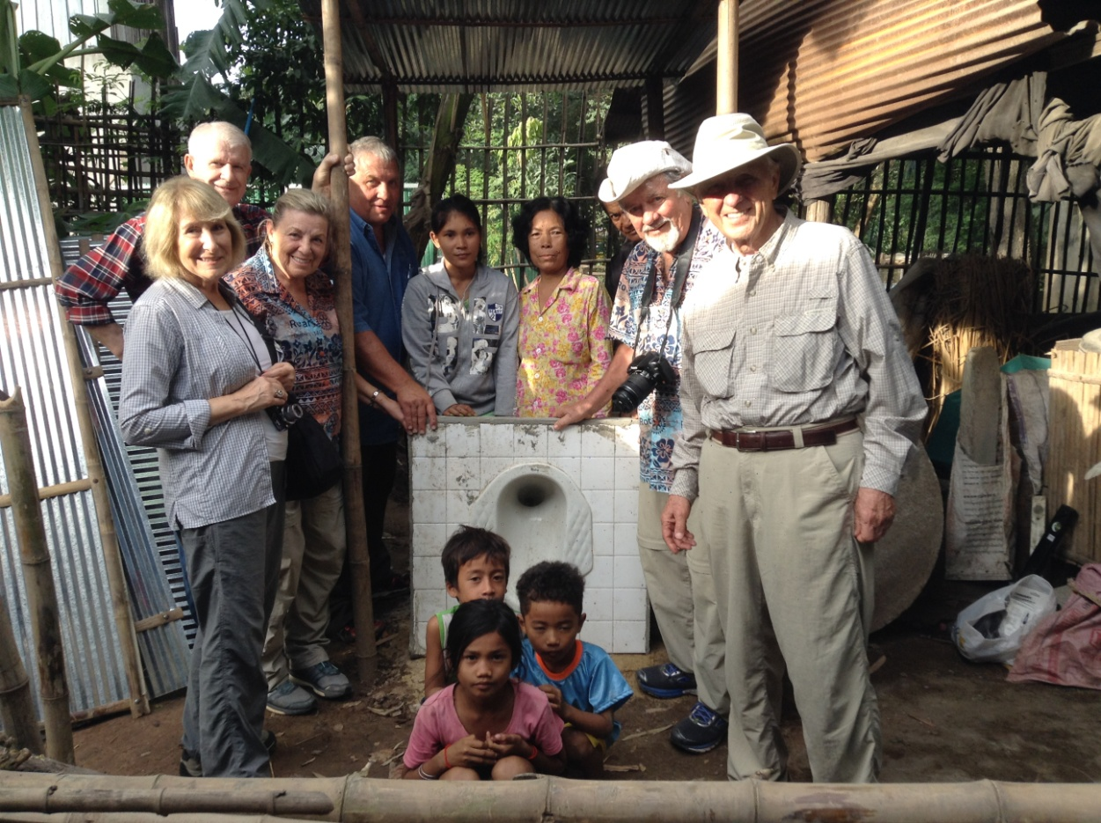
Cache Valley Morning & Solana Beach ECO Rotary Club members

The latrine sanitation project is coordinated by Latrines For Life, a local San Diego non-profit organization, in partnership with the Cambodia NGO, Solidarity Fund for Rural Development (SFRD). Several Rotary clubs in District 5340 have sponsored latrines through this program. While in Cambodia the Solana Beach ECO Rotary members visited not only their own sponsored project, but also that of the Rotary Club of Valley Center. Each recipient family receives a recognition plaque mentioning the sponsoring club.

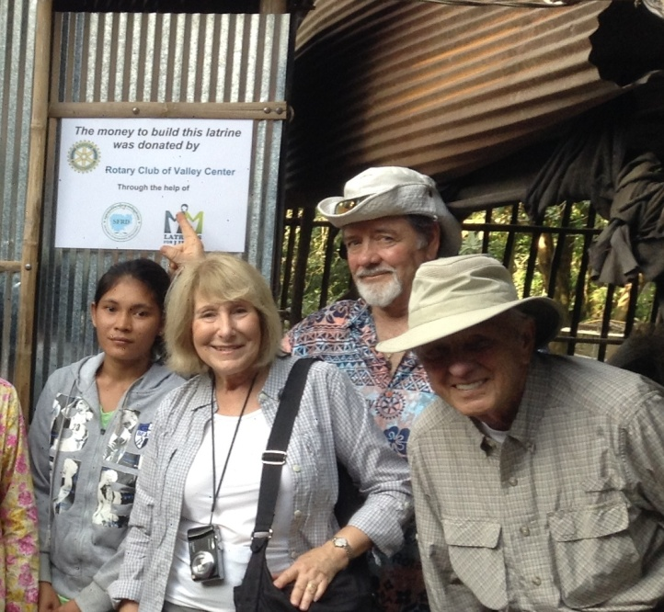
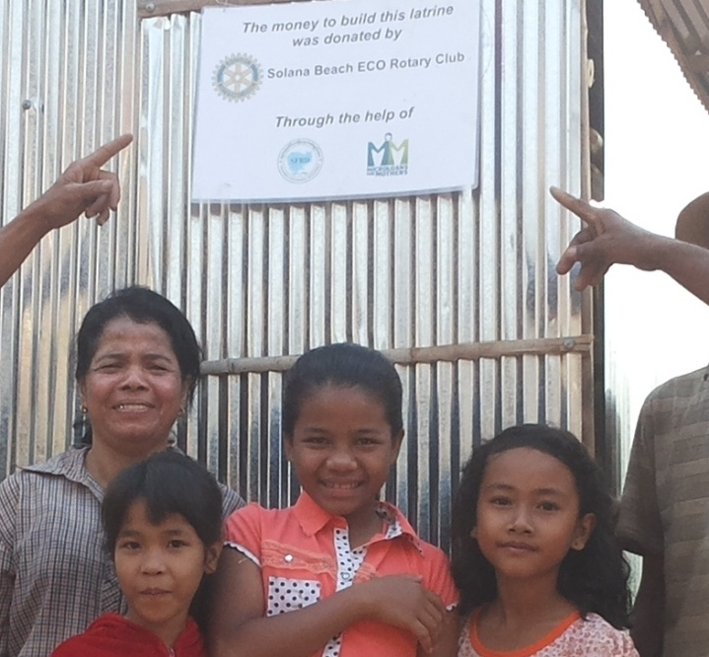
Solana Beach ECO Rotary Club Sponsored Rotary Club of Valley Center Sponsored

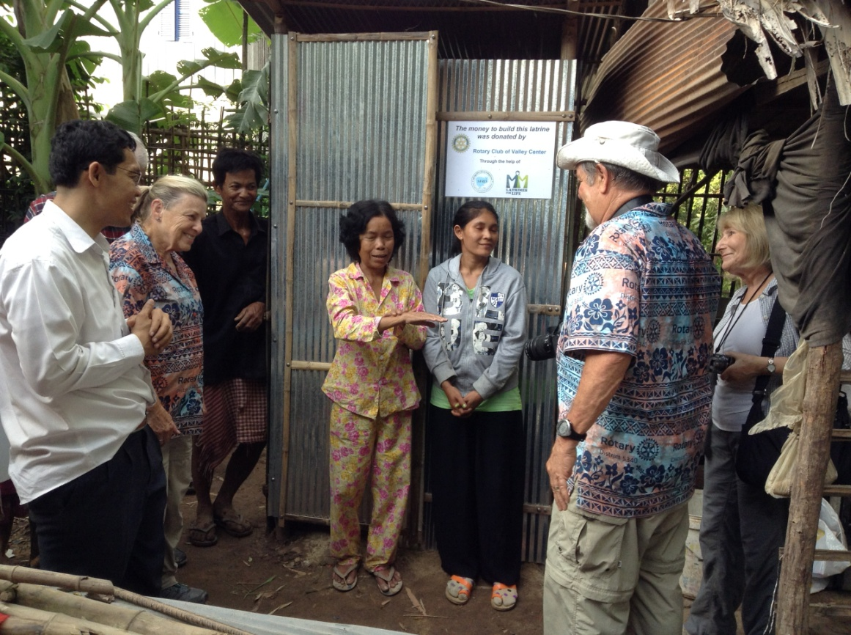

Above Mrs. Hem Kor of the recipient family thanks the members of the Solana Beach ECO club for their donation, as SFRD director, Suy Leang (white shirt) looks on. In the progress report prepared by Leang, Mrs. Hem writes, "We are very excited to meet you so happy to get the latrine from our program.......My family is living in the rural area cannot afford this without your donation, your fund is making a great change in our family. You are ALL bringing the hope to our family and we will remember your gift today and forever!"
CAMBODIA SANITATION PROJECT

Good sanitation is not the norm in rural Cambodia where old habits of poor hygiene are still wide spread. The result is the contamination of streams and soils, the spread of disease, high rates of infant and young child mortality, and heavy caseloads of diarrhea and other infections.
Latrines For Life provides latrines for many such poor rural families in Cambodia. The latrines are a "double-pit" system with an attached ceramic squatting base surrounded by a simple enclosure. The family makes the commitment to fund 6% of the cost and assist with the construction. For each latrine an inexpensive "Tippy-tap" soap hand washing station is added that provides "running water" for the washing of hands. Construction management is done through partnership with an NGO in Cambodia, Solidarity Fund For Rural Development (SFRD).
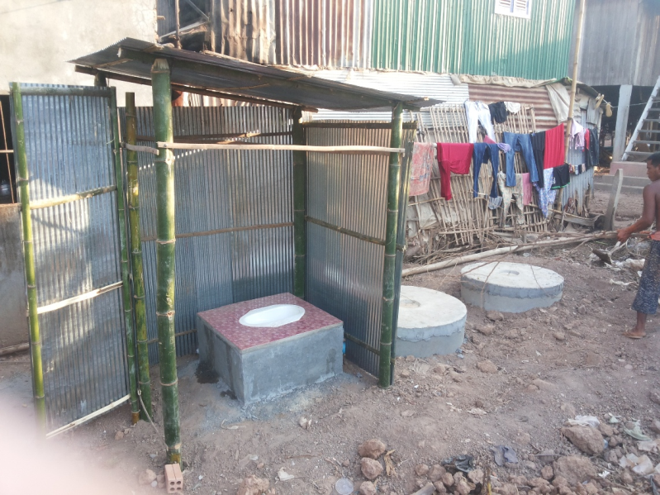

Double-pit design
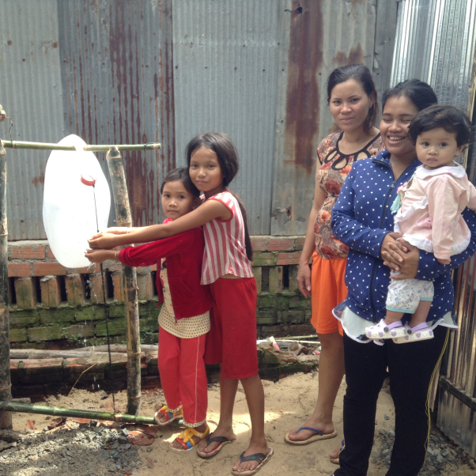
Tippy-tap hand washing

Latrines For Life has received donations from several District 5340 Rotary Clubs that recognize the vital need for latrines and soap hand washing stations in the rural areas of Cambodia where old habits of poor hygiene, of using open fields in elimination of body waste, are still wide spread. According to the World Bank's Sanitation program, and other studies, only about 17% of Cambodian rural poor have access to improved facilities, and among the very poor fewer than 5% have access to a decent toilet facility.

Other Rotary clubs can easily contribute to help alleviate this problem. Visit the Latrines For Life website at www.latrinesforlife.org or contact the director, Niels lund, at nlund@latrinesforlife.org.

