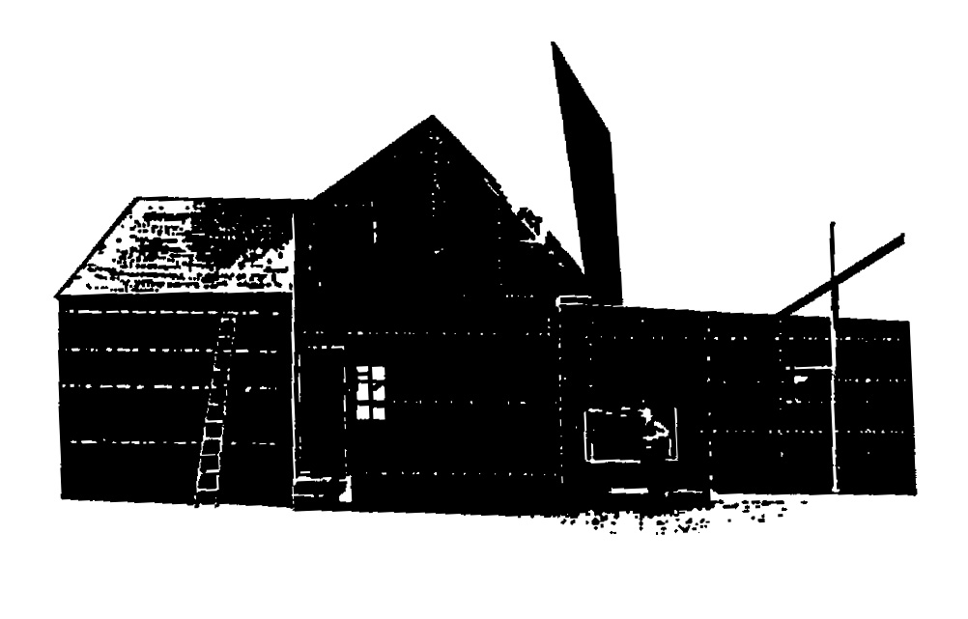
37th Black Maria Film Festival Tour - 2018
Capri Theatre, Montgomery, Alabama
Saturday May 19th, 3:00PM

Black Maria Film Festival Introduction

Theatrum Magicum (Magical Theater) – Narrative
23 min. by Marcin Gizycki, Warszawa, Poland
Inspired by the short plays of the eccentric Count Jan Potocki, author of the famous novel Manuscrit trouvé à Saragosse, “Theatrum Magicum” tells the story of a magic show performed at the end of the 18th century by a magician and his troupe. The idea for the film came to Marcin Gizycki in 2007, nearly 100 years after the great cinematic pioneer George Méliès made his own “Theatrum Magicum.”

Dandelion – Animation
3 min. by Lisa Talentino, Torino, Italy
The double time Bourrée dance is full of romantic meaning. Dancers come close, reaching towards each other, then they turn away, find and avoid each other, without ever touching. The dandelion flower is a spring oracle. The legend says that lovers give their wishes to the flower and then blow them away to make them come true. “Dandelion” is an antique dance and courting ritual – a dandelion flower to blow desires.

Atlantic City Character Study – Documentary
29 min. by Billy Linker and Ben Carey, NY, NY
An eerie microcosm of Trump's America, Atlantic City is in the midst of an identity crises. Once the most popular family vacation destination in the United States, the city has slid into a dystopian version of its former self with beachfront property plummeting amidst vacant lots and deserted high-rise hotels garishly positioned against the coastal backdrop. As the city tries in vain to regain its footing, residents are left living in the broken shell of a city. This film provides an unfiltered look at what it means to live in a once iconic American resort town, surrounded by the glory of the past as it struggles towards an unknown future.

Phototaxis – Animation
7 min. by Melissa Ferrari, Val Verde, CA
“Phototaxis” draws parallels between Mothman, a prophetic and demonized creature in West Virginia lore, and Narcotics Anonymous, the main treatment program in West Virginia’s addiction epidemic. Rooted in nonfiction, this animated film contemplates synchronicity and the role of belief systems in perception; the tendency to assign supernatural meaning to tragedy and the unknowable; anonymous and apocryphal oral histories; and the moth to the flame. To visualize these narratives, natural materials and pastel-on-paper palimpsest animation are woven together using a multiplane and analog overhead projection.

Lion in a Box – Documentary
4 min. by Melanie Brown, Los Angeles, CA
This first-person documentary recounts one woman's military training, and the battles she endured to achieve her goals. Created in a short film class for veterans, Brown uses voice-over, photo montage and animation, to tell her story. “Lion in a Box” shines a light on the traditional definitions of sacrifice and combat.

Little Potato – Documentary
14 min. by Wes Hurley, Seattle, WA
“Little Potato” is an autobiographical film about a boy growing up gay in the Soviet Union, his mother Elena, and their adventurous escape to America. Struggling to survive in the USSR during the turbulent years of Perestroika, Elena and her son escape into a world of pirated American movies. But soon the movies are not enough, homophobia is rampant in the Soviet Union, and Elena decides to become a mail-order-bride and discover America for herself and her son. Saving its most unexpected twist till the end, this is an inspiring and timely story of two immigrants taking on the American Dream.

The Driver is Red - Animation
15 min. by Randall Christopher, San Diego, CA
Set in Argentina in 1960, this true crime documentary follows the story of secret agent Zvi Aharoni as he searched for a mysterious man named Ricardo Klement. What he discovered in the remote outskirts of Buenos Aires would send shockwaves around the
world.

Mama - Narrative
10 min. by Mert Canatan, Valencia, Spain
Life can change in a blink of an eye, a thin line separates heaven from hell. You may never know when you have to leave your safe zone until you get the hit and everything that used to be there, is gone in the next minute. This is the story of a Syrian refugee girl, who crossed that thin line and saw her entire life altered forever.

Sans Chlorophyll – Animation
3 min. by Phil Davis, Baltimore, MD
A short experimental film created using hundreds of scanned and photographed leaves animated and choreographed in time to an original banjo score by the filmmaker.

Thomas A. Edison Media Arts Consortium - Black Maria Film Festival

The films that become the centerpiece of the Black Maria Film Festival honor the vision of Thomas Edison, New Jersey inventor and creator of the motion picture. It was his New Jersey studio, the world’s first, which he called the “black maria” from which we take our name. The Festival reaches out to diverse audiences in diverse settings including universities, museums, libraries, community organizations, and arts venues. The cutting edge, cross-genre work that makes up the Festival’s touring program, has been traveling across the country every year for decades.

We focus on short films – narrative, experimental, animation, and documentary - including those, which address issues and struggles within contemporary society such as the environment, public health, race and class, family, sustainability, and much more. These exceptional works range from animation, comedy, and drama to the exploration of pure form in film and video and are the heart and soul of the festival.

www.blackmariafilmfestival.org, office: 201.200.2043
info@blackmariafilmfestival.org

Festival Jurors for the 2017 Festival Tour

Henry Baker works in video, television, film, sound, print and interactive media. In 1987, he founded his video company BXB in NYC. Clients include HBO, Cinemax, SONY, Panasonic, Four Seasons Hotels and many others. At BXB he received numerous awards for his creative work in video and television including: Houston International Film Festival, Broadcast Designer’s Association, ACE and IFTA awards.

His work has been screened at various locations including: Leslie Lohman Gallery, National Museum of LGBT History, Simon Watson Gallery, Vancouver College, Hallwalls, Intermedia Arts Center, Matrix Gallery et al. His works are in the collections at The NY Public Library and the Everson Museum. He administered the Video Artist Grant Program at Synapse Video Center, Syracuse NY, serving ultimately as Director of the Center from 1978-81. At Synapse he also curated their video exhibitions and distribution programs. He served as a panelist at the National Endowment for the Arts, the WNET-TV Lab, the Broadcast Designer’s Association and the Ithaca Video Project. In 2015, he served as a pre-screening juror at Black Maria Film Festival. Henry has given lectures at the International Television Society, Video Free America, Greenwich High School, Boston Film and Video Foundation and the San Francisco Art Institute. He co-founded the New York State Media Alliance.

A consummate sound aficionado, he produced regular radio broadcasts for over a decade at WAER-FM and WONO-FM. Henry has worked in film since the 1950s and video since the 1970s. He received a BFA in Media Communications and an MFA in Synaesthetic Education at Syracuse University. He later received an MS in Information and Library Science at Pratt Institute. He is currently Chief Creative Officer at BXB LLC, Washington DC.

Margaret Parsons is curator of film and media programs at the National Gallery of Art in Washington DC. Besides an international film exhibition program, the Gallery maintains an archival collection of documentary media on the arts. Parsons has organized media events for other organizations including the Corcoran Gallery of Art, American University, the National Archives, and the Smithsonian Museum of American History. She has served as a trustee for film organizations ranging from the Robert Flaherty Film Seminar to CINE, and she has been on the editorial boards for The Moving Image and the Getty Trust’s experimental Art on Film in association with the Metropolitan Museum of Art. She has served as festival juror for numerous international film festivals including Washington, Nashville, Syracuse, Turin (Italy), and Tulcea (Romania).

Currently, Parsons is a member of the advisory board for the Washington DC Environmental Film Festival and curator for Glimmerglass Film Days, a festival she founded in central New York State. She has recently received awards for her work in film preservation from the governments of France, Georgia, and the Czech Republic, and in the U.S. has been the recipient of awards from the Black Maria, the Washington DC Independent Film Festival, and from Women in Film and Video. Her other interests include photography (35mm film and dark room), as well as naïve and outsider art which she collects. Her writing has been published in the journals Raw Vision, Folk Art, The Folk Art Messenger, New York Folklore, Curator, and The Moving Image.

The Consortium is grateful for generous funding and support from:
New Jersey State Council on the Arts;
The Hudson County Office of Cultural and Heritage Affairs and Tourism;
New Jersey City University, Jersey City, NJ;
WithumSmith+Brown;
The Edison Foundations;
Monster Remotes;
Mass Art’s 2-year MFA in Film and Video;
Private foundations, corporations, and private donors.

And most importantly, viewers like you!

Please visit our website and click on “Donate” to support the Black Maria Film Festival. www.blackmariafilmfestival.org

