M & M MARS
PROMO
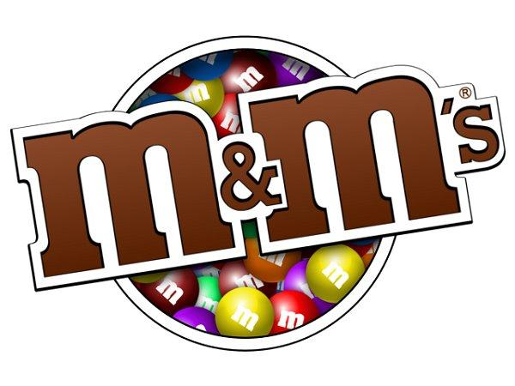
$5 OFF PER BOX 48CT
401398 M&M PEANUT 48CT
405720 SNICKERS 48CT.
$4 OFF PER BOX 36CT
406231 THREE MUSKATEER 36CT 405464 TWIX CARAMEL 36CT
406629 MILKY WAY 36CT 401320 M&M PLAIN 36CT
405475 TWIX DARK 36CT
$2 OFF KING SIZE
405746 SNICKERS KING 406232 THREE MUSKATEER KING
405758 SNICKERS ALMOND KING 401331 M&M PLAIN KING
401422 M&M PEANUT KING 25981 M&M PEANUT BUTTER KING
405472 TWIX CARAMEL KING 13615 TWIX PEANUT BUTTER KING
407361 MILKY WAY KING 030859 SNICKER P.B. SQUARE KING
401490 M&M ALMOND KING 401335 M&M CRISPY KING
417742 M&M MINI MEGA TUBE 24CT 405751 SNICKERS EXTREME TO GO KING
033928 MILKY WAY SIMPLY CARAMEL KING 401510 M & M CARAMEL KING
401495 M & M COFFE NUT KING 401530 M & M STRAWBERRY PEANUT KING

$1 OFF STANDARD 24CT
026617 MILKY WAY SIMPLY CARAMEL 24CT 028613 M & M PRETZEL 24CT
038059 M & M DARK MINT 24CT 401325 M & M CRISPY SINGLE 24CT
401455 M & M PEANUT BUTTER 24CT 401465 M & M WHITE CHOCOLATE 24CT
401470 M & M CARAMEL 24CT 405022 SNICKERS ALMOND 24CT
406611 MILKY WAY MIDNIGHT 24CT 417741 M & M MINI TUBE 24CT
401475 M & M WHITE SHARE 24CT 405480 TWIX WHITE SHARE 20CT
405470 TWIX WHITE STANDARD 20CT 405755 SNICKERS PB CRISPER SHARE

05-19-18 thru 06-23-18

