Advent FAITH Steps in Action
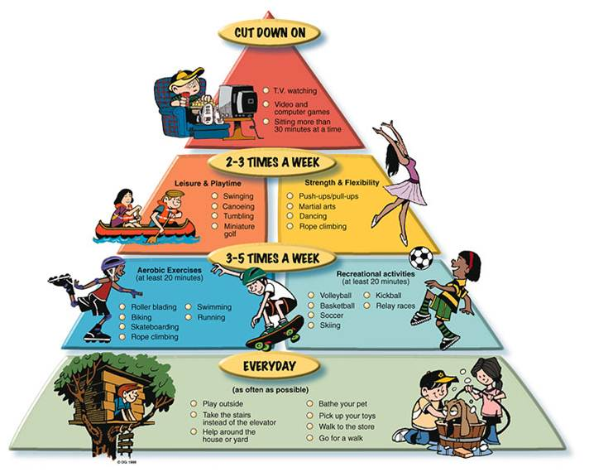
St. Julian’s is offering Walking to Bethlehem during Advent as an opportunity for each of us to walk the 100 miles that Mary and Joseph walked from Nazareth to Bethlehem. The walk is designed to increase our physical, spiritual and emotional health.
The walk is our Faith Steps in Action and a supplement to our Living Compass Advent Meditation booklets – Living Well Through Advent 2018, Practicing Generosity with all your Heart, Soul, Strength and Mind. Living Compass is a program that offers the opportunity for us to pause and check our bearings and check the direction in which we are heading in different aspects of our Life. We will receive more information about Living Compass in the months to come.
To make this easy and fun, we have prepared some helpful hints.
2,000 FAITH steps equal one mile and takes about 15 minutes to complete.
Alternative steps can be attained so that every 15 minutes of any kind of exercise equals a mile.
Exercise also includes chair exercises or 15 minutes of meditation and prayer.

FAITH Steps are:
Focused
Action Oriented
Inspired
Time-Specific
Heartfelt and Honest

An additional resource is Christ Walk: A 40-Day Spiritual Fitness Program by Anne Fitch Courie. The book is available as a Kindle Edition and hard copy. There is also a companion book – A 40 Day Spiritual Journey for Tweens and Teens (Ages 14 and up). You may select different biblical routes to complete through walking, biking running etc. while reading a reflective passage on health and spirituality each day of the journey. We encourage each of you to consider an Advent practice that works well for you and your family.
If you walk, please let us know about your progress, and comments. Patty Ely

