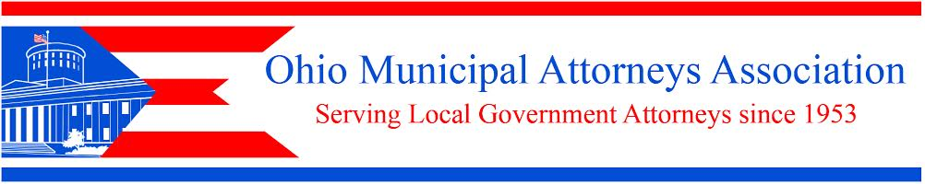
175 South Third Street, Suite 510, Columbus, Ohio 43215
Phone: 614-221-4349 Fax: 614-221-4390

Thursday, June 21, 2018 - 10:00 to 11:00 a.m.

Small Cell Wireless Service &
Placement of Facilities in the Public Way (HB 478)
Presenter – Gregory J. Dunn, Ice Miller LLP

PLEASE PRINT:

Municipality_______________________________________________

Address __________________________________________________

_________________________________________________________

Name of Law Director/Solicitor/Official___________________________

Email____________________________________Phone______________

The email you indicate above is the email to which I send all correspondence – info about how the webinar works, the power point slides and the webinar email invitation.

(Notice: We always email registration confirmation and info about how to enter the webinar at the latest by 5:00 p.m. the day before the webinar. If you do not receive this confirmation let us know.)
COST: $100 per registrant (limit of 50 registrants per webinar session)
Your municipality counts as 1 registrant. You may have as many city officials (attorneys, mayors, council members, etc.) attend as you wish, for this $100 fee. (Mail your check, made out to OMAA, to our offices. If we should bill someone besides the municipality please also indicate the name and full address of that entity on this form.) You may email or fax the registration form to us.) (For our records we appreciate your advising us, at cgrant@omlohio.org, how many officials you plan to have participate.)

