WRITTEN TESTIMONY TO THE HOUSE STATE AND LOCAL GOVERNMENT COMMITTEE
HB 633
June 13, 2018
Chair Anielski, Vice Chair Hambley, Ranking Member Holmes, and members of the House State and Local Government Committee, thank you for the opportunity to testify in support of HB 633.
HB 633 would prohibit those who own or control private property within a municipality’s jurisdiction from littering on that property. The Ohio Municipal League is supportive of this legislation due to its intention of dealing with a serious problem many municipalities face: urban blight.
The issue of urban blight negatively affects an entire local community. When properties are littered with trash and debris it creates more than just an unattractive property. Property values can drop while health hazards rise as these littered properties become breeding grounds for rodents or contain other types of dangerous pollutants. In additional to the financial impact on the community, these properties pose a threat to the general health and safety of the community.
We appreciate that Rep. Boggs and Rep. Miller have recognized the problem these properties pose to municipalities and that the bill they have written is designed to criminalize a failure to clean litter from a property. This bill would give municipalities the tools they need to effectively address urban blight within their jurisdictions, helping them create a safe, healthy and prosperous community. We urge your support for this bill.

Thank you for your consideration.
Sincerely,
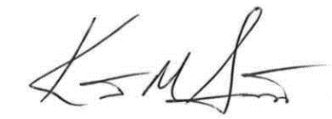

Kent Scarrett
Executive Director
Ohio Municipal League

