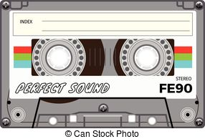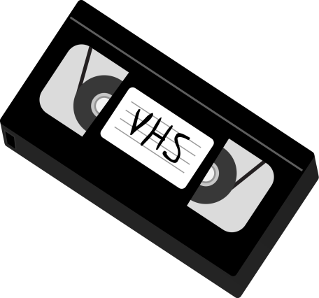

Do you have any old

Cassette Tapes or VHS Tapes

You’d like to donate?

The Dance Committee is collecting them to make some

Like Totally Awesome 80’s

decorations for the Middle School Dance

Please bring your donations to the

Drop Box

located in the office

Beginning on **Tuesday, September 5th**

**(They will NOT be returned)**

