[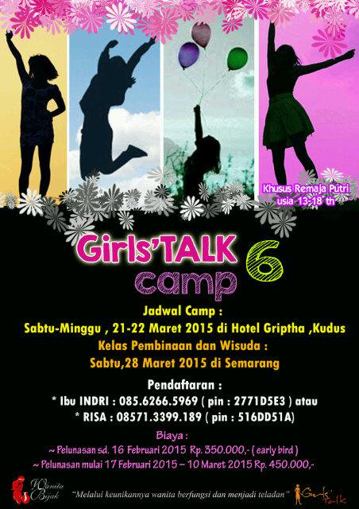](https://www.google.com/url?sa=i&rct=j&q=&esrc=s&source=images&cd=&cad=rja&uact=8&ved=0ahUKEwiMn7uezv7SAhUBLSYKHaSYDOcQjRwIBw&url=https://twitter.com/girlstalksmg&psig=AFQjCNETD9fVeIbir66H-eEQNoTi7hqfsA&ust=1490976384893079)

**Girl Talk Camp**

**Female empowerment camp for grades 6-8**

**June 5 – June 9, 9:00am-12:00pm ∙ 8768 Quarters Lake Rd, Baton Rouge, La 70809**

**Identity and relationships are the heart and soul of Girl Talk Camp. Camp offers a safe space where girls can learn who they are and a safe environment to find connection and a sense of belonging. Campers will experience activities and group discussions that create a safe, trusting environment to learn more about their selves and each other. We will focus on social awareness, identity development, building self-confidence, body image, self-compassion, developing empathy, and navigating the transitions of adolescence and early adulthood. Girls will learn to celebrate their unique selves and foster healthy friendships. Experiential activities such as art, music, yoga, meditation, and psychodrama will be used to enhance the group’s experience. All materials are covered in the camp fee.**

**Girl Talk will be led by former teacher and certified Mental Health Therapist, Tara Dixon. Tara has 11 years of classroom experience, behavior interventions, and counseling teenagers and their families.**

**Girl Talk will be limited to 12 participants. Additional dates and times may be opened as needed.**

**Please register at** [**www.healyourlifecounselingllc.com**](http://www.healyourlifecounselingllc.com) **or email Tara at** [**tara.hylc@gmail.com**](mailto:tara.hylc@gmail.com)**.**

**Girl Talk Camp fee is $100 for one week and includes all art supplies and healthy snacks daily.**