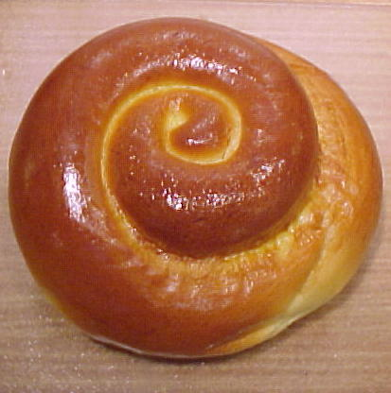
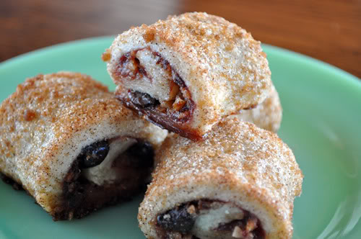
HADASSAH’s Annual
CAKE & CHALLAH SALE
From
CHERYL ANN’S

^{Item} | ^{Qty} | ^{Price} | ^{Total}
^{Plain Challah} |  | ^{10.00}
^{Raisin Challah} |  | ^{11.00}
^{Chocolate Bubke Loaf} |  | ^{16.00}
^{Cinnamon Raisin Bubke Loaf} |  | ^{13.00}
^{Ruggalach (Assorted)} |  | ^{18/lb}
^{TOTAL:}

Orders (with checks) must be received by SEPT 10!
***** Please select your Pick up Location *****
Pick up Details:
Tuesday, Sept 19 from 4-6pm
________ ACTON: Congregation Beth Elohim
________ CHELMSFORD: Congregation Shalom

NAME____________________________________PHONE__________________
Please make checks out to Nashoba Valley Hadassah
MAIL to: Caren Boroshok - 1 Magnolia Drive, Westford, MA 01886
Send questions to anne.rosenberg@rcn.com or carenb@yahoo.com

