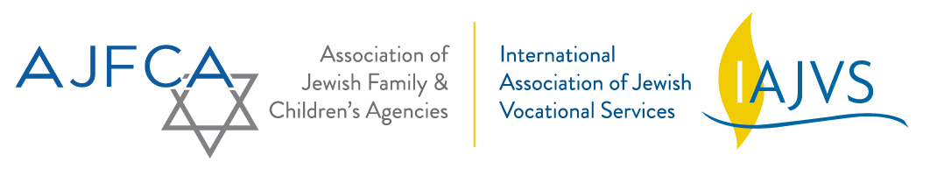

Please help get the word out at your agency for this upcoming webinar.

Topic: JVS Boston’s Re:Launch Event

Description: JVS Boston designed Re:Launch, an event that combines large group sessions, networking opportunities, and small clinics to assist clients with REfocusing, REaffirming and REnewing their careers. Re:Launch was created to address both the tactical and emotional hurdles associated with being unemployed. The event has been specifically targeted to the long-term unemployed population, but anyone job-seeking is welcome. The discussion will include the research that inspired this event, as well as the format, frequency, and content to help you to decide if hosting a RE:Launch-style event could be right for your organization.

Speaker: Katherine Kent, Career Navigator/Communications Associate, JVS Boston

DATE/TIME: Wednesday, December 14th at 1pm eastern time
Register now:
https://attendee.gotowebinar.com/register/2154515402768785666

