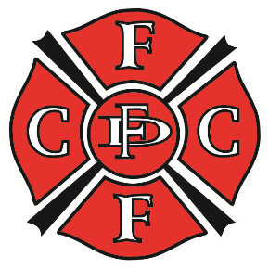
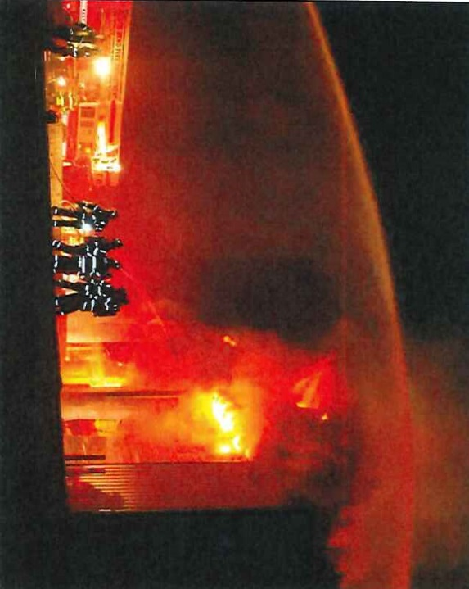
Firefighterclosecalls.com

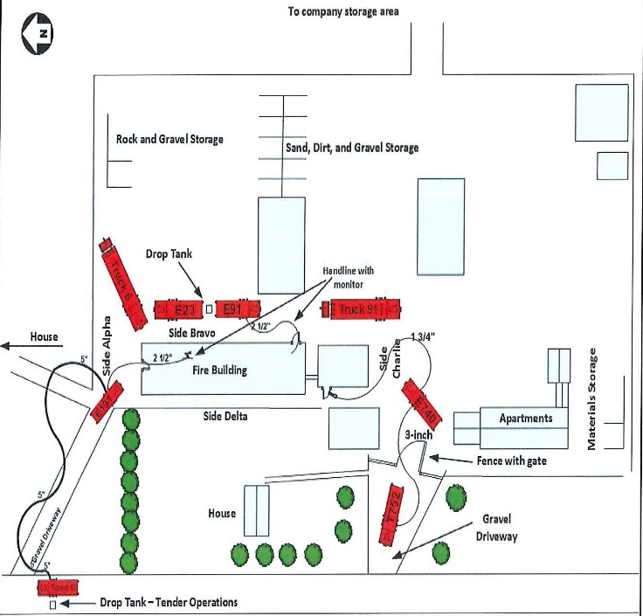
Read the entire report at:
https://www.cdc.gov/niosh/fire/pdfs/face201418.pdf

Contributing Factors
- Incident Management
- Incident action plan and assessment
- Offensive actions in a defensive fire
- Communications
- Mutual aid
- Collapse/exclusion zones and situational awareness
- Lack of a Safety Officer

Just Released
NIOSH FF Fatality Report 2014-18
On August 5, 2014, Assistant Fire Chief Jamie Middlebrook of New Carlisle (IN) FD died in the Line of Duty after being trapped under a roof collapse while fighting a fire at a commercial storage building. Heavy fire was showing through the roof on Side B and Side C of the structure when the first-due company arrived. After a brief conversation with the assistant fire chief (victim), the Incident Commander decided to open the doors on the north end (Side A) of the building to set an unmanned ground monitor to keep the contents of the building cool.
A defensive fire attack was initiated - however - the Assistant Chief was one of 3 Firefighters who entered Side A of the structure to stretch a 2½-inch hoseline to protect equipment and acetylene. Command was unaware of their decision to enter.

The fire was already in the overhead truss system above the Assistant Fire Chief and the Firefighter, and the fire was likely concealed by the ceiling. As the third Firefighter got to the overhead door, a loud crash occurred. The truss system failed and the ceiling and roof assembly collapsed on the Assistant Fire Chief and Firefighter. Chief Middlebrook was killed by the collapsing truss system. The Firefighter, who suffered a broken leg, was able to crawl under some equipment before being rescued by a Rapid Intervention Crew.

