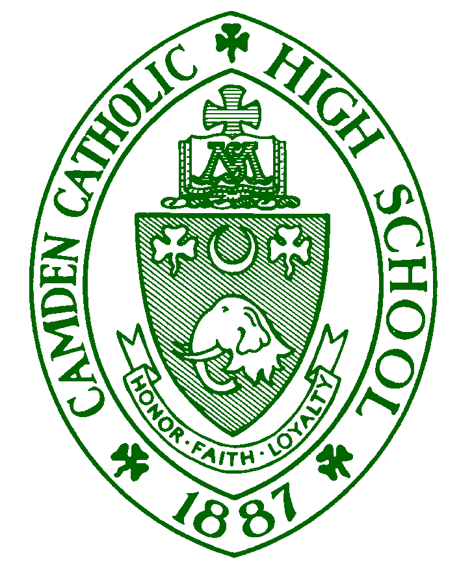
FOR IMMEDIATE RELEASE

Press contact: Kate Bieg 856-663-2247 ext. 134/cell 610-730-1532
kate.bieg@camdencatholic.org

John DiCarlo Named Head Swim Coach for Camden Catholic High School

(Cherry Hill, NJ) June 11, 2018 — The administration of Camden Catholic High School has announced the hire of John DiCarlo as head swim coach. Coach DiCarlo is a graduate of Bishop Eustace Preparatory School, where he was a member of the 2007 State Championship Boys Swim Team. He attended Catholic University where he was a member of the Cardinals swim team for one season. He also is a record-holder at Woodbine Swim Club and Pomona Swim Club, where he qualified for the Tri-County Championships for 11 consecutive years.

“Coach DiCarlo’s passion for the sport of swimming is evident. He is a lifelong student of the sport who is excited to share his experience as a state champion swimmer with our student-athletes. His leadership qualities, and competitive and enthusiastic attitude are certain to invigorate our program.” said Derrick Levine, Director of Athletics. Former coach Mike Parker (Bishop Eustace) said about DiCarlo: “I have known John for over 15 years and had the pleasure of coaching him for four years in high school at Bishop Eustace. John will bring a level of commitment, competitiveness, excitement and enthusiasm that will be a breath of fresh air for the Camden Catholic swim team. John understands high school swimming and I am excited for the CCHS swim program.”

“I am thankful for the opportunity Camden Catholic High School has given me to coach young student athletes at such a prestigious school,” said DiCarlo. “I look forward to bringing much success back to the Irish program. As a man of great faith, I share the ultimate mission Camden Catholic teaches their students each and every day. When I looked at the history of the program, I saw great potential, and a unique opportunity to share my knowledge and passion for the sport, while building a winning tradition. I look forward to bringing championships back to the Irish program and helping each student athlete achieve their individual goals,” said DiCarlo.
# # #
Facebook: www.facebook.com/camdencatholic
Twitter: www.twitter.com/camdencatholic and @camdencatholic
Instagram: @camdencatholic
Flick’r: www.flickr.com/photos/camdencatholic
YouTube: www.youtube.com/camdencatholic1887
About Camden Catholic High School: South Jersey’s oldest Catholic co-educational college preparatory school, founded in 1887, is a suburban, college preparatory, day and boarding school. It educates young men and women spiritually, academically, socially, and physically in a faith community to develop as life-long learners and leaders in a global society in the Catholic tradition. For more information visit www.camdencatholic.org.

