Are you highly motivated and interested in the fire service?
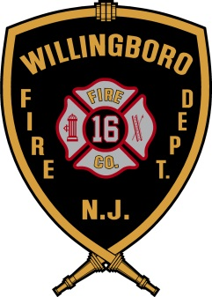
Then you need to join us this summer at the…
WILLINGBORO FIRE DEPARTMENT
YOUTH FIRE ACADEMY CLASS #3
July 10-21, 2017
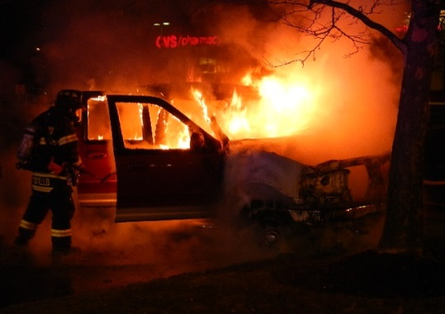
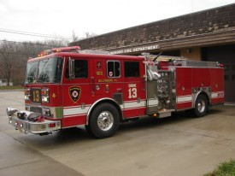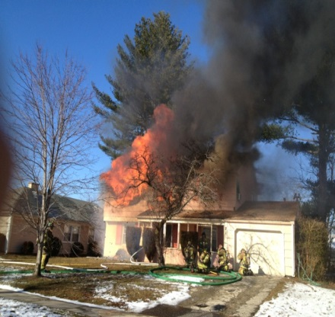

The Willingboro Fire Department is seeking students, ages 14-17, who are interested in a career in the fire service to participate in the Youth Fire Academy. This two week fire academy style training program is designed to expose you to the many different aspects that can be found in the fire service community. While at the Academy, you will participate in a variety of activities that actual Fire Recruits participate in as part of their training. Some of the activities you will learn about and participate in include:

- Fire Behavior  - Firefighting Tactics  - Vehicle Extrication/Jaws of Life  - First Aid/Emergency Medical Services  - Fire Scenario Demonstrations  - Physical Training  - Military Style Drills  - Teamwork & Leadership  - Trips to Various Agencies  - AND MUCH MORE!!! | For an application, please visit our  website at: www.willingborofire.org or  email request to: rcostello@willingboronj.gov  Willingboro Fire Department  Youth Fire Academy  398 Charleston Rd.  Willingboro, NJ 08046  (609) 871-7476 ext.1089  PLEASE NOTE: All applicants will be required to submit a completed application prior to the start of the Academy. A background check will also be conducted on all applicants.
APPLICATION DEADLINE IS JUNE 16, 2016

