UMA College of Arts and Sciences
and UMA Senior College present
Climate Change - How Maine Will Cope
2 pm Sun., Oct. 30 Jewett Hall, Augusta
The prospect of climate warming will present significant problems for the future economy of Maine and the health of its people. The speakers are highly qualified to help us understand the cause and effects of global warming and what we can do about it. Ivan Fernandez is associated with the Institute on Climate Change at UMaine and co-author of the report “Maine’s Climate Future.” He is prepared to discuss planet warming and how we can mitigate its effects and make the adaptations required in the future. Andrew E. Smith, State Toxicologist in Maine’s Center for Disease Control (CDC), will discuss dealing with health threats such as excessive heat and disease-bearing ticks.
We welcome James Conneely, our new UMA President and a leading consultant on education for students of all ages, who will comment on UMA’s theme for this academic year: Climate Change.
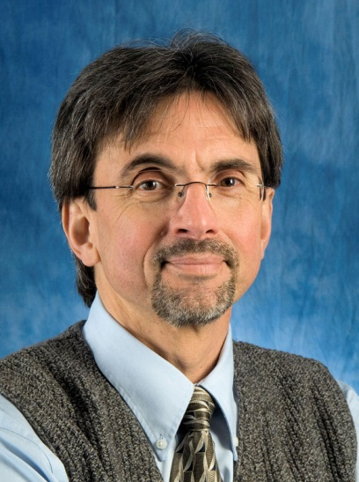
Prof. Ivan Fernandez’s cur-rent research focuses on soil processes in forested eco-systems [Maine’s north woods], with emphasis on critical environmental issues such as climate change.
Dr. Andrew Smith leads a team of health professionals and technical specialists. Since 2010, he has been the Principal Investigator on a federal CDC grant: Building Resilience Against Climate Effects.
Panel Moderator: Chuck Acker, FoF Chair
Forum on the Future is free!
Next: 2 pm Sun. Jan. 22, Maine’s Economy - Options & Opportunities

