Clinton W. Babcock, Bio 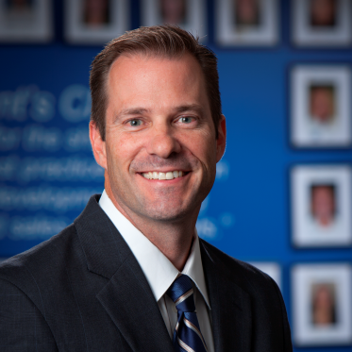
Clint Babcock, Partner with Sandler Training, has worked with CEO’s and Presidents of various companies to help them strategically build their businesses and their sales forces. He’s worked with hundreds of sales teams and thousands of sales people. To remedy today’s short attention spans, Clint’s interactive style keeps top producers of every company engaged, and learning. Clint advises his clients in four areas of the sales side of their business: Strategy, Structure, Staff, and Skills.
Clint knows that creating great leaders, managers, and sales people goes beyond techniques and encompasses a focus on behaviors and attitudes. He creates value by genuinely connecting with his clients who are committed to working at doing what it takes to grow their business and revenues. He listens to what his client’s issues and concerns are and uses his business experience, as well as the Sandler sales program of training, coaching and reinforcement to teach people an approach they may not have considered. He has a knack for delivering coaching and training to match his clients’ personality and learning style. He makes the unclear become crystal clear.
Experience
Clint's background includes top performances in leadership, management, consultative sales, revenue strategies, executive coaching, as well as training and development.
Recent Speaking Engagements
- The Vinoy Business Alliance – “Negotiating Strategies for Buyers and Sellers”
- Tampa Downtown Rotary – “The 4 S’s of Running a Business”
- Tampa Connections Charity: "Kick-off Event, Networking"
- Tampa Chamber of Commerce: "Communicating through DISC Personality Profiles."
- St. Petersburg Chamber of Commerce Entrepreneurs Academy
Day to Day
Clint keeps a busy schedule training, coaching, and mentoring his clients. Routinely, he is in front of his corporate and individual clients providing training 8-11 times per week. He fields real world scenarios for managers and sales people daily to help them become better at their professions. Some of his current clients are:
- TravelClick – A $1b hospitality technology company based in New York
- Vector Learning – An online learning and development company
- United Way of Tampa Bay – Non- profit
- Girl Scouts of West Central FL – Non-profit
- Aspire Financial – 401k and 403b record keeping company
- Premiere Executive Suites – Canadian corporate housing company
Visit his Linkedin profile for more detailed information:
http://www.linkedin.com/in/tampasalestraining
Before joining Sandler, Clint was the Vice President of National Sales for a technology training and education organization. Clint set the strategic business development direction for the company and hired management and sales positions during his tenure working for small, medium, and Fortune 500 companies. He is also the CEO of ImproveU Corporation, a sales and management recruiting company.
________________________________________________________________
Contact Information
Clint Babcock
Sandler Training and ImproveU Corp
3030 N. Rocky Point, Suite 100
Tampa, FL 33607
C. 813-361-8706
O. 813-287-1500
cbabcock@sandler.com

