Lovely 3-Story Condo, Steps from Westville Village
New Price: $119,900

This huge, bright two-bedroom, 1.5 bath 3-story 1400 sq foot condo has it all! Enjoy views of West Rock from private balcony off the large and airy living room. Also on main floor, nice galley kitchen opens onto a bright dining room. Downstairs is a large workroom/home office (could be 3rd bedroom) and attached garage. Upstairs features two large bedrooms and full bath.

Conveniently located right on Whalley Avenue, this end-unit condo at the very back of the Westgate Complex feels like a quiet bungalow, with a small garden area out front and a semi-private yard out back. At this price, owning is cheaper than renting!
Easy walk to Westville Village shops & restaurants, to Edgewood Park, to Congregation BEKI or to St. Aedan’s & St. Brendan’s. Right by Chapel Haven. Easy on/off access to route 15. About 5 min drive from SCSU, or 15 min drive from Yale.
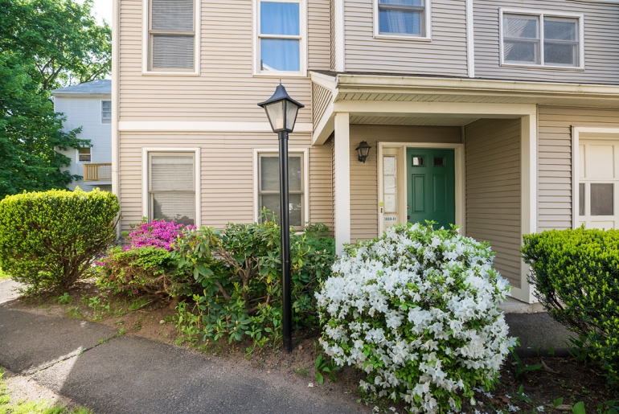 | 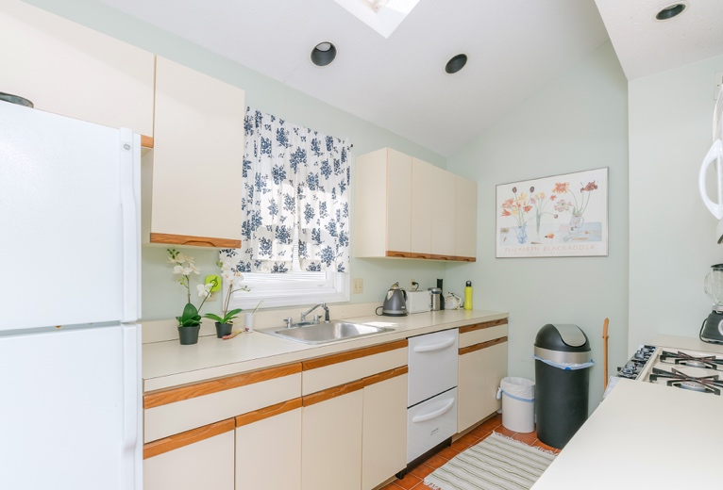
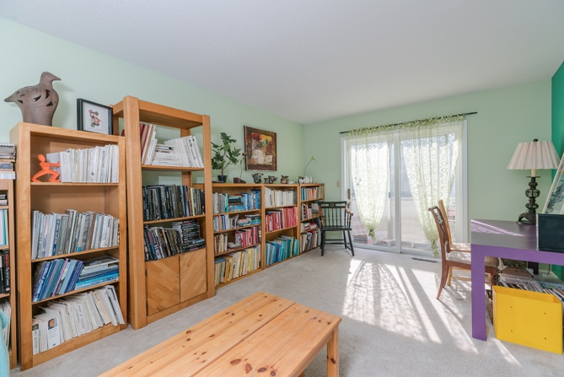 | 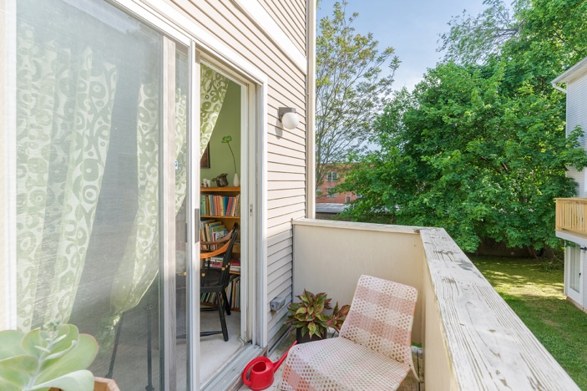
FOR MORE INFORMATION: Please contact Rebecca Weiner, Betsy Grauer Realty, 197 Bradley Street, New Haven, CT 06511 . rhweiner@sbcglobal.net, 203-687-8227.

