**BONUS CHECK ENTRY**

We will use Additional Check – Gross Up as the example, however the steps are applicable for the other check types.

**Entering in bonus checks for individual employees**

1. Select the employee from the Employee List (bulleted list icon)

cid:image001.png@01D31046.BD54C200

1. Go to: PAYROLL PROCESSING/Payroll Entry < Individual Time Entry
2. Select: +Add New on the blue bar
3. Choose from the drop down. Example - Additional Check – Gross Up
4. Select Save
5. Select the Template from the top right drop down so that BONUS appears as a column. It most cases it will be Regular or Bonus. *If you do not have Bonus listed in the Grid, select a different Template type. If you still do not see Bonus as an option, please contact Kabel Business Services as it will need to be set up.*
6. Enter in the dollar amount of the bonus: Row - Bonus   Column – Dollars

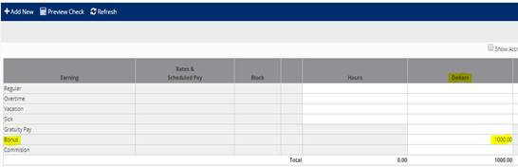

1. Select Preview Check on the blue bar. This will display what this Additional Gross Up check will look like
2. There is no save option – your entries are automatically saved.
3. When finished previewing, select the back button on the blue bar

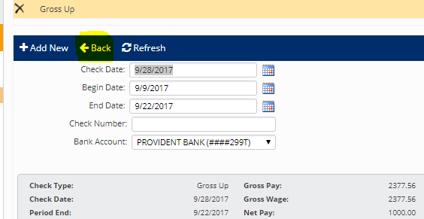

1. If you need to delete this additional check you can click on the X by the newly added check

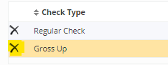

1. Click on the bullet list icon to go back to the full employee list



**Entering in bonus checks for all or most of your employees**

The Additional Check Entry Grid will allow you to enter the bonus amount for multiple employees at a time.

1. Navigate to: PAYROLL PROCESSING/Payroll Entry/Additional Check Entry Grid
2. Select the Template from the top left drop down. *It most case, the Template Type will be Regular or All.*
3. Select the Additional Check Type. In the example below I selected Gross Up, however see the list of check types above for option descriptions.
4. Hit Apply to view the grid
5. *If you do not have Bonus listed in the Grid, select a different Template type. If you still do not see Bonus as an option, please contact Kabel Business Services as it will need to be set up.*



1. Enter in the bonus amounts for the applicable employees.

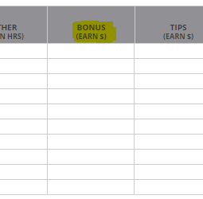

1. There is no save option – your entries are automatically saved.

***IMPORTANT:*** Try not to move off the Additional Time Entry Grid until you have entered in all of the employees as needed. If you do move off the grid, just be sure to re-select the Template Type and Additional Check Type again.

**Previewing Bonus Checks:**

1. Preview all of the bonus checks entered in on this grid by navigating to: PAYROLL PROCESSING, Preview Payroll. (Same process you follow when previewing your payrolls)
2. Select the Preview Payroll button 
3. Review the Payroll Register Report.

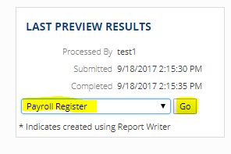

**Deleting Bonus Checks:**

* If you find a bonus check that has to be deleted, you must go to that employees Individual Time Entry screen to make the individual deletion.
  + Go to: PAYROLL PROCESSING/Payroll Entry < Individual Time Entry
  + Click on the X near the newly added check



* If you find an amount that needs to be changed
* Go back to the Additional Time Entry Grid
* Key in the change(s) needed

**Final Steps**

After any of the above changes are made, be sure to go back to the Preview Payroll and re-run the Payroll Register Report to review your changes.

Once you are satisfied with the Bonus Checks, there is no further action. The Bonus Checks will be pulled into the next payroll.

**Bonus Check Guidelines**

**Taxations**

Bonus amounts are subject to taxes

**Due Date**

The Bonus Check data entry is due the same date that your regular payroll is due. The bonus checks and the regular payroll checks will be dated the same.

**Off Cycle Bonus Checks**

If you require an off cycle Bonus Check payroll run, you must email Kabel Business Services at [payrolldepartment@kabelbiz.com](mailto:payrolldepartment@kabelbiz.com) 3 Days prior to the requested check date. Be sure to complete, save and attach to your email the “Off Cycle Bonus Check Request Form”

The fees for off cycle runs are as follows:

* 0-25 employees: $25.00
* 26-50 employees: $50.00
* Over 50 employees: $75.00
* Plus any shipping fees if applicable

**Tax Liability Notification**

If your bonus payroll amount is over $100,000 OR if the combined amount of your regular payroll plus the added bonuses is over $100,000, you must notify Kabel Business Services at least 3 days prior to the payroll being processed. Please email [payrolldepartment@kabelbiz.com](mailto:payrolldepartment@kabelbiz.com) and CC: [erins@kabelbiz.com](mailto:erins@kabelbiz.com)

**Blocking Direct Deposit**

If you would like the Bonus Checks to be paper checks rather than direct deposited, please email Kabel Business Services at [payrolldepartment@kabelbiz.com](mailto:payrolldepartment@kabelbiz.com) 3 Days prior to the check date.

**Employee Notification**

For employees enrolled in Employee Self Service, they will get the email notification and be able to see the Bonus Check voucher as soon as you submit the bonus payroll.