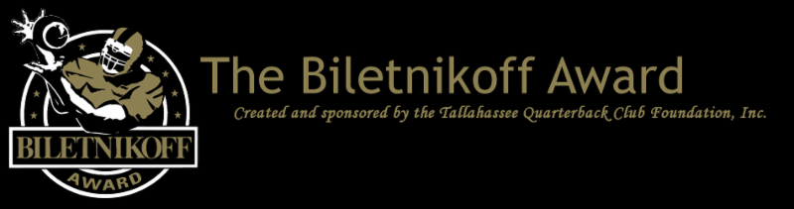

The Tallahassee Quarterback Club Foundation, the Creator and Sponsor of the Biletnikoff Award, Announces the 2018 Preseason Biletnikoff Award Watch List

  For Immediate Release: July 19, 2018
  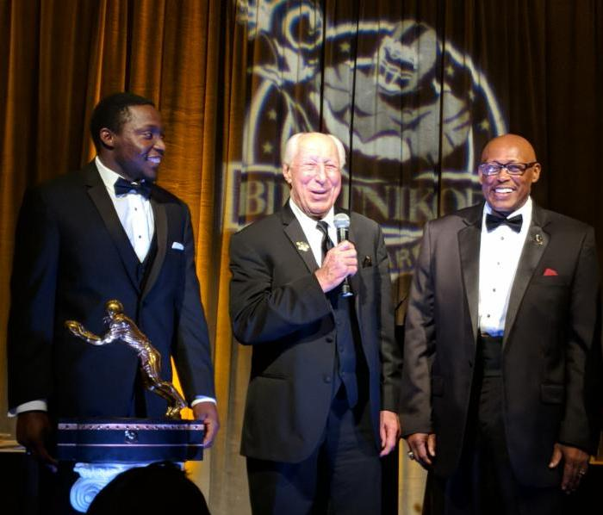
  2017 Biletnikoff Award winner James Washington with Fred Biletnikoff and keynote speaker Floyd Little at the 2018 Biletnikoff Award Banquet.
  Tallahassee, FL - The Tallahassee Quarterback Club (TQC) Foundation, Inc., the Florida-based creator and sponsor of the Biletnikoff Award, has released the 2018 Biletnikoff Award Preseason Watch List. The Biletnikoff Award annually recognizes the outstanding FBS receiver in college football. Any player, regardless of position (wide receiver, tight end, slot back, and running back) who catches a pass is eligible for the award. As such, the Biletnikoff Award recognizes college football's outstanding receiver, not merely college football's outstanding wide receiver. The award recipient is selected by the highly distinguished Biletnikoff Award National Selection Committee, a group of prominent college football journalists, commentators, announcers, Biletnikoff Award winners, and other former receivers. Foundation trustees do not vote and have never voted. For a list of voters, please see BiletnikoffAward.com/voters
  Receivers are periodically added to the watch list as their season performances dictate. Actual, not potential, performance is the basis for inclusion on the Biletnikoff Award Watch List.
  The transparently detailed and explicit criteria for candidate eligibility, watch list inclusion, and voting appear at: BiletnikoffAward.com/criteria
  The 2018 Biletnikoff Award winner will be presented live on December 6, 2018, on The Home Depot College Football Awards presented by Gildan to be broadcast 7:00 - 9:00pm (EST) on ESPN. College and pro football hall of famer Fred Biletnikoff will announce the 2018 Biletnikoff Award winner on the show.
  The correlation between Biletnikoff Award winners and stardom in the National Football League is nearly uniformly consistent. Past Biletnikoff Award winners include Calvin Johnson, Randy Moss, Michael Crabtree, Amari Cooper, and Larry Fitzgerald.
  The 2018 Biletnikoff Award winner will be presented the Biletnikoff Award trophy by college and pro football hall of famer Fred Biletnikoff and keynoter & 1993 Lombardi Award and Jim Parker Award winner Aaron Taylor before 550 patrons at the Biletnikoff Award Banquet at the University Center Club at Doak Campbell Stadium in Tallahassee on Saturday, February 16, 2019. The banquet was hailed by 2014 keynote speaker Dick Vermeil, as well as by 2013 keynoter Larry Csonka, as "the best banquet in college sports."
  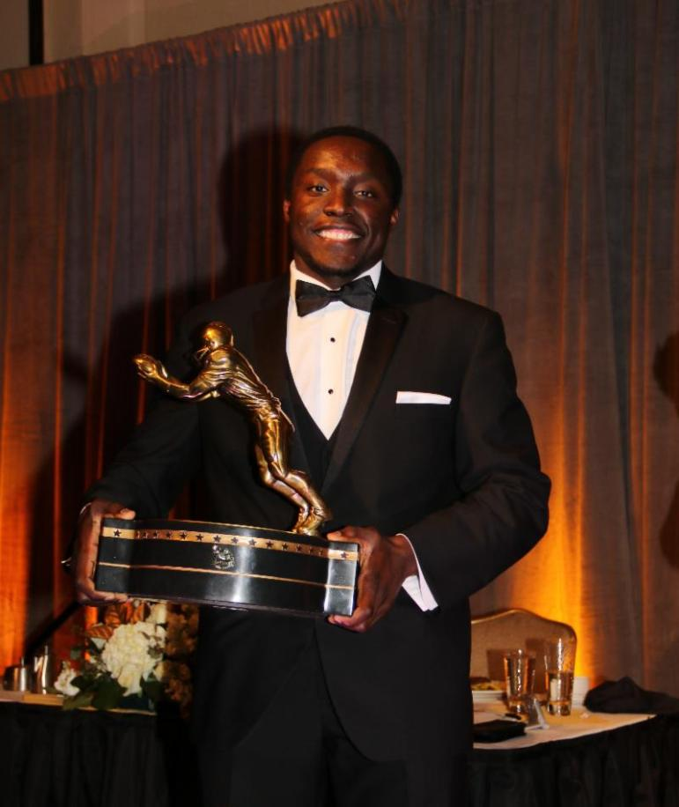
  The banquet has featured distinguished keynoters of profound character and accomplishments including Bart Starr, Dick Vermeil, Floyd Little, Larry Csonka, Steve Largent, Mike Ditka, Don Shula, Dan Reeves, Archie Manning, Ron Jaworski, Gene Stallings, Bob Griese, Bill Curry, Bobby Bowden, Jim Kelly, Jerry Kramer, Joe Theismann, and Dan Fouts.
  The banquet also recognizes the Foundation's scholarship recipients who will be offered by the Foundation over $800,000 in college and vocational scholarships and related benefits in 2019 alone, as in 2017 and 2018.
  The Foundation's charitable mission is the provision of college and vocational scholarships and related assistance to North Florida high school seniors who have overcome significant barriers to achieve at the highest academic and extra-curricular levels.
  The Tallahassee Quarterback Club Foundation, Inc., will announce the ten Biletnikoff Award semifinalists on November 12, 2018, following the vote by the distinguished members of the Biletnikoff Award National Selection Committee. Likewise, the three finalists will be declared, following another vote, on November 20, 2018. For complete details and updates of interest, together with weekly statistics and timely, important news of the Biletnikoff Award candidates, as well as a fan vote and discussion board, please consult the Foundation's highly informative website at BiletnikoffAward.com.
  The name Biletnikoff is synonymous with the term receiver. Fred Biletnikoff, a member of the pro and college football halls of fame, was a consensus All-America receiver at Florida State University, and an All-Pro receiver for the Oakland Raiders. He caught 589 passes for 8,974 yards and 76 touchdowns in his 14-year Raiders career from 1965 through 1978. Fred was the Most Valuable Player of Super Bowl XI.
  The 2018 Biletnikoff Award Preseason Watch List
  (Other receivers will be added as their season performances dictate)
  NAME | SCHOOL
  JJ Arcega-Whiteside | Stanford
  Tyre Brady | Marshall
  A.J. Brown | Ole Miss
  Marquise Brown | Oklahoma
  Trevon Brown | East Carolina
  Ryan Davis | Auburn
  Greg Dortch | Wake Forest
  Terren Encalade | Tulane
  Dez Fitzpatrick | Louisville
  James Gardner | Miami-Ohio
  Jonathan Giles | LSU
  Marcus Green | ULM
  Jalen Guyton | North Texas
  Emanuel Hall | Missouri
  Justin Hall | Ball State
  Kelvin Harmon | North Carolina State
  N'Keal Harry | Arizona State
  Penny Hart | Georgia State
  Justin Hobbs | Tulsa
  Andy Isabella | Massachusetts
  Gary Jennings, Jr. | West Virginia
  Anthony Johnson | Buffalo
  Collin Johnson | Texas
  Diontae Johnson | Toledo
  KeeSean Johnson | Fresno State
  CeeDee Lamb | Oklahoma
  Michael Lawrence | North Texas
  Ty Lee | Middle Tennessee
  McLane Mannix | Nevada
  Scott Miller | Bowling Green
  Denzel Mims | Baylor
  Stanley Morgan, Jr. | Nebraska
  Kanawai Noa | California
  James Proche | SMU
  T.J. Rahming | Duke
  Ahmmon Richards | Miami
  Deebo Samuel | South Carolina
  David Sills, V | West Virginia
  Steven Sims, Jr. | Kansas
  Jaylen Smith | Louisville
  Kwadarrius Smith | Akron
  JD Spielman | Nebraska
  Cody Thompson | Toledo
  John Ursua | Hawaii
  Teddy Veal | Louisiana Tech
  Jamarius Way | South Alabama
  Nick Westbrook | Indiana
  Vic Wharton, III | California
  Malcolm Williams | Coastal Carolina
  Olamide Zaccheaus | Virginia
  The Biletnikoff Award
  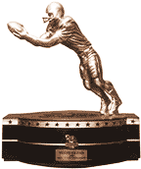
  The Biletnikoff Award is presented annually to the season's
  outstanding college football receiver regardless of position (the award defines receiver as any player who catches a pass, hence tight ends, slot receivers and backs, inside receivers, wide receivers, split ends, and running backs are eligible)
  (BiletnikoffAward.com/about_award)
  The TQC Foundation, Inc., is an independent, charitable organization that was founded in 1994. Past and Current Chairman & Founding Trustee Professor Walter W. Manley II, Founding Trustee L. Thomas Cox, Jr., Founding Trustee Rocky Bevis, and Founding Trustee Bob Teel established the award and the TQC Foundation, Inc., that sponsors it. Many more trustees have contributed to its development as one of the most prominent awards in college football. The TQC Foundation, Inc., joined the idea of a college receiver's award to the organization's vision and created the outstanding award and dynamic organization.
  The trophy, presented to each winner, is the most beautiful in college football - it has won several national, juried competitions for design excellence and aesthetic appeal.
  Likewise, the website and printed banquet program have been cited nationally for excellence in design.
  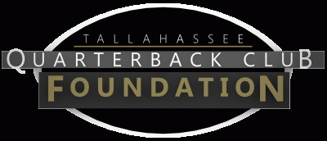
  The Tallahassee Quarterback Club Foundation, Inc., a 501(c)(3) organization, is the creator and sponsor of the Biletnikoff Award. The Foundation administers the Biletnikoff Award, its charitable activities, and the distinguished Biletnikoff Award National Selection Committee. Foundation Trustees are prohibited from serving on the National Selection Committee. For a full recounting of the Foundation's activities, please consult BiletnikoffAward.com.
  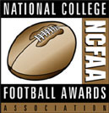
  National College Football Awards Association
  The Biletnikoff Award is a member of the National College Football Awards Association (NCFAA), which includes college football's most prestigious awards. Founded in 1997, the NCFAA and its 23 awards boast 800 recipients, dating to 1935. Visit NCFAA.org to learn more about the NCFAA.
  The members of the NCFAA are unveiling their preseason watch lists over a two-week period this month. Sixteen of the association's 23 awards select a preseason watch list and the NCFAA has spearheaded a coordinated effort to promote each award's preseason candidates. Following is the complete 2017 preseason watch list calendar:
  Date | Award
  July 16 | Bednarik Award & Maxwell Award
  July 17 | Davey O'Brien Award
  July 18 | Doak Walker Award
  July 19 | Biletnikoff Award
  July 20 | John Mackey Award & Rimington Trophy
  July 23 | Butkus Award & Paycom Jim Thorpe Award
  July 24 | Bronko Nagurski Trophy & Outland Trophy
  July 25 | Lou Groza Award & Ray Guy Award
  July 26 | Paul Hornung Award & Wuerffel Trophy
  July 27 | Walter Camp Award
  Important Dates
  July 19, 2018:
  Pre-Season Watch List announcement
  September 4, 2018:
  FanVote opens
  November 5-11, 2018:
  Vote by the Biletnikoff Award National Selection Committee to determine 10 Semifinalists
  November 12, 2018:
  10 Semifinalists announcement
  November 13-18, 2018:
  Vote to determine 3 Finalists
  November 20, 2018:
  3 Finalists announcement
  November 27 - December 3, 2018:
  Final vote to determine Biletnikoff Award Winner
  December 6, 2018:
  Biletnikoff Award Winner announced on The Home Depot College Football Awards presented by Gildan
  The Home Depot College Football Awards airs live on ESPN December 6, 2018, 7 - 9pm (EST)
  The Biletnikoff Award Banquet
  honors the 2018 Biletnikoff Award Winner on Saturday, February 16, 2019
  University Center Club at
  Doak Cambell Stadium, Tallahassee, Florida
  Inquiries:
  Professor Walter W. Manley II
  Founding Trustee & Chairman of the Tallahassee Quarterback Club Foundation, Inc.
  Creator and Sponsor of the Biletnikoff Award
  BiletnikoffAward.com/Manley
  Cell 850-766-0800
  prof.wwmii@comcast.net
  Selection Chairman:
  Professor Walter W. Manley II
  Selection Deputy Chairman:
  Ritchie Pickron
  Cell 850-363-0174
  rpickron123@yahoo.com
  Website and Publicity Contact:
  Will Stewart
  biletnikoffaward@biletnikoffaward.com
  Website
  www.biletnikoffaward.com
  Fan Vote
  www.biletnikoffaward.com/fan-vote


  Biletnikoff Award, PO Box 10762, Tallahassee, FL 32302
  SafeUnsubscribe™ {recipient's email}
  Forward email | Update Profile | About our service provider
  Sent by biletnikoffaward@biletnikoffaward.com in collaboration with
  
  Try it free today

