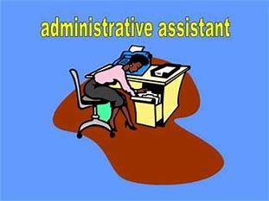
Date Open: 1/3/18

Date Close: 1/11/18

Administrative Aide II
Job Order #786787

Job Summary:
To perform administrative and office support activities. Duties include: Fielding telephone calls; receiving and directing visitors; creating spread- sheets; filing; other duties as assigned.

Location: Largo, MD Work: M-F; 8:30am—5:30pm
*MUST be a Prince George’s County resident

Submit resumes to: kcox@cmtservicesinc.com
Subject line: Administrative Aide #786787

For More Details Please Visit: https://mwejobs.maryland.gov

