**Employee of the Month**

**Resident’s Choice**



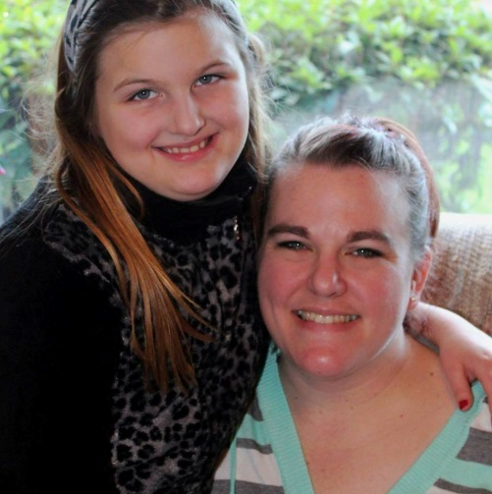****

**Thank you for ALWAYS going the EXTRA mile!**

Born and raised in Oregon, Carly has worked at The Park since September and has become a favorite among her residents and her coworkers. Carly was a CNA for 8 years and has been a CMA, (Certified Med Aide) for 6. She states she has always loved taking care of others and we can attest that shows in her wonderful work ethic and beautiful smile.

Mom to 10 years old, Margaret, and to a chiweenie/yorkie mix named Sally; Carly loves to spend her days off with her family and in “taking long country drives with no destination”!

We are so happy your destination brought you to us, Carly!!

**Carly Stahl**

**(and Darbie Lynn)!**