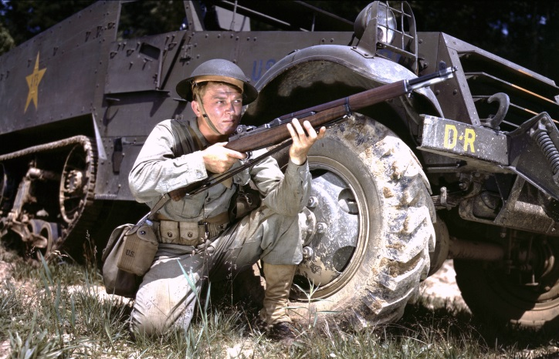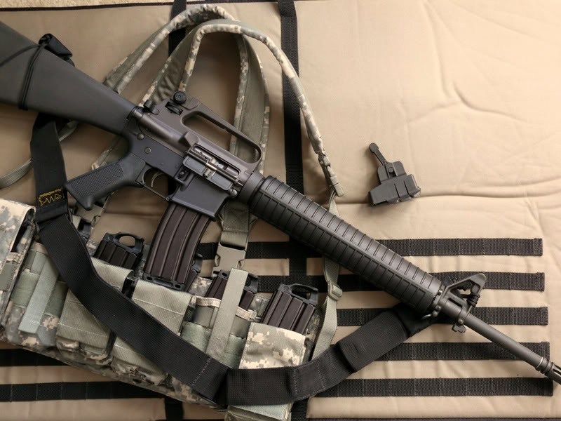
2017 PCSC SERVICE RIFLE COMPETITIONS SCHEDULE
…go to www.parkersportman.com for specific match details
GENERAL MATCH DESCRIPTIONS – MATCH DETAILS ON PCSC WEBSITE
JANUARY 21, 2017 200YD 3 POSITION (35 RD) MATCH - OPEN SIGHTS
FEBRUARY 18, 201 7 ‘BLACK HAWK DOWN’ MODERN BLACK RIFLE MATCH
MARCH 18, 2017 CMP VINTAGE and MODERN DIVISIONS
APRIL 15, 2017 ‘RATTLE BATTLE’ 250 PRONE, 200 SITTING, 150 OFF-HAND
MAY 20, 2017 CMP VINTAGE and MODERN DIVISIONS
JUNE 17, 2017 ‘FUN FAMILY & FRIENDS’ TWO MATCH EVENT & ‘HOT DOG BURN’! MATCH ‘A’ - WWII CARBINE and FOREIGN CARBINE MATCH OPEN SIGHTS – 100 YDS 3 POSITIION (35 RDS/ 30 FOR SCORE) MATCH ‘B’ – SPECIAL YOUTH’ .22 RIMFIRE RIFLE MATCH OPEN SIGHTS – 50 YDS, 3 POSITION (35 RDS/ 30 FOR SCORE)
JULY 15, 2017 ‘TWO DIVISION’ SNIPER MATCH – 20 RDS, 250 YDS WITH SR-1 TARGET DIVISION I – MILITARY SERVICE SNIPER RIFLES W/ PERIOD CORRECT OPTICS AND BI-POD (EXAMPLE - M14/M1A1), FRONT SAND BAGS, SLING DIVISION II – ‘OPEN’ SNIPER RIFLES – ANY CENTER FIRE RIFLE CALIBER BELOW .50 BMG, ANY OPTIC, BI-POD, FRONT SAND BAGS, SLING
SEPTEMBER 16, 2017 ‘URBAN RIFLE MATCH’
OCTOBER 21, 2017 CMP VINTAGE and MODERN DIVISIONS
NOVEMBER 18, 2017 SNIPER RIFLE ‘TWO MATCH’ EVENT MATCH ‘A’ – 200 YDS VINTAGE SNIPER ‘TWO-MAN TEAM’ MATCH - MR-52 TARGET MATCH ‘B’ – 200 INDIVIDUAL VINTAGE SNIPER MATCH - SR-1 TARGET
