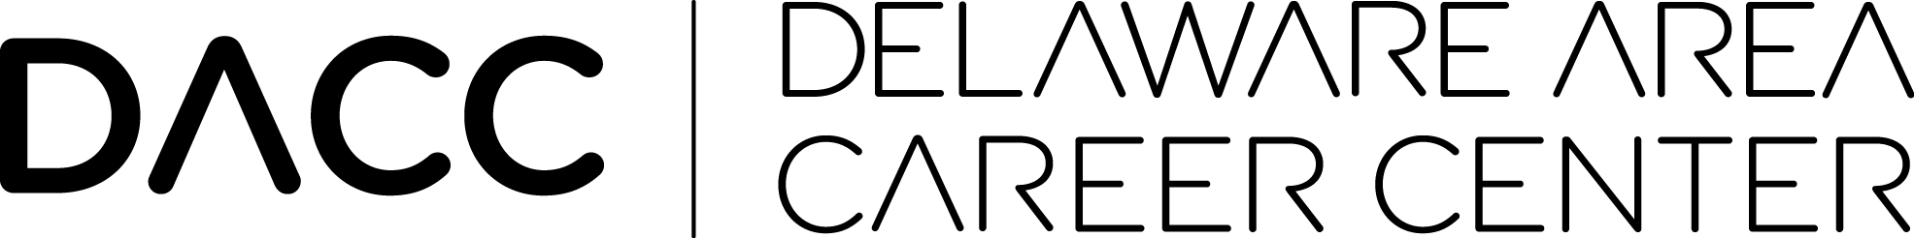

August 29, 2018

Dear Student & Parent(s)/Guardian(s),

To better align with our home school districts, Delaware Area Career Center, in partnership with Helpline, is excited to be offering a Signs of Suicide Program at both North and South Campuses on October 1st-3rd. This program will take place for all junior on campus students during their scheduled lab times for 40 minutes a day. The Signs of Suicide High School Prevention Program is a three-day, award winning, nationally recognized program designed for high school aged students. Signs of Suicide is the only suicide education, training and screening program listed on the Substance Abuse and Mental Health Services Administration’s National Registry of Evidence-based Programs and Practices that addresses depression and suicide risk, while also reducing suicide attempts. Students will be given a brief depression screening on the last day of the program. This screening assists in the referral process to connect at-risk students to the help they need.

Through discussion and a video, students will learn to:

* Identify signs of suicide in themselves and their friends, while understanding the risks associated with stress and suicide.
* Discuss depression as a treatable illness.
* Identify where they can go for help, including our local and national, 24/7 hotlines.
* Use the ACT (Acknowledge, Care, and Tell) technique to support their friends.

If you do not wish to have your son or daughter participate in this three day event held at both campuses, please fill out the pertinent information below and return to North or South Campus to David Gilliam, Student Services Supervisor. Delaware Area Career Center will accommodate a supervised area for those students opting out of the program.

Student Name:____________________________________________

Student Lab: ______________________________________________

Campus Location: __________________________________________

Parent/Guardian Name: _____________________________________

Signature: ________________________________________________

Sincerely,



David Gilliam

Student Services Supervisor

Delaware Area Career Center

*The Delaware Area Career Center, in partnership with community, is an innovative model for developing lifelong learners, quality leaders, and critical thinkers for the dynamic and global environment.*