
Conestoga Ice Hockey Club
2016-2017 Kick-Off Clinic!

Know someone who wants to play hockey?

The Conestoga Ice Hockey Club is open to all boys and girls living in the T/E school district.

To introduce potential new players to the team, we are hosting a Kick-Off clinic for boys and girls in grades 5-8 and we’re asking all of our current players to “Bring a Friend” on Sunday, September 11 at 4:15pm!

This is a fun hockey clinic open to new and experienced players who want to meet the Middle School coaches & returning players and
learn more about playing ‘Stoga hockey!

Conestoga High School Varsity players and coaches will also be on hand to help the kids with skating, stick handling, and shooting.
Invite your friends, teammates, and siblings!
To learn more, please contact Nicole Bennyhoff at nicolebennyhoff@gmail.com or Kristin Pisano at Kristin.pisano@yahoo.com.
See you on the ice!
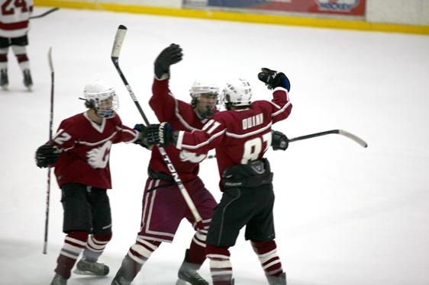

Helmet, gloves, skates and stick are mandatory for all players on the ice. Rental skates are available and players can wear bike/lacrosse helmets and lacrosse gloves. A limited amount of equipment can be borrowed from the rink. Pre-owned equipment can also be purchased at Play it Again Sports in Berwyn.

