
Home Together – Preach!
The Metro Dallas Homeless Alliance (MDHA) and Faith Forward Dallas (FFD@TGS) are encouraging members of the clergy to use their sermons during Hunger and Homelessness Awareness Week, November 10-18, 2018, to educate their congregations on how they can help end homelessness.
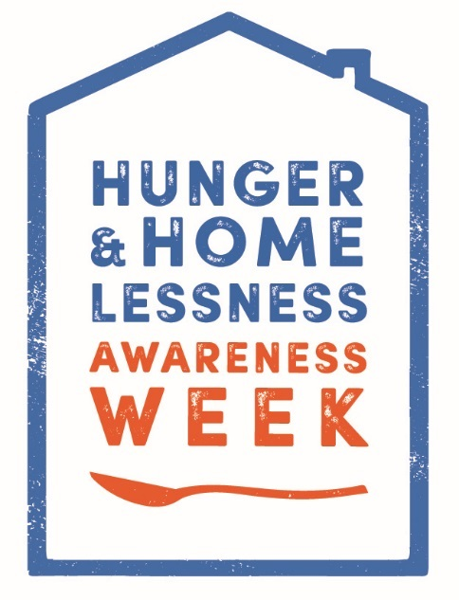
Here are some simple steps for clergy who wish to join this effort:
- Solidify a specific date that you will be preaching on homelessness, during that week;
- Publicize the fact that you will be preaching on homelessness, as part of Hunger and Homelessness Awareness Week, November 10-18, 2018;
- Think about content and ideas for your sermon. In this post on the MDHA blog – Home Together – Preach – It’s Time to Plan! www.mdhadallas.org/blog/home-together-preach-how/ we have provided exhaustive resources to help you with just that.
- Think about how you can leverage your sermon, to garner support for taking steps that can really help end homelessness. For ideas, check out MDHA and FFD@TGS’s shared homelessness initiative, which is linked to in the above blog post.
We hope many congregations will join us in this effort. Please feel free to reach out to David Gruber, MDHA Development and Communications Director, with any questions, at 469-222-0047 or David.Gruber@mdhadallas.org.

