How Much Should I Give to MDHA This North Texas Giving Day?

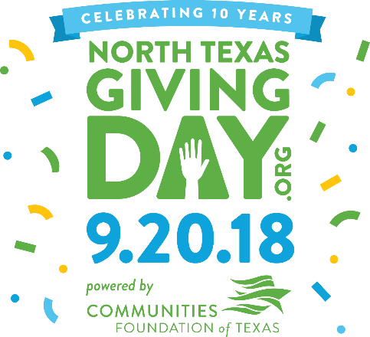

North Texas Giving Day is a very important day for us, at MDHA, in our effort to end homelessness. You may be wondering: How much should I give to MDHA on September 20, 2018? Here are some suggestions, based on how much we gave our homeless friends:

$43.75. $43.75 allowed Judith and her dog Simon to move from a tent into their own apartment.

$103.53. $103.53 allowed Jonathan to reconnect his electricity, and avoid a return to homelessness.

$120.75. $120.75 allowed Daniel and Karla to remain housed, Abraham to pursue a job, and Richard to become eligible for a housing voucher. No, not $120.75 each; $120.75 total.

$200. $200 allowed Laura to move from Austin Street Center into her own apartment.

$350. $350 allowed Tom, a military veteran, to move from The Bridge into his own apartment.

$500. $500 allowed Julia, a single mom with three little kids, to move from a motel room into their own apartment.

$600. $600 allowed Pearl and Donna to move from Austin Street Center into their own duplex.

North Texas Giving Day – Give to MDHA!
http://northtexasgivingday.org/metro-dallas-homeless-alliance

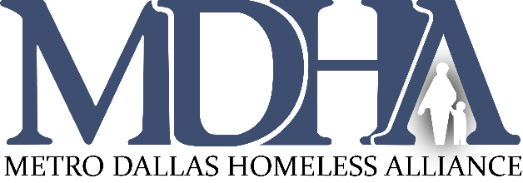
Why Should I Give to MDHA This North Texas Giving Day?

North Texas Giving Day is a very important day for us, at MDHA, in our effort to end homelessness. You may be wondering: Why should I give to MDHA on September 20, 2018? Let’s, actually, break it down:

Q: With so many great causes out there, why should I give, specifically, to MDHA, an organization fighting to end homelessness?

A: The foundation for everything in life is a home. Without a home, how do you escape poverty, maintain your health, or educate a child? It can’t be done.

Q: Of all the organizations fighting to end homelessness, why should I give, specifically, to MDHA?

A: Research shows that the only way to make real progress is through collective impact, many organizations working together to achieve a common goal, like ending homelessness. Research further shows that you need a strong backbone organization, like MDHA, to lead the collective impact, in order for it to work.

Q: I thought you are funded by the government, so why are you asking me to donate?

A: Here is how our funding works: We must show that for every $3 the government gives us, we have raised $1. If we can’t we, literally, have to give the money back. That is why your donations are so critical to our work. Every dollar you give powers $3 more dollars of funding.

North Texas Giving Day – Give to MDHA!
http://northtexasgivingday.org/metro-dallas-homeless-alliance

