The Chronic Disease Self-Management

Program (CDSMP) is a community-based

program which assists participants in

maintaining quality of life when faced with

chronic medical conditions. The CDSMP is

provided in two-and-a-half-hour-long sessions,

once a week for six weeks, in community settings

e.g., senior centers, churches, libraries). People with

(

different chronic health problems attend together. Workshops

are facilitated by two trained leaders, one or both of whom deal

with chronic diseases themselves. Subjects covered include: 1) techniques to

deal with problems such as frustration, fatigue, pain and isolation, 2) appropriate exercise for maintaining and improving

strength, flexibility, and endurance, 3) appropriate use of medications, 4) communicating effectively with family, friends,

and health professionals, 5) nutrition, and, 6) how to evaluate new treatments. Classes are highly participative, where

mutual support and success build the participants’ confidence in their ability to manage their health and maintain active

and fulfilling lives.

W

h

a

t

y

o

u

l

e

a

r

n

W

h

y

y

o

u

l

e

a

r

n

H

o

w

y

o

u

l

e

a

r

n

Description

maintaining quality of life

with a chronic disease

in highly participative classes

in a community setting

Live an active and fulfilling life when faced with chronic medical conditions.

to build confidence in your ability

to manage your health



an equal opportunity/ADA institution

Chronic Disease

Self-Management

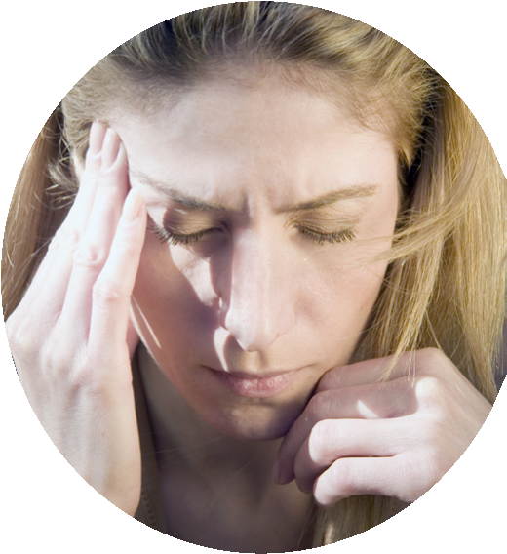

Information:

April 3rd 1:00-3:30pm

April 10th 1:00-3:30pm

April 17th 1:00-3:30pm

April 24th 1:00-3:30pm

May 1st 1:00-3:30pm

May 8th 1:00-3:30pm

Location: Higginsville Senior Center

101 W. 21st St

Higginsville, MO 64037

Instructors: Tracy Delaney and Tyler Hall

To register call 660-584-3658

**FREE COURSE**

Human Environmental Sciences Extension: Solutions for Better Living

