

**Project Blueprint**

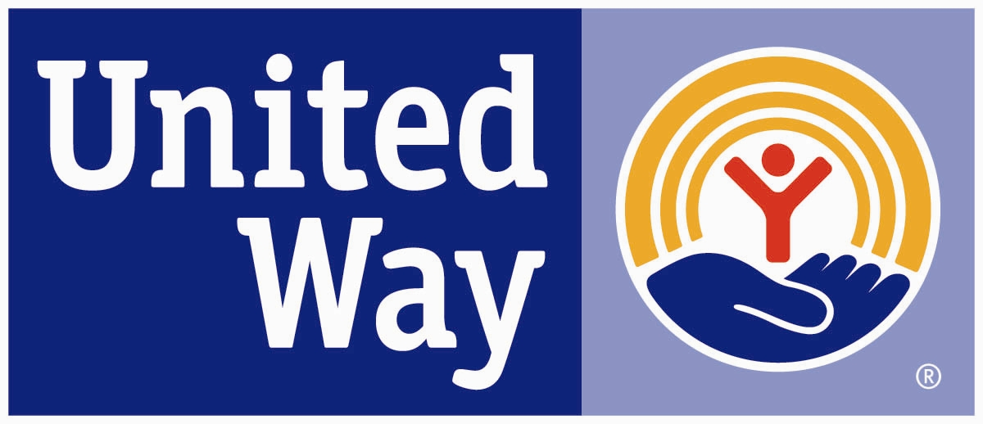

Project Blueprint is a leadership development program designed to increase representation of underrepresented groups on local nonprofit boards and committees. The program consists of a series of training sessions that introduce participants to the roles and responsibilities of a nonprofit board while developing their skills to help them become successful board members. United Way Worldwide launched Project Blueprint in 1987 as a pilot program funded by the W.K. Kellogg Foundation and the first Project Blueprint class from United Way of Forsyth County graduated in 1992. Since then over 200 individuals have graduated from the program. Project Blueprint is now a partnership between United Way of Forsyth County and HandsOn Northwest North Carolina.

**Goals**. Project Blueprint seeks to:

* Recruit volunteers from underrepresented populations for involvement in nonprofit organizations
* Develop and improve leadership skills
* Improve service delivery through volunteer involvement in the workplace and community at large
* Ensure that local volunteer leadership is more reflective of our diverse community
* Create a network of ethnically and culturally diverse professionals
* Place program graduates on local nonprofit boards or committees where they can use their knowledge and skills to serve their community

**Eligibility**. Project Blueprint seeks applicants who:

* Are from diverse cultural and ethnic backgrounds
* Exhibit or have the potential for leadership
* Show an interest in community involvement and a desire to serve and strengthen our community
* Will to commit to serve on a nonprofit board of directors or committee upon graduation from the program

**What You Can Expect:**

* Acquire knowledge and skills needed to effectively serve on a nonprofit board or board committee
* Build a peer group of other civic minded persons
* Help with placement on a nonprofit board

**Program**. Recruitment for the next Project Blueprint class begins in November and continues through the application deadline of **February 16, 2018**. Class size is limited to ensure a high quality experience and more meaningful networking. A half day orientation event will be held on **March 14**. This event is followed by 9 **consecutive classes that will meet each Tuesday, March 13-May 22 from 12-2 pm**. The program closely follows the **Ten Basic Responsibilities of Nonprofit Boards,** published by BoardSource, a nationally recognized organization dedicated to increasing nonprofit board governance. Participants are also required to attend a **Nonprofit Board Speed Dating** event on Tuesday, May 22, to talk with various nonprofits about board and board committee opportunities. All classes include a networking lunch.

**Requirements**. Participants are expected to attend all classes, so check your calendar to make sure the dates and times do not conflict with other commitments. You may miss only one class in order to graduate from the program. If more than one class is missed, you will be required to repeat the entire program.

**Location**. Training sessions will be held at **The Winston-Salem Foundation** building, located at **751 West Fourth Street, Winston-Salem, 27101**, on the 3rd floor in the Neill Board Room.

**Cost**. The cost to participate in the program is **$75 per person** and is due by **March 13, 2018**. Many companies sponsor their employees’ tuition, but a limited number of partial scholarships are available. For information on scholarships, please email [KathyDavis@HandsOnNWNC.org](mailto:KathyDavis@HandsOnNWNC.org).

**Curriculum and Schedule**

Orientation March 13, 2018 12-3 pm

Nonprofit Overview, Board Functions & Responsibilities March 20 12-2 pm

Selecting, Supporting and Evaluating the Chief Executive March 27 12-2 pm

Strategic Planning April 10 12-2 pm

Program & Service Evaluation April 17 12-2 pm

Philanthropy April 24 12-2 pm

Fiscal Responsibility May 1 12-2 pm

Board Development and Operations May 8 12-2 pm

Legal and Ethical Integrity, Advocacy May 15 12-2 pm

Nonprofit Speed Dating May 22 12-2 pm